What is Grace?

regarded the Samaritans as a people to themselves, in spite of an obviously

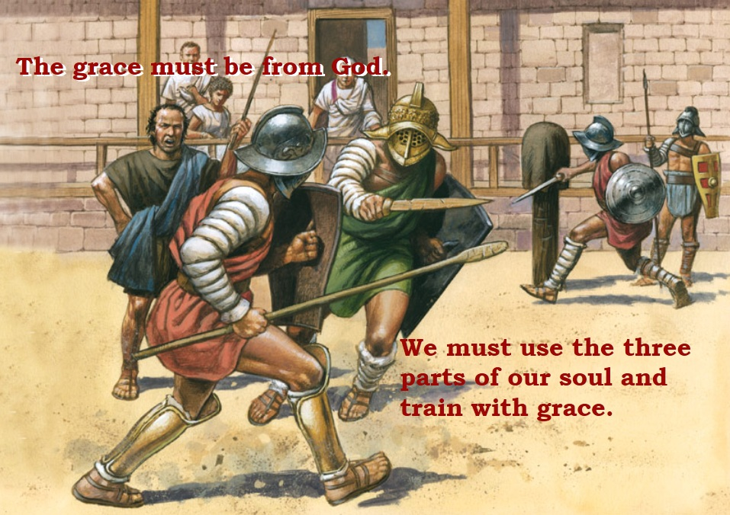

Paul's Epistles give us two definitions of grace.

^{Tit 2:11} "For the grace of God has appeared for the salvation of all men, training us to reject godless ways and worldly passions, and to live sober, upright and godly lives in this world".

^{Gal 1:15} "But when He (God) who had set me (Paul) apart before I was born, and had called me (Paul) through His grace, was pleased to reveal His Son to me, in order that I might preach Him among the Gentiles, I did not confer with flesh and blood".

What is grace?

Apostle Paul has given us two definitions for grace. The first is in Paul's Epistle to the Titus, he writes: Titus (2:11) "For the grace of God has appeared for the salvation of all men, training us to reject godless ways and worldly passions, and to live sober, upright and godly lives in this world".

The soul has three parts, memory, understanding and will and all three parts are needed when we use grace as a trainer. See lesson on the soul.

All men are given grace because every human soul is taught grace by God the Father. All men are taught the Natural Law, also called the "Golden Rule".

^{Mt 7:12} So whatever you wish that men would do to you, do so to them; for this is the law and the prophets.

Ask yourselves, are you aware of the Natural Law when you make choices throughout your day? Do you treat others in the way you would want to be treated? Our souls are needed when we contemplate and place into action (training) the Natural Law.

John the Apostle writes in his Gospel the following words spoken by Jesus.

^{Jn 6:45} It is written in the prophets, ‘And they shall all be taught by God.’ Every one who has heard and learned from the Father comes to Me.

Does another person have to tell you about the Natural Law? The Natural Law should be obvious. Scripture says the following:

^{Dt 30:11} “For this commandment which I command you this day is not too hard for you, neither is it far off.
^{30:12} It is not in heaven, that you should say, ‘Who will go up for us to heaven, and bring it to us, that we may hear it and do it?’
^{30:13} Neither is it beyond the sea, that you should say, ‘Who will go over the sea for us, and bring it to us, that we may hear it and do it?’
^{30:14} But the word is very near you; it is in your mouth and in your heart, so that you can do it.

Those who have trained using the grace called the Natural Law will be given the proper spirit to come to Jesus. When we "train" and obey the Natural Law we will have "learned" from the Father. Because most men ignore they even have a soul and ignore the grace called the Natural Law, Jesus has a name for them and He calls them hypocrites. (See lesson on hypocrites.)

By obeying the Natural Law, we will be given a strong desire to know Jesus. For Jesus came into the world to give us more grace.

The greatest grace Jesus gave us was spoken by Him on the night He was arrested.

^{Jn 13:34} A new commandment I give to you, that you love one another; even as I have loved you, that you also love one another.

Jesus gave us grace when He told us to love one other. How did Jesus love us? We need far more than the Scriptures to understand how Jesus loved us.

Where do we go to understand how Jesus loved us? Grace is given to us through the "keys" of Peter. The Popes have approved 35 saints called doctors. These doctors have written books to explain godless actions and upright and sober virtues. A special book written by Saint Catherine the "Dialogue" is a great "trainer" teaching us the thoughts of God. Her writings can be found on first page of this website.

Five Popes approved the "City of God" by Mary of Agreda. Her book is a great place to find grace because she was given the story of Jesus and Mary when they lived here upon the earth. The lives of Jesus and Mary are revealed explaining how they lived among the Jews.

Catholics have the "keys" of Peter which open the door to countless number of grace. Because the Protestants have protested against the "keys", their grace is limited to the Natural Law and the Protestant Bible.

Like at the Tower of Babel, Christians around the world are speaking babel when it comes to doctrine. If we interpret the Scriptures incorrectly, we have damaged the grace God has given us. If we reject the "keys" of Peter, we are actually rejecting the graces God has given us. The Bible does not say that grace stopped after the Final Book called "The Book of Revelation". Just as it rains upon the earth, God continues to rain His grace upon us through "keys" of Peter.

Every person has an opinion on what is godless or evil. If grace is a trainer to teach us to reject godless ways, but each denomination teaches a different way of being holy, why do Christians not see the problem? Are all Christian denom-inations correct! But arrogance is the sin that allows people to believe in their doctrines and recognize everyone else is in error. But this would never happen if Christians had the humility of the eunuch found in the Acts of the Apostles. The eunuch had left Jerusalem and was reading the book of Isaiah. Apostle Philip was sent by the Holy Spirit and Philip asked the eunuch if he understood what he was reading. The eunuch responded by saying: "How can I unless some one guides me"? Act (8:31)

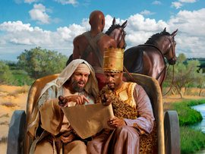

The eunuch's response should be our response. Thus who can be a worthy trainer to teach us how to reject godless ways? Jesus must have a direct hand in choosing our trainer. And Jesus did by giving Peter the "keys". Those who do not like such an answer must like confusion and arrogance that Christianity has experienced from the start. Recall the words of Paul: Cor (11:18) "For, in the first place, when you assemble as a church I hear that there are divisions among you, and I partly believe it". It's very unfortunate that the writings of Paul, Peter and John didn't inform us of the importance of Jesus giving the "keys" to Peter. If they had plainly done this simple teaching, the number of Christian denominations and religious opinions would have sharply dropped.

Unfortunately Christians have been taught the following definition of grace. Grace is God's unmerited favor. That is, grace is God doing good for us that we do not deserve. What good is this definition? Did we learn anything? This definition and others like it say nothing. What good is grace if we do not understand it? By reading the lessons and chapters on this website, the reader will be trained on how to reject worldly passions and practice the virtues. But the greatest grace is to understand how Jesus loved us. This website is dedicated to showing the reader the "keys" of Peter.

The second definition for grace comes from the Epistle to the Galatians, he writes: Gal (1:15) "But when He (God) who had set me (Paul) apart before I was born, and had called me through His grace, was pleased to reveal His Son to me, in order that I might preach Him among the Gentiles, I did not confer with flesh and blood".

Grace means that God reveals His Son to us. The question must be asked, how does God reveal Jesus to us? The answer, God reveals the emotions of Jesus; and the emotions of Jesus are called the Seven Spirits of God. By understanding the emotions of Jesus we will understand how Jesus loved us.

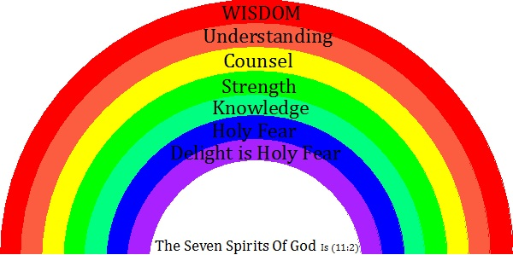

The Gospel of John calls Jesus the light of the world. The light has seven parts.

But we must realize there are many different theologies about Jesus, thus men are being taught with errors. For example many men preach that Jesus had brothers and sisters. Other errors involve the words Jesus spoke from the Cross. For example when Jesus says: "My God, my God, why have you forsaken Me!" Mt (27:46). They will say that the Father had separated Himself from the Son. But grace will reveal that Jesus wanted men to hear His complaint that that the Father's justice has only selected 1/3 of the human race for salvation. The human will of Jesus wanted all men to be saved, but the Father's justice required men to appreciate Jesus' Passion. Chapters one and two, on this website, reveal many of the emotions of Jesus. The most important emotion is to appreciate how Jesus tasted death by experiencing the suicidal emotions of all those that failed their Final Tests. When we take the time to contemplate the emotions of Jesus, we are in training and using the grace Jesus has sent to us.

Again I say, grace comes from God through the "keys" of Peter and we are to use grace by using the power of our souls. How do we train using grace? We must first study grace and then we must contemplate grace and our wills must apply it in our actions. The goal of our training with grace is to understand Jesus emotions and appreciate His emotions and to recognize how God defines evil and good.

What is a life like without grace?

People like to ignore how God taught them the Natural Law. Because of this sin, they will not be given the spirit to read, study and apply the Scriptures to their lives. The words spoken to Adam by God applies to these people. "Cursed is the ground because of you, in toil (useless work) you shall eat of it all the days of your life, thorns and thistles it shall bring forth to you". Gn (3:17) Very few people use their souls. Those who study the Scriptures are few because so few use the grace called the Natural Law. Those who study and use the graces given to us through the "keys" of Peter are even fewer. The lesson on "Pearls and Swine" will reveal the quality standards we must use when training with God's graces.

Questions

1) Grace trains us to reject _______ ways and worldly ______.

2) Grace trains us to live _____, upright and _____ lives.

3) All men are given grace by the Father because all men are taught the _________ _______.

4) What does it mean when a man learns from the Father? See verse John 6:45

5) What happens to a man when he learns from the Father? See verse John 6:45

6) If we fail to apply the Natural Law to our lives, Jesus will call us a ___________.

7) The greatest grace given to us was the commandment to love one another. On what night did Jesus give us this commandment?

8) The doctors of the church are saints whose books are used train us how to _______ sin and practice the ________.

9) How many doctors are their in Catholic Church?

10) Saint Catherine wrote the book called __________.

11) The "City of God" was written by _________ and approved by five ________ using a document called a Papal _______.

12) Because the Protestants have protested against the "keys", their grace is limited to the _______ Law and the ________ Bible.

13) Christians argue all the time about what is godless and sinful. They also argue what is sober and virtuous. The tower of ______ is the symbol and story of how no one can understand each other.

14) A eunuch was reading Isaiah and Philip asked him if he understood what he was reading. The eunuch responded by saying "___________________"?

15) It is very common that Christians give meaningless definitions for religious words like grace. What good is a definition if we can't understand and apply it. Some people like to define grace as God's _______ favor.

16) The emotions of Jesus are called?

17) By understanding the emotions of Jesus we will understand how Jesus ______ us.

18) Jesus tasted death by experiencing the _______ emotions of all those that failed their ______ Tests.

19) People will ignore God and His graces. If they ignore the _______ _____ these people will not have the spirit to read and apply the graces that come from the Scriptures.

20) The soul is the power that God has given us to train with grace. If we ignore grace, we are not using our souls. We can say a person's life that fails to use their soul as being cursed. What are the words that God says to Adam?

21) There are two goals that we want to achieve when training with grace. Name both goals.

