Faith.

Faith

The following Gospel stories speak how Jesus cured the following people and said your faith has healed you. This will be the foundation in which faith can be defined.

1) The centurion servant.
2) The paralytic at Capernaum.
3) A woman afflicted with hemorrhages.
4) Two blind men.
5) A canaanite woman's daughter possessed by a demon.
6) Bartimaeus a blind beggar.
7) Ten leapers.

Not only did Jesus cure each of them, He said that their faith was the reason why He healed them.

^{﻿Mt 8:3﻿} As Jesus entered Capernaum, a centurion came forward to Him, beseeching Him ﻿
^{8:6﻿} and saying, “Lord, my servant is lying paralyzed at home, in terrible distress.”
^{8:﻿7﻿} And Jesus said to him, “I will come and heal him.” ﻿
^{8:8﻿} But the centurion (A roman officer commanding 100 men.) answered Jesus, “Lord, I am not worthy to have you come under my roof; but only say the word, and my servant will be healed.
^{8:﻿9﻿} For I am a man under authority, with soldiers under me; and I say to one, ‘Go,’ and he goes, and to another, ‘Come,’ and he comes, and to my slave, ‘Do this,’ and he does it.”

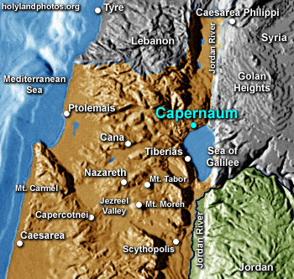
﻿
^{8:10﻿} When Jesus heard him, He marveled, and said to those who followed Him, “Truly, I say to you, not even in Israel have I found such faith.
^{8:﻿11﻿} I tell you, many will come from east and west and sit at table with Abraham, Isaac, and Jacob in the Kingdom of Heaven,
^{8:﻿12﻿} while the sons of the kingdom will be thrown into the outer darkness; there men will weep and gnash their teeth.”
^{8:﻿13﻿} And to the centurion Jesus said, “Go; be it done for you as you have believed.” And the servant was healed at that very moment. (Same story in Luke 7:1)

^{﻿Mt 8:32﻿} And getting into a boat Jesus crossed over and came to His own city. (Capernaum)
^{2:﻿2﻿} And behold, they brought to Him a paralytic, (Paralysis of the legs.) lying on his bed; and when Jesus saw their faith He said to the paralytic, “Take heart, My son; your sins are forgiven.”
^{2:﻿3﻿} And behold, some of the scribes said to themselves, “This man is blaspheming.”
^{2:﻿4﻿} But Jesus, knowing their thoughts, said, “Why do you think evil in your hearts?
^{2:﻿5﻿} For which is easier, to say, ‘Your sins are forgiven,’ or to say, ‘Rise and walk’? ^{﻿2:6﻿} But that you may know that the Son of man has authority on earth to forgive sins”—He then said to the paralytic—“Rise, take up your bed and go home.” ﻿
^{2:7﻿} And he rose and went home. (Same story in Mark 2:1 and Luke 5:18)

In the story above, the men who brought the cripple man to Jesus had faith Jesus would and could cure him.

^{﻿Mt 9:17﻿} And behold, a woman who had suffered from a hemorrhage (uncontrollable bleeding) for twelve years came up behind Jesus and touched the fringe of His garment; ﻿
^{9:21﻿} for she said to herself, “If I only touch His garment, I shall be made well.”
^{9:﻿22﻿} Jesus turned, and seeing her He said, “Take heart, daughter; your faith has made you well.” And instantly the woman was made well. (Same story in Mark 5:25 and Luke 8:43)

^{﻿Mt 9:27﻿} And as Jesus passed on from there, two blind men followed Jesus, crying aloud, “Have mercy on us, Son of David.” ﻿
^{9:28﻿} When Jesus entered the house, the blind men came to Him; and Jesus said to them, “Do you believe that I am able to do this?” They said to Him, “Yes, Lord.” ﻿
^{9:29﻿} Then He touched their eyes, saying, “According to your faith be it done to you.” ﻿
^{9:30﻿} And their eyes were opened. And Jesus sternly charged them, “See that no one knows it.”
^{9:﻿31﻿} But they went away and spread his fame through all that district.

In the story above, notice how Jesus asked the blind men “Do you believe that I am able to do this?” .

^{﻿Mt 15:18} And Jesus went away from there and withdrew to the district of Tyre and Sidon.

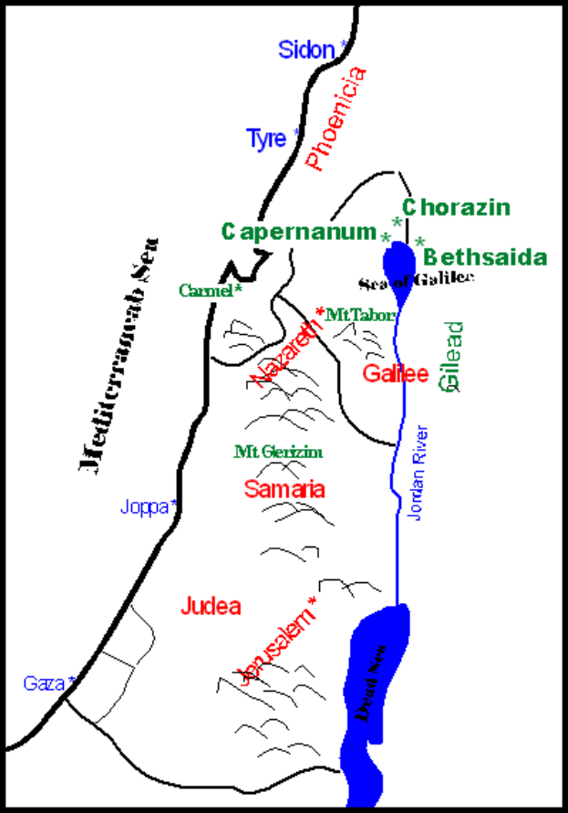

^{15:﻿22﻿} And behold, a Canaanite woman from that region came out and cried, “Have mercy on me, O Lord, Son of David; my daughter is severely possessed by a demon.”
^{15:﻿23﻿} But Jesus did not answer her a word. And His disciples came and begged Him, saying, “Send her away, for she is crying after us.”
^{15:﻿24﻿} He answered, “I was sent only to the lost sheep of the house of Israel.”
^{15:﻿25﻿} But she came and knelt before Him, saying, “Lord, help me.”
^{15:﻿26﻿} And He answered, “It is not fair to take the children’s bread and throw it to the dogs.” ﻿
^{15:27﻿} She said, “Yes, Lord, yet even the dogs eat the crumbs that fall from their masters’ table.” ﻿
^{15:28﻿} Then Jesus answered her, “O woman, great is your faith! Be it done for you as you desire.” And her daughter was healed instantly.

^{﻿Mk 19:46 ﻿} And they came to Jericho; and as Jesus was leaving Jericho with His disciples and a great multitude, Bartimaeus, a blind beggar, the son of Timaeus, was sitting by the roadside.
^{19:47﻿} And when he heard that it was Jesus of Nazareth, he began to cry out and say, “Jesus, Son of David, have mercy on me!”
^{﻿19:48﻿} And many rebuked him, telling him to be silent; but he cried out all the more, “Son of David, have mercy on me!”
^{﻿19:49﻿} And Jesus stopped and said, “Call him.” And they called the blind man, saying to him, “Take heart; rise, He is calling you.”
^{﻿19:50﻿} And throwing off his mantle he sprang up and came to Jesus.
^{﻿19:51﻿} And Jesus said to him, “What do you want Me to do for you?” And the blind man said to Him, “Master, let me receive my sight.”

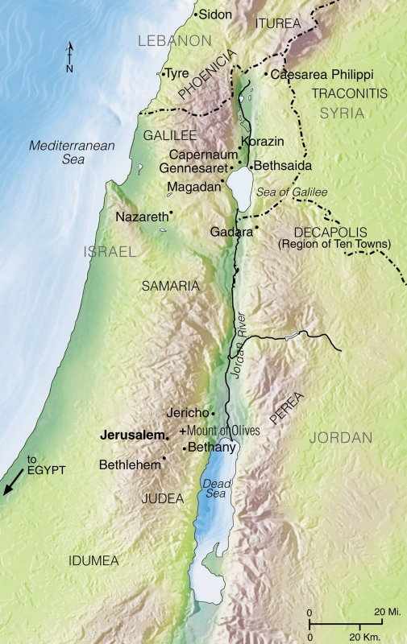

^{﻿19:52﻿} And Jesus said to him, “Go your way; your faith has made you well.” And immediately he received his sight and followed Him on the way. (Same story Luke 18:35)

^{﻿Lk 17:11﻿} On the way to Jerusalem Jesus was passing along between Samaria and Galilee. (See map above.)
^{17:12﻿} And as He entered a village, He was met by ten lepers, who stood at a distance ^{﻿17:13﻿} and lifted up their voices and said, “Jesus, Master, have mercy on us.” ﻿
^{17:14﻿} When He saw them He said to them, “Go and show yourselves to the priests.” And as they went they were cleansed. ^{﻿17:15﻿} Then one of them, when he saw that he was healed, turned back, praising God with a loud voice; ﻿
^{17:16﻿} and he fell on his face at Jesus’ feet, giving him thanks. Now he was a Samaritan. ﻿
^{17:17﻿} Then said Jesus, “Were not ten cleansed? Where are the nine?
^{17:﻿18﻿} Was no one found to return and give praise to God except this foreigner?”
^{17:﻿19﻿} And Jesus said to him, “Rise and go your way; your faith has made you well.”

Each cured person had faith that Jesus would heal them. Each reasoned that Jesus cared about people and their illness and went to Him. Caring about others in their suffering is called love. They believed that Jesus loved them and thus they sought out Jesus. Jesus calls their seeking Him as faith. The lesson to be learned is we must seek Jesus and asked to be healed from our sinfulness because sinfulness is an illness that needs to be cured.

He who is forgiven little, loves little.

^{﻿Lk 7:36﻿} One of the Pharisees asked Jesus to eat with Him, and He went into the Pharisee’s house, and took His place at table. ﻿
^{7:37﻿} And behold, a woman of the city, who was a sinner, when she learned that he was at table in the Pharisee’s house, brought an alabaster flask of ointment, ﻿
^{7:38﻿} and standing behind Jesus at His feet, weeping, she began to wet His feet with her tears, and wiped them with the hair of her head, and kissed His feet, and anointed them with the ointment. ﻿
^{7:39﻿} Now when the Pharisee who had invited Him saw it, he said to himself, “If this man were a prophet, he would have known who and what sort of woman this is who is touching him, for she is a sinner.” ﻿
^{7:40﻿} And Jesus answering said to the Pharisee, “Simon, I have something to say to you.” And he answered, “What is it, Teacher?” ﻿
^{7:41﻿} “A certain creditor had two debtors; one owed five hundred denarii, (Roman silver coin.) and the other fifty.
^{7:﻿42﻿} When they could not pay, he forgave them both. Now which of them will love him more?”
^{7:﻿43﻿} Simon the Pharisee answered, “The one, I suppose, to whom he forgave more.” And Jesus said to Simon, “You have judged rightly.”
^{7:﻿44﻿} Then turning toward the woman He said to Simon, “Do you see this woman? I entered your house, you gave Me no water for My feet, but she has wet my feet with her tears and wiped them with her hair. ﻿
^{7:45﻿} You gave me no kiss, but from the time I came in she has not ceased to kiss My feet.
^{7:﻿46﻿} You did not anoint My head with oil, but she has anointed My feet with ointment.
^{7:﻿47﻿} Therefore I tell you, her sins, which are many, are forgiven, for she loved much; but he who is forgiven little, loves little.” ﻿
^{7:48﻿} And He said to her, “Your sins are forgiven.” ﻿
^{7:49﻿} Then those who were at table with Jesus began to say among themselves, “Who is this, who even forgives sins?” ﻿
^{7:50﻿} And Jesus said to the woman, “Your faith has saved you; go in peace.”

This is the only time recorded in Scripture that Jesus said; "Your faith has saved you". A soul who has been forgiven much will love much. Love is directly related to faith. But each person must understand their many sins and asks forgiveness for each of their sins. Most people will not recognize their sins and thus do not ask forgiveness and have little love. Thus we must train ourselves to see our sins. The best way of doing this is to imagine our Final Tests. God will empower the armies of hell to accuse us. We will be treated like an adulterous woman and this event is depicted below.

^{﻿Jn 8:3} The scribes and the Pharisees brought a woman who had been caught in adultery, and placing her in the midst
^{8:﻿4﻿} they said to Jesus, “Teacher, this woman has been caught in the act of adultery. ﻿
^{8:5﻿} Now in the law Moses commanded us to stone such. What do You say about her?” ﻿
^{8:6﻿} This they said to test Him, that they might have some charge to bring against Him. Jesus bent down and wrote with His finger on the ground.
^{8:﻿7﻿} And as they continued to ask Him, He stood up and said to them, “Let him who is without sin among you be the first to throw a stone at her.”
^{8:﻿8﻿} And once more He bent down and wrote with His finger on the ground.
^{8:﻿9﻿} But when they heard it, they went away, one by one, beginning with the eldest, and Jesus was left alone with the woman standing before Him.
^{8:﻿10﻿} Jesus looked up and said to her, “Woman, where are they? Has no one condemned you?”
^{8:﻿11﻿} She said, “No one, Lord.” And Jesus said, “Neither do I condemn you; go, and do not sin again.”

The woman caught in adultery and the woman washing the feet of Jesus with her hair are likely the same woman according to Mary of Agreda. Her name was Mary Magdalene. These two stories actually will apply to all the elect. For we must understand that the elect are rescued from their accusers in the same manner as the adulterous woman. And when the elect see how close they came to eternal depression and suicide, they will have such great love of their Savior Jesus that their faith will have saved them.

You of little faith.

The next three Gospel stories well show doubting during bad times, we are men of little faith.

^{Mt 6:30﻿} But if God so clothes the grass of the field, which today is alive and tomorrow is thrown into the oven, will he not much more clothe you, O men of little faith?
^{6:﻿31﻿} Therefore do not be anxious, saying, ‘What shall we eat?’ or ‘What shall we drink?’ or ‘What shall we wear?’ ﻿
^{6:32﻿} For the Gentiles seek all these things; and your heavenly Father knows that you need them all.
^{6:﻿33﻿} But seek first His kingdom and His righteousness, and all these things shall be yours as well. (Same story Luke 12:28)

^{﻿Mt 8:23﻿} And when Jesus got into the boat, His disciples followed Him.
^{8:﻿24﻿} And behold, there arose a great storm on the sea, so that the boat was being swamped by the waves; but He was asleep. ﻿
^{8:25﻿} And they went and woke Him, saying, “Save, Lord; we are perishing.”
^{8:﻿26﻿} And He said to them, “Why are you afraid, O men of little faith?” Then He rose and rebuked the winds and the sea; and there was a great calm. ﻿
^{8:27﻿} And the men marveled, saying, “What sort of man is this, that even winds and sea obey Him?” (Same story Mark 4:35 and Luke 8:22)

^{﻿Mt 14:22﻿} Then Jesus made the disciples get into the boat and go before Him to the other side, while He dismissed the crowds. ﻿
^{14:23﻿} And after He had dismissed the crowds, He went up on the mountain by Himself to pray. When evening came, He was there alone,
^{14:﻿24﻿} but the boat by this time was many furlongs distant from the land, beaten by the waves; for the wind was against them. ﻿
^{14:25﻿} And in the fourth watch of the night Jesus came to them, walking on the sea. ﻿
^{14:26﻿} But when the disciples saw Jesus walking on the sea, they were terrified, saying, “It is a ghost!” And they cried out for fear.
^{14:﻿27﻿} But immediately He spoke to them, saying, “Take heart, it is I; have no fear.”
^{﻿14:28﻿} And Peter answered Him, “Lord, if it is you, bid me come to you on the water.” ﻿
^{14:29﻿} He said, “Come.” So Peter got out of the boat and walked on the water and came to Jesus;
^{14:﻿30﻿} but when he saw the wind, he was afraid, and beginning to sink he cried out, “Lord, save me.”
^{14:﻿31﻿} Jesus immediately reached out His hand and caught him, saying to him, “O man of little faith, why did you doubt?” ^{﻿14:32﻿} And when they got into the boat, the wind ceased.
^{14:﻿33﻿} And those in the boat worshiped him, saying, “Truly you are the Son of God.”

We must not doubt the love of Jesus. If we have no doubts about Jesus love, this is called faith.

A hardened heart causes little faith.

The Book of Hebrews, verse 3:13, tells us that sin hardens a man's heart. Jesus reveals to the Apostles that they have little faith and hardened hearts because they didn't understand what Jesus was talking about when He said: “Take heed and beware of the leaven of the Pharisees and Sadducees.” The question must be asked; what sin hardened the Apostles hearts?

^{Heb 3:13﻿} Encourage yourselves daily while it is still “today,” so that none of you may grow hardened by the deceit of sin.

^{﻿Mt 16:5﻿} When the disciples reached the other side, they had forgotten to bring any bread. ﻿
^{16:6﻿} Jesus said to them, “Take heed and beware of the leaven of the Pharisees and Sadducees.” ﻿
^{16:7﻿} And they discussed it among themselves, saying, “We brought no bread.”
^{16:﻿8﻿} But Jesus, aware of this, said, “O men of little faith, why do you discuss among yourselves the fact that you have no bread?
^{16:﻿9﻿} Do you not yet perceive? Do you not remember the five loaves of the five thousand, and how many baskets you gathered?
^{16:﻿10﻿} Or the seven loaves of the four thousand, and how many baskets you gathered?
^{16:﻿11﻿} How is it that you fail to perceive that I did not speak about bread? Beware of the leaven of the Pharisees and Sadducees.” ﻿
^{16:12﻿} Then they understood that he did not tell them to beware of the leaven of bread, but of the teaching of the Pharisees and Sadducees.

^{﻿Mk 8:14﻿} Now they had forgotten to bring bread; and they had only one loaf with them in the boat.
^{8:﻿15﻿} And Jesus cautioned them, saying, “Take heed, beware of the leaven of the Pharisees and the leaven of Herod.” ﻿
^{8:16﻿} And they discussed it with one another, saying, “We have no bread.” ﻿
^{8:17﻿} And being aware of it, Jesus said to them, “Why do you discuss the fact that you have no bread? Do you not yet perceive or understand? Are your hearts hardened? ﻿
^{8:18﻿} Having eyes do you not see, and having ears do you not hear? And do you not remember? ﻿
^{8:19﻿} When I broke the five loaves for the five thousand, how many baskets full of broken pieces did you take up?” They said to him, “Twelve.”
^{18:﻿20﻿} “And the seven for the four thousand, how many baskets full of broken pieces did you take up?” And they said to him, “Seven.” ﻿
^{18:21﻿} And he said to them, “Do you not yet understand?”

By combining these stories, a hardened heart and little faith are directly related. Since a hardened heart is caused by sin, then it can be said that sin causes little faith. People will say that a person can't lose his salvation when he believes that Jesus is Lord and Savior. But this is a great error because a person can sin and harden his heart and thus lose his faith.

Since it was sin that caused the Apostles to have little faith, what sin can the Apostles be guilty of? The answer can be found in the story of the sorrowful women, Mary Magdalene, who washed Jesus feet with her hair. She saw her sins and showed great love to Jesus for saving her from the crowd with rocks. We must realize it's a sin not to recognize our sins and show great love to Jesus for His future saving hand at our Final Tests. The Apostles were guilty of not recognizing their sins and showing great appreciation to Jesus. For if the Apostles had seen their sins and faced stoning like Mary Magdalene, the Apostles would have loved Jesus and had great faith at the same time. This is why all men must be subjected to the Final Test. This is the only way to arrive into purgatory and then heaven with the proper love for Christ.

God will punish us when our sins become huge and thus will not give what is holy to dogs or pearls to swine.

^{Mt 7:6} “Do not give dogs what is holy; and do not throw your pearls before swine, lest they trample them under foot and turn to attack you.

The way God does this is by "cutting off our ears to hear". Sinners do not have ears to hear God's truth because God does not allow them to hear.

^{Ez 12:1} The word of the Lord came to me: (Ezekiel is speaking.)
^{12:2} “Son of man, you dwell in the midst of a rebellious house, who have eyes to see, but see not, who have ears to hear, but hear not;
^{12:3} for they are a rebellious house.

Another name for sinners is hypocrites. When men treat others in the way they would not want to be treated (Natural Law), they are hypocrites and God will not draw them to His Son. God will not give what is holy to dogs and thus will not lead them to Christ. Sinner's hearts are so hard and their ears are gone, it's impossible to speak the Gospel to them. They can't hear the truth. And if you try to tell them the truth, they will trample what you say and attack you.

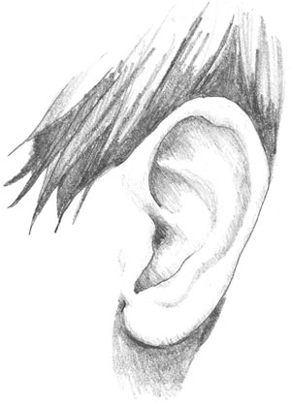

The human ear is the symbol that represents how a person can hear God's words.



Pearls represent God's words and how we are able to understand their beauty.

We must realize how the Apostles were unable to hear the words Jesus said to them. They were unable to see the pearls of wisdom Jesus was telling them.



If the Apostles had hardened hearts, how much more do we? That is why people do not know about the Final Test. Even those that call themselves religious will reject the events after death.

Abraham the Father of Faith.

^{Gal 3:6} Thus Abraham “believed God, and it was reckoned to him as righteousness.”
^{3:7} So you see that it is men of faith who are the sons of Abraham.
^{3:8} And the Scripture, foreseeing that God would justify the Gentiles by faith, preached the gospel beforehand to Abraham, saying, “In you shall all the nations be blessed.”
^{3:9} So then, those who are men of faith are blessed with Abraham who had faith.

1) "Preached the gospel beforehand to Abraham". The word "gospel" means good news. Since the gospel pertains to when Jesus lived upon the earth, how does this pertain to Abraham? In order to have faith in Jesus, people must have knowledge of Jesus. Abraham had knowledge of Jesus because Abraham meet Jesus in person. How can this be because Jesus was not born for 1800 years after Abraham. Read the following verses. fornication

^{Gn 12:4} So Abram went, as the Lord had told him; and Lot went with him. Abram was seventy-five years old when he departed from Haran.
^{12:5} And Abram took Sarai his wife, and Lot his brother’s son, and all their possessions which they had gathered, and the persons that they had gotten in Haran; and they set forth to go to the land of Canaan. When they had come to the land of Canaan,
^{12:6} Abram passed through the land to the place at Shechem, to the oak of Moreh. At that time the Canaanites were in the land.
^{12:7} Then the Lord appeared to Abram, and said, “To your descendants I will give this land.” So he built there an altar to the Lord, who had appeared to him.



What does it mean that the Lord appeared to Abram? Abraham saw and spoke with Jesus. Abraham was not told to call Him Jesus but Lord. Jesus was born to Mary 1800 years later, but being the Second Person of the Holy Trinity, He has the power to appear to Abraham as Jesus. The Book of Genesis informs us Jesus had the following interactions with Abraham: Gn (12:1); (13:14); (15:1); (17:1); (18:1) and (22:1). It's very likely that Jesus spoke or appeared to Abraham other times as well. The following verse is from the Gospel of John.

^{Jn 8:52} The Jews said to Jesus, “Now we know that you have a demon. Abraham died, as did the prophets; and you say, ‘If any one keeps My word, he will never taste death.’ (Refers to the Final Test and how 144,000 do not have to go to purgatory because they were not wounded by the accusers accusations.)
^{8:53} Are you greater than our father Abraham, who died? And the prophets died! Who do you claim to be?”
^{8:54} Jesus answered, “If I glorify Myself, My glory is nothing; it is My Father who glorifies Me, of whom you say that He is your God.
^{8:55} But you have not known Him; I know Him. If I said, I do not know Him, I should be a liar like you; but I do know Him and I keep His word.
^{8:56} Your father Abraham rejoiced that he was to see My day; he saw it and was glad.”

Jesus informed us in the Gospel of John that Abraham was told about Himself and Abraham was glad to have saw the future.

^{Gal 3:23} Now before faith came, we were confined under the law, kept under restraint until faith should be revealed.
^{3:24} So that the law was our custodian until Christ came, that we might be justified by faith.
^{3:25} But now that faith has come, we are no longer under a custodian;
^{3:26} for in Christ Jesus you are all sons of God, through faith.
^{3:27} For as many of you as were baptized into Christ have put on Christ.
^{3:28} There is neither Jew nor Greek, there is neither slave nor free, there is neither male nor female; for you are all one in Christ Jesus.
^{3:29} And if you are Christ’s, then you are Abraham’s offspring, heirs according to promise.

1) So that the law was our custodian until Christ came. Except for Abraham, Isaac, Jacob, Joseph, Moses and Aaron, the Jews didn't know Jesus and thus had only the law. For the rest of the Jews, the law was a custodian. But we now that the Gospels have come we are no longer under a custodian. If we have faith In Christ Jesus, we are sons of God.

The verses above are saying that faith can't occur unless we are told about Jesus first. When we hear about Jesus, this is called the "good news" or gospel. The Jews were given the law by Moses many years after Abraham lived. The law can't produce faith, only the good news about Jesus produces faith.

Questions.

1) On what shore is Capernaum located? (see map)

2) A roman centurion had compassion on a man not of his family. This centurion went to Jesus to ask a cure for who?

3) A man whose legs were paralyzed was brought to Jesus. Jesus saw that man and said: "Take heart, My son: your _____ are ______."

4) A woman who had uncontrollable bleeding was cured by Jesus when she touched what?

5) Jesus cured two blind men. Jesus asked them a question before He cure them. What was the question?

6) You would think that if you were cured by Jesus and Jesus asked you not to tell anyone you would obey. Who ignored this command of Jesus?

7) Since we do not live in Jerusalem when Jesus was curing the sick, we can still seek Him out in prayer. If we have physical illness, we must pray with the same ______ as the people that came to Him.

8) We may not be physically ill, but all of us are spiritually sick because of our many sins. Thus we should pray with _____ that Jesus will cure us from our sins and thus be able to pass our Final Tests.

9) In order for us to love Jesus much, we must know our many sins and have great sorrow for them. The Gospel of Luke reveals this great truth when a woman anointed Jesus feet at the house of the Pharisee named ______.

10) It's very hard for men to love Jesus because they do not ask for their sins to be forgiven with great sorrow. In God's eyes there are sins in which men do not consider as sins. But the truth about sin will be revealed to every person at their _____ ______.

11) In this life we do not see our sins clearly. But at our Final Tests everything will be revealed. If we are the elect, our love for Jesus will be directly related to the debt that has been forgiven. We can think of ourselves as the _______ women.

12) Jesus said only one time in Scripture to a sinful woman at Pharisees house, "Your faith has saved you". When we understand our many sins and ask forgiveness, our love will be great because we have been ______ greatly.

13) If I have little love for Jesus, then I have asked _____ to be forgiven.

14) Who is the person most likely the sinful woman at Simon's house and the woman that was going to be stoned for adultery?

15) If we are people who worry about what are we to eat and drink, Jesus calls us "O men of ____ _____".

16) Jesus says we must seek His _______ and His _______, then the daily requirements of life will be given.

17) The Apostles were in a boat with Jesus and a great storm tossed the boat in it's waves. The Apostles woke Jesus and said we are perishing. Jesus said, " O men of ______ ______".

18) What causes a man's heart to be hardened? What verse proves this answer?

19) We need to practice our faith when we are alive in order to be ready when we need faith to survive the ______ ______.

20) Faith can only occur if we have been given the gospel. Jesus lived 1800 years after Abraham. How did Abraham have faith if Jesus was not born yet?

21) What is the symbol that represents we can hear God's words? What is the symbol that represents that we value God's words?

