The Soul

regarded the Samaritans as a people to themselves, in spite of an obviously

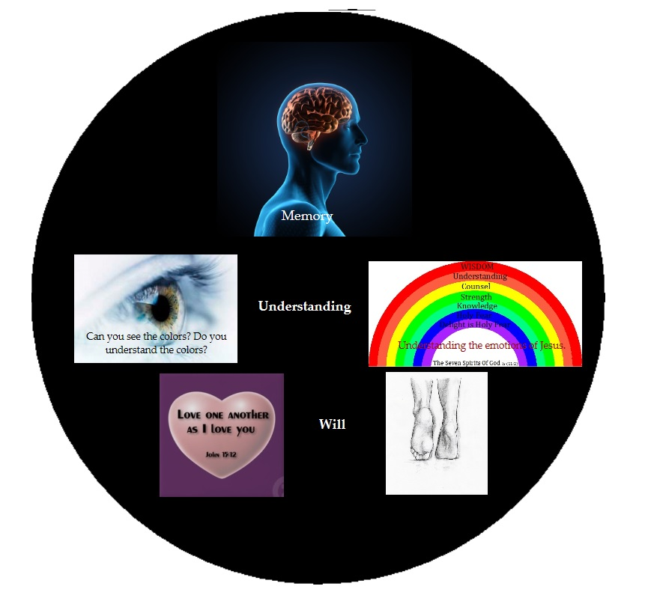
.

The book named "The Dialogue" written by Saint Catherine Siena is filled with Catholic theology. God the Father speaks to Saint Catherine about many topics and one topic that this book discusses is the soul. God the father informs Catherine that the soul has three main gates and five smaller gates. (section 144) Listed below is the three main gates.

1) Memory
2) Understanding
3) Will (heart & feet)

Below are the words that God the Father spoke to Saint Catherine.

"I gave him a memory so as to remember My benefits, understanding so as to see and know the truth and will love Me, eternal Truth, once understanding has known Me". (section 4)

"The memory holds on to My blessings and My goodness to the soul. Understanding contemplates the unspeakable love I have shown you though the mediation of My only- begotten Son, whom I have set before your mind's eye for you to contemplate in Him the fire of My charity. The will, finally, is joined with them to know and desire Me, your final goal". (section 54)

"I provided you with the gift of memory so that you might hold fast My benefits and be made a sharer in My own, the eternal Father's power. I gave you understanding so that in the wisdom of My only-begotten Son you might comprehend and know what I the eternal Father want, I who gave you graces with such burning love. I gave you a will to love, making you a sharer in the Holy Spirit's mercy, so that you might love what your understanding sees and knows". (section 135)

1) The memory. The ear is the symbol of the memory. The ear hears the word of God and places it in the memory. Even when we are reading, we hear our voices in our minds. The memory needs to record the blessings that God has given us. The greatest blessings are the graces that we need for training. For instance we need the details of Jesus Passion. This blessing was given to us as graces through the Gospels and the book "City of God" written by Mary of Agreda. Other blessings include the food we eat and water we drink; the clothes we wear and houses we live in. A very great blessing is to be born to parents that baptize their children as Catholics and teach them Catholic theology. Our main goal is to fill the mind with graces so we are able to train ourselves to know Jesus and His Passion and recognize good from evil.

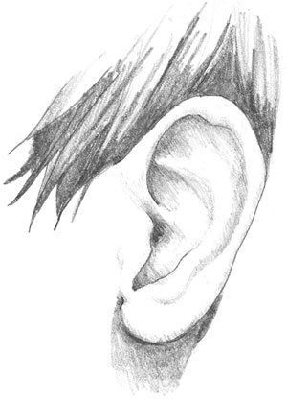

2) The understanding. The eye is the symbol of the understanding. The eye "sees" the emotions of Jesus in His Passion and thus understands the unspeakable love God has for us. As the physical eye sees the seven colors of light, our spiritual eye understands the Seven Spirits of God. Then we are able to comprehend and know what God desires.

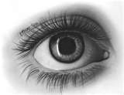

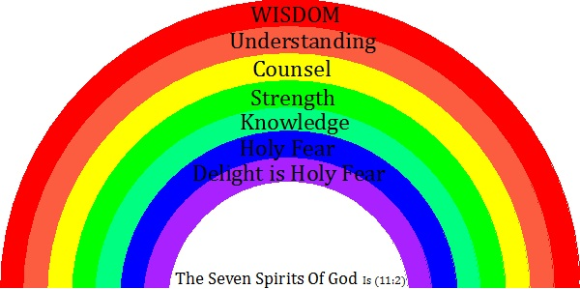

3) The will. The heart and feet are the symbol of the will. Follow the feet and you can witness the things in which the heart loves. The will allows us to love what we understand. Do we love all the graces that God has given us to use as trainers? Do we desire God as our final goal? Have we applied the Commandment to Love one another as Jesus loved us? Jn (15:12)

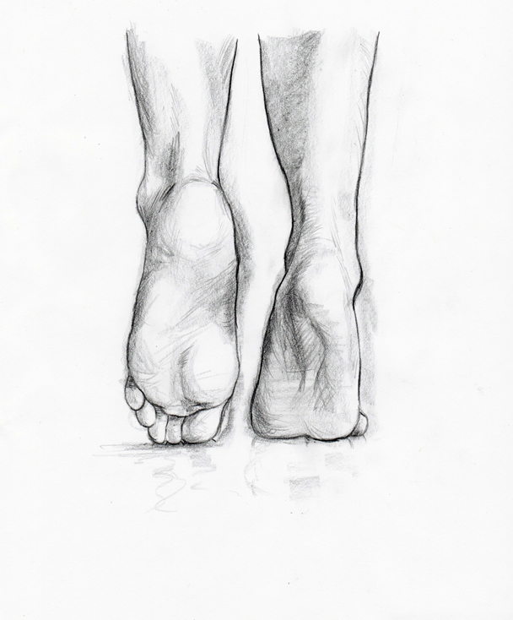

The Five Smaller Gates allow Sin to Enter.

Sin can also enter into the soul through the bodies 5 senses. Because of the flesh or also called the dopamine that is released in our brains, our eyes can look upon the world's indecencies and vanities. Our ears can listen to gossip and the tongue can act like a knife and provoke others to anger. The taste and smell can cause gluttony (inordinate eating) which leads to firing up the weak flesh by corrupting us with sinful desires. The feet and hands (sensual feelings) can take us to filthy miserable touching. The feet can take the body to all kinds of sinful places.

We must realize that all human beings are being tested. As Adam and Eve were tested, we as their descendants are also being tested. The five small gates to the soul are constantly under attack. No attack could happen if there was no dopamine released when we sinned. As dopamine is released, we feel pleasure. Sin is pleasurable. If we fail to place guards at these 5 gates, the wages of sin will lead to suicidal depression at our Final Tests.

The three main gates into our souls are given to us in order to train with the graces God has given us. Our goal is to appreciate the Blood and Passion of Jesus. This can only occur if we have loved others in the way Jesus loved us. It's through our experience with loving others are we able to appreciate the actions of Jesus. Only through this experience of loving others can we arrive and experience intoxicating effects of Jesus Passion. This intoxication will last forever and thus we will become a member of the communion (community) of saints.

God is the God of the Living not the Died.

What makes a soul living and not dead? The soul must be in training using the graces God has given us. The symbol of this is the three Patriarchs.

The Patriarchal Age is the era of the three biblical Patriarchs, Abraham, Isaac and Jacob. A Patriarch is a man who exercises unlimited power over a "family". Jesus said the following:

^{Mt 22:31} And concerning the resurrection of the dead, have you not read what was said to you by God,
^{22:32} ‘I am the God of Abraham, and the God of Isaac, and the God of Jacob’. He is not God of the dead, but of the living?”

So the question must be asked, what is the spiritual significance of Abraham, Isaac and Jacob? My answer to you is, they represent the three powers of our being.

Lets consider the following verse from the book of Daniel.

^{Dn 3:35} and do not withdraw Your mercy from us, for the sake of Abraham Your beloved and for the sake of Isaac Your servant and Israel Your holy one,

Consider combining the three parts of the soul with the verse above from Daniel. Thus the following statements can be made. The man that places the word of God in his memory is called beloved. The man that ponders and understands the Lord’s word is called God’s servant. The man that places the Lord’s word in his heart and acts upon it is called God’s holy one. Such a man shall father twelve virtues.

Our memories were created to hold God's words. Our understanding must see the emotions of Jesus in His Passion and our feet must show how we appreciate Jesus' emotions by imitating Jesus. As Jesus said, God is not the God of the dead. When a man fails to use his soul in this way, he is considered dead. Jesus has called us the living when our soul trains with the graces God has given us.

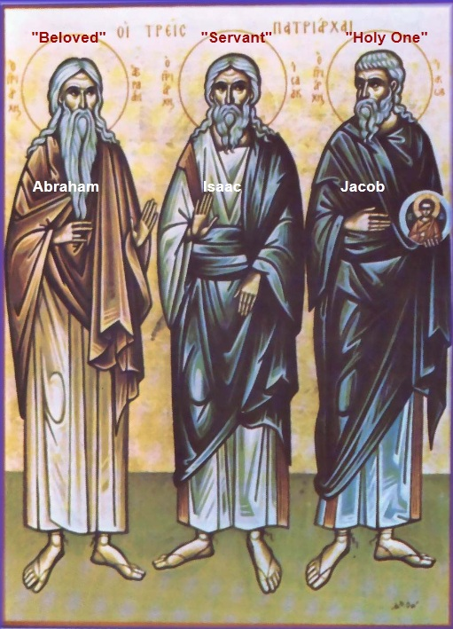

The Soul is on a Journey.

Abraham, Isaac and Jacob were sojourners. They lived in tents and thus symbolized how earth was not their home but were waiting on a better place. Saint Peter wrote the following:

^{1 Pet 2:11} Beloved, I urge you as aliens and sojourners to keep away from worldly desires that wage war against the soul.

The following verses come from the Psalms.

^{Ps 119:18} Open my eyes, that I may behold wondrous things out of Your law.
^{119:19} I am a sojourner on earth; hide not Your Commandments from me!

^{Ps 146:9} The Lord watches over the sojourners, he upholds the widow and the fatherless; but the way of the wicked he brings to ruin.

The Soul is on a "Three Day" Journey.

When Scripture speaks of a three day journey or a period of three days, Scripture is speaking about the journey in which the soul must take. It takes years to place into action the soul's memory, understanding and heart. One "day" which represents years of time. It's the time it takes for the soul to memorize the word of God in the soul's memory. The second "day" also representing years of time is the time it takes too understand the emotions of Jesus' Passion. The third "day" is a life time of loving others in the way Jesus loved us. In other words, our three day journey is the remainder of our lives. Thus, do you see how our souls, memory, understanding, and heart are on a journey? A journey that does not end until we reach the Final Test.

In the Revised Standard addition Bible, three days appears 70 times. Four days only appears 5 times and two days 11 times. When reading the bible, three days will seem to pop up any many stories. Jesus used three days in the following verses.

^{Jn 2:18} The Jews then said to Jesus, “What sign have you to show us for doing this?”
^{2:19} Jesus answered them, “Destroy this temple, and in three days I will raise it up.”
^{2:20} The Jews then said, “It has taken forty-six years to build this temple, and will you raise it up in three days?”
^{2:21} But He spoke of the temple of His Body.
^{2:22} When therefore He was raised from the dead, His disciples remembered that He had said this; and they believed the Scripture and the word which Jesus had spoken.

We can destroy our souls when we commit serious sin. When our memories are filled with the world's wisdom, and our emotions are fixed upon our passions and when our feet take us to places to commit sin, we destroy our souls in "three days". Again "three days" can be years of time such as our entire childhood. Or three days could represent minutes of time. Because it only takes one serious sin to destroy our temples. Since the soul can be represented as a temple, sin can be represented as a ruined temple. (Our ruined soul can be compared to the ruined church.)

^{1 Cor 3:16} Do you not know that you are the temple of God, and that the Spirit of God dwells in you?

^{2 Cor 13:5} Examine yourselves to see whether you are living in faith. Test yourselves. Do you not realize that Jesus Christ is in you?—unless, of course, you fail the Test.

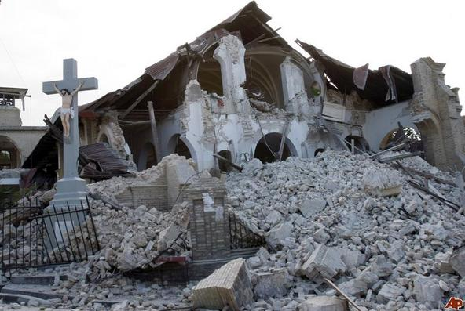

The destruction above is away to visualize symbolically the destruction of our souls when our sins are serious.

Jesus said, destroy this temple and in three days I will raise it up. Jesus was talking about the Temple of His Body within us. If we have failed our test by sinning, the Lord's Temple with in us is destroyed. Our Temples were destroyed because we didn't stand guard at the five smaller gates called the senses. With the power of God's grace however, the three powers of our soul can train with the graces God has given us, and Jesus will rebuild His Temple within us by sharing His Seven Spirits with us.

If we respond to our teacher grace by using the three powers of our souls, the ear hears the word of God and places it in the memory. The eye "sees" the emotions of Jesus in His Passion. As the physical eye sees the seven colors of light, the spiritual eye understands the Seven Spirits of God. The feet imitate Jesus by loving others in the way Jesus loved us. The analogy is this, we can destroy the Temple of the Lord within us in three days and then by grace Jesus can rebuild His Temple. Thus it can be said that life can be represented a six days. On the seventh day, a day of rest called the Sabbath and this day can be likened to our physical deaths in which we will be subjected to our Final Tests. Scripture forbids working on the Sabbath, and when we die, will not have the opportunity for Jesus to rebuild His Temple on earth. Only the 144,000 have their temples completely restored when they physically die. The rest of the elect must go to purgatory and their temples are rebuilt through suffering. What kind of suffering you ask? The suffering pertains to the witnessing of the damage our sins have caused. The events after death and purgatory will be explained in another lesson.

regarded the Samaritans as a people to themselves, in spite of an obviously

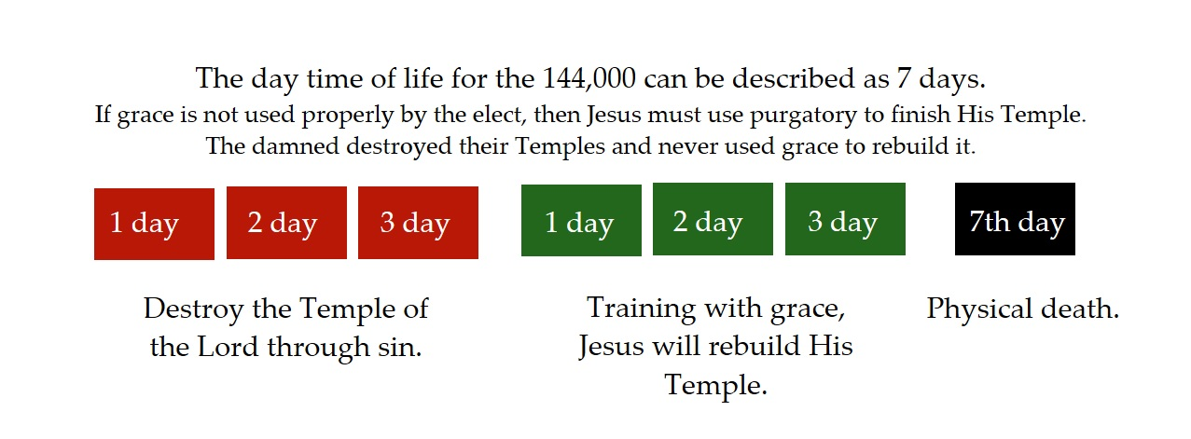
.

Questions

1) The soul has three main gates, name the three.

2) The ________ needs to record the blessings that God has given us. Graces are a blessing from God and we need graces in order to train ourselves to know Jesus and His _________ and recognize _______ from evil.

3) What human body part is the symbol for understanding?

4) Our spiritual eye must understand the _______ Spirits of ______.

5) Name the Seven Spirits of God?

6) What two body parts represent the third gate called the will?

7) Follow a persons feet and you will know what he _________.

8) Name the five smaller gates to the soul.

9) Sin is pleasurable because ________ is released in the brain.

10) The three main gates, memory, understanding and will are needed when we train with the ________ God has given us.

11) What makes a soul living and not dead?

12) God is of the living, not the ________. Name the three Patriarchs that represent the God of the living?

13) The Patriarch that is called beloved is who? The Patriarch that is called holy is who?

14) What name does the Bible use to describe a person who has not made earth his home but rather seeks a better life in heaven?

15) We can liken our souls as temples. When our sins are serious enough, we can like our temple as _________.

16) If we have destroyed our temples through sin, we need to train with _________ in order for Jesus to rebuild our temples.

17) Only one group has rebuilt their temples during the daytime of life, name that group. If we fail to use grace perfectly in our training, after death we will need ___________ to finish our temples.

regarded the Samaritans as a people to themselves, in spite of an obviously

.

