Chapter Two
Part 5 "Jesus carries the Cross".

GOD’S WISDOM IS THE WISDOM OF THE CROSS. 2
The Wood. 3
The Cross. 6
The Feet. 7
The Hands. 7
The Body Of Jesus. 7
Our daily cross. 9
Satan’s reaction to Jesus picking up the Cross. 9
Jesus Meets His Mother the Third Time. 11
A Passerby was Forced to Carry the Cross 11
Jesus Meets the Daughters of Jerusalem 14
Questions 15

GOD’S WISDOM IS THE WISDOM OF THE CROSS.
(Contains the revelations of Mary of Agreda.)

Jesus Carries the Cross.

The Lord’s executioners loosened the bonds holding His hands so He might carry the Cross. They drew two loops around His throat in order to torment Him the more. They loaded the heavy Cross upon His wounded shoulders. The Cross was fifteen feet long, made from thick and heavy timbers. Before Jesus received the Cross, He looked upon it with extreme joy and said to Himself:

“O Cross, beloved of My Soul, now prepared and ready to still My longings, come to Me, that I may receive you in My arms, and that, My arms attached to you, that I may be accepted as the sacrifice to reconcile the human race with eternal Father. I have descended from heaven and assumed mortal flesh to accept the Cross as My scepter (http://en.wikipedia.org/wiki/Scepter) so I may triumph over My enemies. This Cross shall be the key with which I shall open the gates of heaven. My Cross shall be the sanctuary (safe place) in which the guilty sons of Adam shall find mercy, and shall be the treasure house to enrich their poverty. Upon the Cross, I desired to exalt and recommend dishonor and discredit among men, so My friends could follow Me and embrace humiliation with joy. My Father and eternal God, I confess You as the Lord of heaven and earth, subjecting Myself to Your power and to Your Divine wishes. I take upon My shoulders the wood for the sacrifice and I accept it willingly for the love of men. Receive Me, eternal Father, this sacrifice as acceptable to Your justice. Look upon men this very day, not any more as servants but sons and heirs of Your Kingdom”.

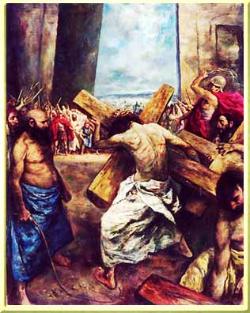

None of these hidden truths and happenings were hidden from the Blessed Virgin. She had a close knowledge and understanding of them. The Mother of God, entered into the deepest consideration of the dignity of the One who was suffering and for whom He was suffering. On this account She alone among all men and Angels attached sufficient importance to His Passion and Death.

The Wood.

It can be shown from Scripture that the wood that makes the Cross is a symbol of arrogance.

^{Is 2:12} For the Lord of hosts has a day against all that is proud and lofty, against all that is lifted up and high; (Arrogance)
^{2:13} against all the cedars (trees) of Lebanon, lofty and lifted up; and against all the oaks of Bashan; (trees)

The word arrogance can be described as lofty attitudes and opinions lifted up and high. Notice how scripture uses trees as symbols of arrogance.

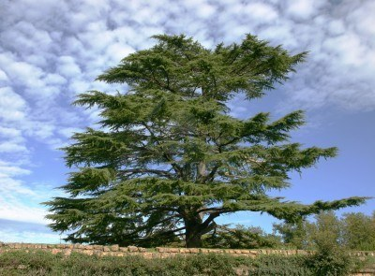
Cedar of Lebanon could be as high as 130 ft.

The vertical post represents the arrogance of the damned while the horizontal beam represents the arrogance of the elect. Jesus embraces the Cross thus showing us His love for all men. (For the sake of the joy that lay before Him He endured the Cross. Heb (12:2)) We must learn from this example of Jesus loving the arrogant. And who are the arrogant? We become arrogant when we depart from God with our hearts and from His word.

^{Sir 10:12} The beginning of man’s arrogance is to depart from the Lord; his heart has forsaken his Maker.
^{10:13} For the beginning of arrogance is sin, and the man who clings to it pours out abominations.

John the Baptized warned us about how the axe is ready to cut down the trees. (Trees represent arrogance.)



^{Lk 3:7} John the Baptist said therefore to the multitudes that came out to be baptized by him, “You brood of vipers! Who warned you to flee from the wrath to come?
^{3:8} Bear fruits that befit repentance, and do not begin to say to yourselves, ‘We have Abraham as our father’; for I tell you, God is able from these stones to raise up children to Abraham.
^{3:9} Even now the axe is laid to the root of the trees; every tree therefore that does not bear good fruit is cut down and thrown into the fire.”

- “You brood of vipers”. Vipers are snakes some of which were poisonous and some not. Because the bite of the poisonous viper could be fatal, people naturally wanted to avoid any contact with any type. Consequently, the term viper came to be used figuratively as a designation for evil. “Brood” is a group having a common nature.



- “Who warned you to flee from the wrath to come”? This line refers to the Final Test.
- “Do not begin to say to yourselves, ‘We have Abraham as our father’”. The Blood of Jesus will not magically take away our sins. We must in truth appreciate and value how Jesus took upon Himself all our sorrows. Let me say this again in another way, it is not enough to proclaim Jesus Christ as our Savior. John the Baptist made this important point when he told the Jews that salvation would take more than proclaiming Abraham as their father.
- “God is able from these stones to raise up children to Abraham”. The stone can represent God’s word; Lk (20:17) it can also represent a man’s stony heart. Ez (11:19) We must realize that God could easily change every man’s stony heart to obey and love His Command-ments. Even the most hardened sinner could be transformed into a saint. Example is Saul who later was known as Saint Paul. Paul was thrown from his high horse and elevated to the Third Heaven.

Recall how Jesus was tempted in the desert to change stones into bread. Mt (4:3) By knowing the emotions of Jesus, we would know that His food is our virtuous actions. The joy of His soul is to witness our love for one another. But because Jesus was in the desert witnessing our sins instead, He was extremely hungry. The problem is this; the Father’s justice will not allow the Son to change mankind’s stony hearts into bread.
- “Even now the axe is laid to the root of the trees”. Scripture represents men as fruit trees or cedars and oaks. Is (2:13) If our trees are bearing bad fruit such as proud and lofty actions (Against all that is lifted up and high.) they will be cut down at our Final Tests.
- “Thrown into the fire”. The fires of hell refer to the anger within each soul and the anger that is let lose against each other.

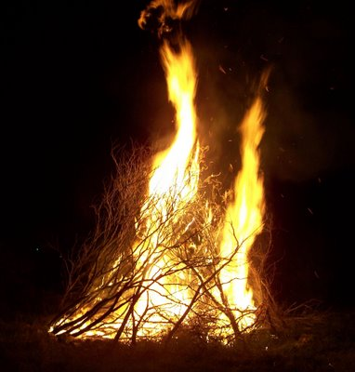

Scripture wants us to know that the 144,000 are the only souls that can spiritually “see” during their lives on earth. The first thing their spiritual eyes “see” is the arrogance of mankind. The following verses in the Gospel of Luke explain this concept.

^{Lk 8:22} And they came to Beth-saida. And some people brought to Jesus a blind man, and begged Him to touch him.
^{8:23} And Jesus took the blind man by the hand, and led him out of the village; and when He had spit on his eyes and laid His hands upon him, He asked him, “Do you see anything?”
^{8:24} And he looked up and said, “I see men; but they look like trees, walking.”
^{8:25} Then again Jesus laid His hands upon his eyes; and he looked intently and was restored, and saw everything clearly.

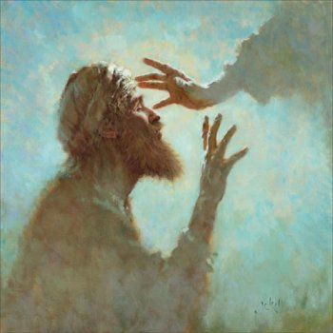

- “I see men; but they look like trees, walking.” We must be aware that every verse in Scripture has a spiritual meaning. We must slow down and examine each verse. It’s not by mistake that this man sees men that look like trees. Before we see the beauty of God’s Seven Spirits, (Seeing everything clearly.) we will see men’s arrogance. (Arrogance is a bold self-confidence in one’s own personal feelings and emotions.)

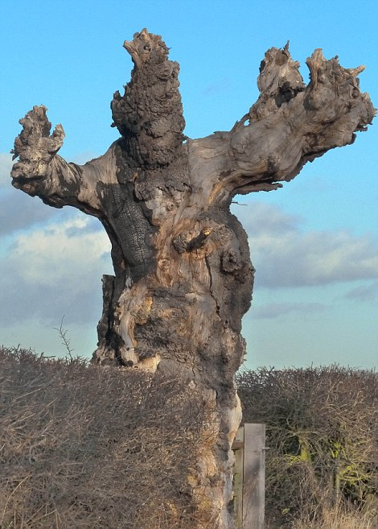
A tree that looks like a man.

- “He looked intently and was restored”. Once we can see the arrogance in men, we need to continue and look intently on the Passion of Christ. Our goal is to see the beauty of God’s Seven Spirits working in our souls.

The "eye" can see the emotions of Jesus. The 144,000 and those in the second and third watches can see the beauty of God’s Seven Spirits. The elect in the fourth watch are blind and thus don’t understand Jesus emotions. As light has seven parts (rainbow), God’s Spirit has seven parts. Rev (3:1) Wisdom, under-standing, counsel, strength, knowledge, Holy Fear and My delight of Holy Fear. Is (11:2)

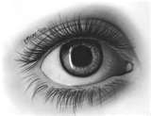

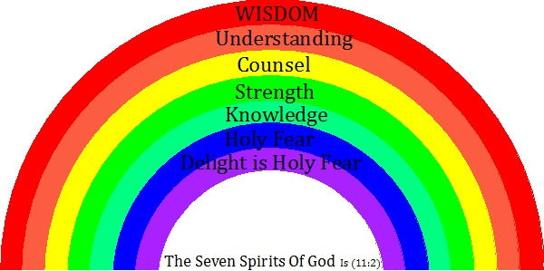

Scripture describes Jesus, the Word became Man, as a light.

^{Jn 1:9﻿} The true light that enlightens every man was coming into the world.
^{1:﻿10﻿} He (Jesus) was in the world, and the world was made through Him, yet the world knew him not.

Colors have always been associated with human emotions. For instance yellow represents being a coward; green with envy, or red with anger. When God shares His Spirit with a soul, the soul can see the Seven emotions of Jesus.

The Cross.

Jesus feet and hands are nailed to the Cross to represent His love for the elect and damned. The horizontal beam represents the arrogance of the elect. Jesus’ saving right hand, in charity, lifts the elect from the valley of death at their Final Tests. His feet represent His heart’s desire to save all men, including the damned. But the damned are not saved because the God's will requires all men to appreciate the actions of Jesus. The feet of Jesus can't save souls, only is hands can save souls from the valley of death.

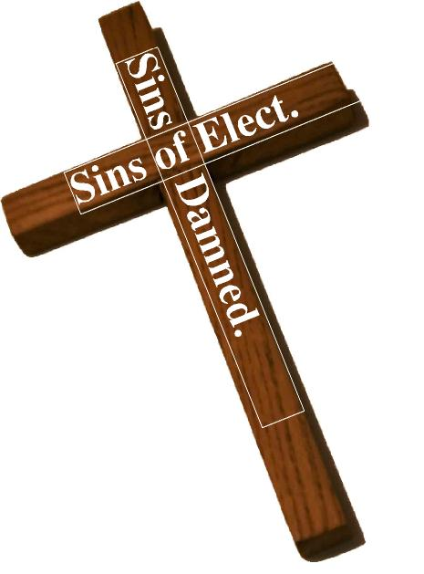

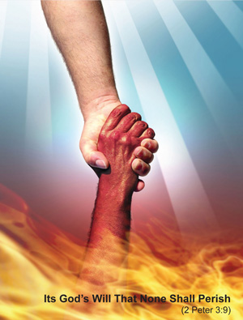

The Feet.

The feet represent our hearts. Clearly it’s our feet that take us to where our hearts desire. Only the 144,000 have the eyes to see the colors (emotions) of God’s Seven Spirits. Their feet carry them too places of charity.

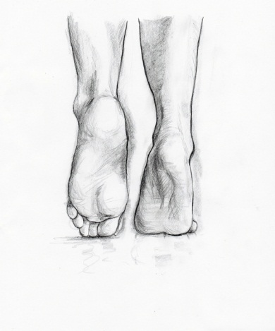

The Hands.

The hands represent charity. When we give charitable assistance to others, it’s our hands that give that assistance. But only the 144,000 and those in the second and third watch have perfect charity. With their spiritual eyes, the 144,000 imitate the emotions of Jesus by praying and giving physical assistance to others.

The Body Of Jesus.

^{Lk 22:19} And He took bread, and when He had given thanks He broke it and gave it to them, saying, This is My Body which is given for you. Do this in remembrance of Me.”

- “Do this in remembrance of Me”. We must daily consider and ponder how Jesus loved the arrogant. Clearly it was His Body that carried the Cross.

^{Jn 6:53} So Jesus said to them, “Truly, truly, I say to you, unless you eat the Flesh of the Son of Man and drink His Blood, you have no life in you;
^{6:54} he who eats My Flesh and drinks My Blood has eternal life, and I will raise him up at the last day.
^{6:55} For My flesh is food indeed, and My Blood is drink indeed.
^{6:56} He who eats My flesh and drinks My Blood lives in Me, and I in him.
^{6:57} As the living Father sent Me, and I live because of the Father, so he who eats Me will live because of Me.
^{6:58} This is the bread which came down from heaven, not such as the fathers ate and died; he who eats this bread will live forever.”

- “For My Flesh is food indeed”. When Jesus picked up the Cross, He was showing us His love for the arrogant. When a man can return good for evil, He is a man that loves the arrogant. He eats from the Tree of Life in the land of paradise. Rev (2:7) This can only be done if He has eaten the flesh of Jesus. Let me explain, it takes Jesus in us and we in Him to allow us to love the arrogant and return good for evil. And the good is represented as twelve virtues; and symbolized as the Tree of Life in Paradise, with its twelve kinds of fruit. Rev (22:1) Simply, returning good for evil should be sweet to our souls as fruit is sweet to our tastes.
- “He who eats Me will live because of Me”. Peace in our hearts is very critical. Suicidal depression will cause our hearts to seek nonexistence. And peace is a product of loving those that sin against us. On the other hand, if we return evil for evil, our hearts will not be at peace. Eventually a heart not at peace will commit suicide. When we eat His flesh at Holy Communion, we are saying to Jesus we are going to love those that sin against us. This will cause peace within our souls. If we have peace, we have life. Having life within our souls is likened to the physical body having food to eat. And during biblical times bread was the main food for the body. That is why Jesus uses bread and changing into His flesh. Let me say this again, it was Jesus Body that carried the Cross. And His Body gives us life when we love those that sin against us; which causes peace inside our souls. And the only way we can love the arrogant is if Jesus shares His Seven Spirits with us.
- “This is the bread (Flesh) which came down from heaven”. Jesus is not only speaking about Himself, but He is also speaking about the Son of man. Jn (6:53) I make the claim that the Son of man is another name for the 144,000. With this being said, the 144,000 are also considered as food for souls when they walk through the Valley of Death at their Final Tests. With Jesus as their example, God will reveal the prayers and fasting’s of the 144,000 to each soul at their Final Test. This can be likened to stars in the night sky. If a soul appreciates how the 144,000 lived their lives like Jesus, they will find peace in their hearts even though hell’s armies are attacking them with accusations.


The prayers and fasting’s of the 144,000 are symbolized as stars.

The 144,000 can speak of heavenly things because they share in Jesus Spirit. And what are heavenly things? The 144,000 can describe the emotions and thoughts of Jesus. (Discussions on how Jesus loved the arrogant.) Jesus makes the following warning, “If you do not believe Me when I speak to you about earthly things, (The seven deadly spirits are examples of earthly things.) how will you believe Me when I speak to you about heavenly things? No one has gone up to heaven except the one who came down from heaven, the Son of man. Jn (3:12) The important thing to remember is this, when Scripture speaks of heaven, it is speaking about the thoughts and emotions of Jesus. (The Seven Spirits of God.)

Brothers, if we have life within our souls, it’s because we have peace in our souls. If we have peace in our souls, it’s because we love those that sin against us. If we love those that sin against us, it’s because we have the Spirit of Jesus in us. If we have the Spirit of Jesus in us, it’s because we have studied and contemplated Jesus carrying the Cross. In the same way bread is food for our bodies, the Body of Jesus carrying the Cross (Which represents loving those that sin against us.) will become food for our souls.

Our daily cross.

^{Lk 9:23} And Jesus said to all, “If any man would come after Me, let him deny himself and take up his cross daily and follow Me.

Each day people will sin against us. We are commanded by Jesus to love those who sin against by returning good for evil. This includes the elect and the damned. Picking up our crosses daily requires the virtue called perseverance.

Satan’s reaction to Jesus picking up the Cross.

Lucifer and his fellow demons, though they could not understand the humiliation of the Lord, were most attentive to all that happened in His Passion. When Jesus picked up the Cross, the demons felt a new weakness, which caused them to feel that their purpose of existing was coming to an end. For you must understand the devil’s goal is to see us all commit suicide. If his goal is no longer possible, satan has no reason to exist. Having nowhere to unleash their hatred and revenge was a pain in which they wanted to escape. Lucifer resolved to fly with all his demons to the abyss of hell. But when Lucifer sought to escape, the Mother of Jesus prevented him. Enlightened from above, Mary hindered them from leaving, ordering them to await and witness the Passion to the end on Mount Calvary. Subject to Her command, they followed Christ as prisoners. They were dragged along in “chains”, where the wisdom of God had determined to triumph over the demons from His throne on the Cross. According to our way of speaking, the demons walked towards Calvary like criminals condemned to a terrible death.

Brothers, if we love those that love us, what credit is that? But to love those that make us suffer; this is great beauty. And since we all have sinned by hurting another’s feelings, thus we have all hurt Jesus because He Himself has felt everyman’s pain. Even though our sins cause others to suffer, Jesus still has feelings for our sorrows. Now notice how Lucifer wants to escape. His spirit of hatred and envy started to lose its intensity. This is a new emotion in which Lucifer is not accustomed too. And when you weaken Lucifer’s hatred, he feels like he is losing his will to live. Simply, Lucifer’s only reason to live is to hate and seek his revenge. Thus Lucifer wanted to regain his strength to hate. So he wanted to escape this Jesus who was draining his desire seek revenge.

Brothers, if we suffer with Jesus, we will also become weak. Yes we will lose our emotions to sin against each other. The emotions of arrogance, anger, and envy will weaken.

The executioners dragged our Lord along with incredible cruelty and insults. Some of them jerked Him forward by the ropes, while others pulled Him from behind. On account of this jerking and of the weight of the Cross, they caused Him to sway back and forth and fall to the ground.

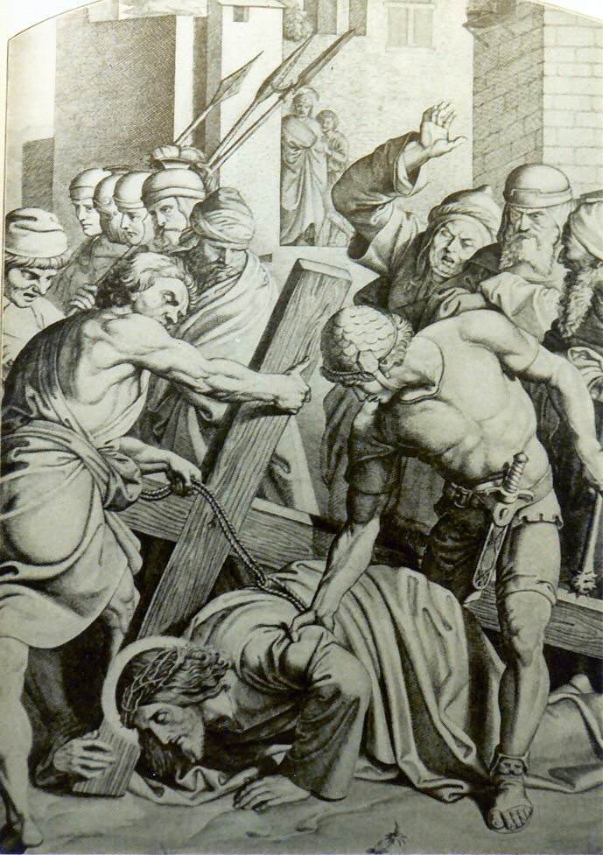

By the hard falls to the ground, the rough stones caused great wounds to His knees. At each repeated fall, these wounds were continually widened. This heavy Cross also inflicted new wounds upon His tender shoulder and the unsteadiness of the Cross caused His Head to knock against it. Thus the thorns from His crown penetrated deeper and wounded new parts of His head.

His executioners continued to eject their spittle and added a new torment, by throwing dirt into His face so mercilessly, that they blinded His eyes. In addition to all this they dragged Him so fast that they didn’t allow Him to catch His breath.

Jesus Meets His Mother the Third Time.

The Blessed Virgin, from the house of Pilate, followed Her Son, accompanied by John and the pious women. As the surging crowds hindered Her from getting very near to the Lord, She asked the eternal Father for help in this matter. With the help the holy Angels, they speedily led Her through some bystreet, in order that She might meet Her Son. Thus it came that both of Them met face to face in sweetest recognition of each other and in mutual renewal of each other’s interior sorrows. Yet They did not speak to one another, nor would His executioners allow such a conversation. But the Most prudent Mother adored Her Son, and interiorly asked Him, that, since She could not relieve Him of the weight of the Cross, He would inspire His executioners to obtain someone for His assistance. Jesus heard this prayer; and so it happened, that Simon of Cyrene was afterwards impressed to help carry the Cross.

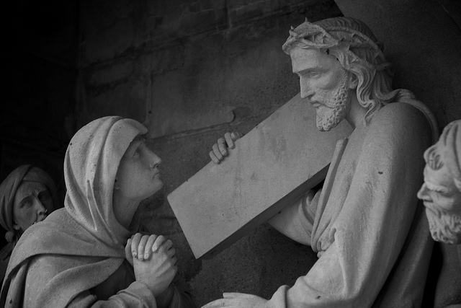

“My Son, and eternal God, light of My eyes and life of My soul, receive, O Lord, the sacrifice of My not being able to relieve You of the burden of the Cross and carry it Myself. As a daughter of Adam, it is I who should die upon it in love of You. O most loving Mediator between guilt and justice. How do You cherish mercy in the midst of so great injuries and such offences? O charity without measure or bounds, which permits such torments and affronts. O infinite and sweet love, would that the hearts and the wills of men were all Mine, so that they could give a thankful return for all that You endure”.

A Passerby was Forced to Carry the Cross

^{Mt 27:32} As they were going out, they met a Cyrenian (Coastal city in North Africa) named Simon; this man they pressed into service to carry His Cross.

^{Mk 15:21} They pressed into service a passer-by, Simon, a Cyrenian, who was coming in from the country, the father of Alexander and Rufus, to carry His cross.

^{Lk 23:26} As they led Him away they took hold of a certain Simon, a Cyrenian, who was coming in from the country; and after laying the Cross on him, they made him carry it behind Jesus.

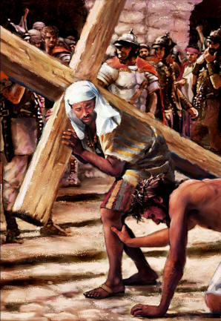
regarded the Samaritans as a people foreign to themselves, in spite of an obviously shared heritage of Jacob as their

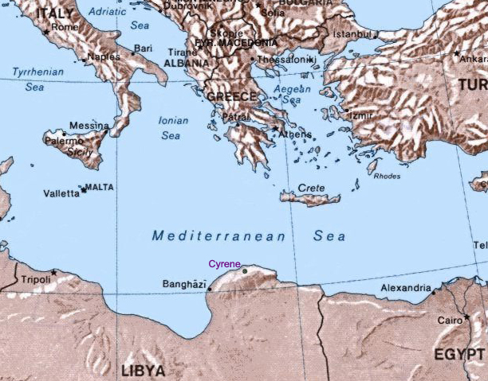

Cyrene

The Pharisees and the executioners were moved to press Simon, of Cyrene, into Carrying the Cross, some of them out of natural compassion, others for fear Jesus would die by exhaustion before they could cruelly crucify Him. This Simon was a native of Cyrene, a city of Lybia. He was forced to carry the Cross part of the way. The Jews themselves would not touch it, would not even come near it. By this pretended caution and avoidance of our Lord’s Cross, they sought to impress upon the people a horror for Jesus. Simon took hold of the Cross and Jesus was made to follow between the two thieves. The Virgin Mother walked very closely behind Jesus. She witnessed with Her own eyes the sufferings of Her Son.

Brothers, the human race requires food, shelter, and medicine. Clearly God has forced us to be charitable to one another; we are not islands of self-sufficiency. The Cross represents arrogance. Many times we are forced to experience the arrogance of others in order to survive. Take for example an owner or employee of a store. Their customers can easily become arrogant when buying products or services. And yet people will politely respond to arrogance to achieve a sale. Why? Because they need the money to buy food and shelter.

There are many other examples of being forced to carry the arrogance of others; the fear of violence is an example. Fear of being hurt is a real concern; Simon picked up the Cross because he feared the violence of the Roman soldiers.

Brothers, many wish to follow Christ and very few who truly allow themselves to imitate Him. For as soon as they feel the sufferings of the flesh (Cross) they cast it aside. There are so many who are forgetful of their mortality and continually indulge earthly pleasures. They love to seek honors and fly from injuries. Many imagine that they are following Christ, though they neither suffer nor engage in any charitable labor. They are content with avoiding boldness in committing sins, and place all their perfection in a certain “earthly” prudence, which prevents them from denying anything at the cost of their flesh.

Jesus Meets the Daughters of Jerusalem

As the Apostle Luke tells us, there were other women among the crowds, who in bitter tears followed Jesus.

^{Lk 23:27} A large crowd of people followed Jesus, including many women who mourned and lamented Him.

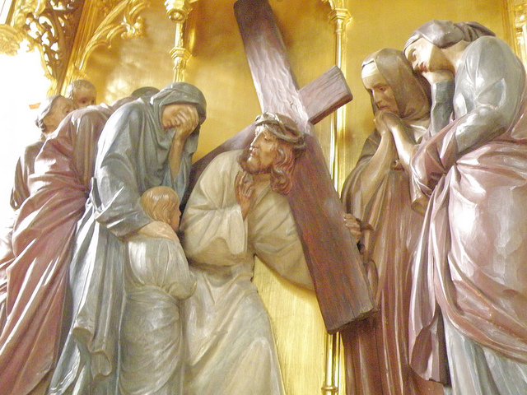

The sweetest Jesus turning toward them, addressed them and said:

^{Lk 23:28} “Daughters of Jerusalem, do not weep for Me; weep instead for yourselves and for your children,
^{23:29} for indeed, the days are coming when people will say, ‘Blessed are the barren, the wombs that never bore and the breasts that never nursed.’
^{23:30} At that time people will say to the mountains, ‘Fall upon us!’ and to the hills, ‘Cover us!’
^{23:31} for if these things are done when the wood is green what will happen when it is dry?”

Jesus wished to teach us for what purpose our tears should be shed. “Don’t cry for Me, but rather the cause of these sufferings. Weep instead over your own sins and over the sins of your brother. I desire you to weep over the damaged caused by sin, for which I suffered”.

Brothers, I must tell the world, I can plainly see my “seven children”, can you see yours? Their names are arrogance, anger, envy, lust, excessive wealth, excessive pleasure and spiritual laziness. I weep over the damage my children have done; everywhere I go, they follow me. You see, the damage my sins have caused continues even today. You must understand, when sin is conceived, it has repercussions throughout time. I clearly see my guilt and weep over my past actions.

So I say to you, in the spirit of reparation, rise up, at the beginning of every day; pour out your heart like water in the presence of the Lord; lift up your hands to Him for the lives of little ones. Lam (2:19) “Weep for him who is going away: never again will he see the land of his birth”. Jer (22:10) Like the sands of the sea, were God’s people, only a very small number of them will return; their destruction is decreed as overwhelming justice demands. Is (10:22)

“If the sins that I carried had such an effect on Me, what horrible punishment will Justice draw down upon those who are so barren and without any fruits of virtue? The damned shall call upon the mountains and the hills to shield them against My anger. At that time, during the Second Woe, the damned will say to the mountains, ‘Fall upon us!’ and to the hills, ‘Cover us!’ Hide us from the face of the One who sits on the throne and from the wrath of the Lamb! The great Day of Their vengeance has come. Who can withstand it? Rev (6:16) But yet, they shall remain stubborn in their sins. You see, the damned failed to give birth to virtue in life, and the Father’s Justice says they shall hate virtue forever. For indeed, the days are coming when the damned shall say sarcastically, ‘Blessed are the barren, the wombs that never bore and the breasts that never nursed.’ Behold how the damned are void of all goodness; their only love is to hate virtue. Their hatred is such that they can neither will nor desire anything good. Yes, they are forever stubborn in their hate”.

^{Hos 9:14} Give them, O Lord— what will You give? Give them a miscarrying womb and dry breasts.

Understand if these things are done when the wood is green, that is, during the Second Woe, what will the punishment be at their Third Woe? Rev (21:8)

Brothers, consider how in the physical world the fire from green wood isn’t as hot as the fire from dry wood. The meaning is clear, the Third Woe is far worse than the Second Woe. You see the body is reunited with the soul at the Final Judgment, thus the Third Woe. At this time, the period of “dry wood”, body and soul will experience the pains of fire (anger) together.

As a reward for their tears and their compassion, the women of Jerusalem were enlightened by God to understand that they should shed tears over their own sins and the sins of their neighbor.

Brothers, when Jesus addressed the women as women of Jerusalem, He was foretelling their spiritual outcome. Jesus in reality was giving them their titles of residents of Heavenly Jerusalem.

Questions

1) The wood that makes the Cross is a symbol of ___________.

2) The cedar of Lebanon is a symbol of _________.

3) Who said “Even now the axe is laid to the root of the trees”?

4) The stone can represent God’s word and it can represent a man’s stony ________.

5) As a tree is cut down by an axe, an arrogant man will be cut down at his ______ _______.

6) Jesus cured a blind man. Jesus used His spit on the blind man eyes and laid His hand upon him. Jesus asked the man if he saw anything. What did the blind man say to Jesus?

7) The Spirit of Jesus has seven parts, name them?

8) Who calls Himself a light?

9) The horizontal beam of the Cross represents who? The vertical beam represents who?

10) What Book in the Bible says “The beginning of man’s arrogance is to depart from the Lord”?

11) Jesus feet and hands are nailed to the Cross and this represents Jesus’ ____ for the ____ and _____.

12) What part of Jesus Body represents how He saves souls at their Final Tests?

13) What do the feet represent? What do the hands represent?

14) If we return evil for evil, our hearts will not be at ______.

15) What happens in our hearts when we return good for evil?

16) What do stars represent?

17) What virtue is needed to carry our crosses on a daily bases?

18) Lucifer and his demons were prevented from fleeing Jesus and His Cross. When Jesus picked up His Cross what happened to satan?

19) Satan does not sleep and has only one purpose in his existence. Satan spends all his time doing what?

