Parable of the sower and seed.

regarded the Samaritans as a people to themselves, in spite of an obviously

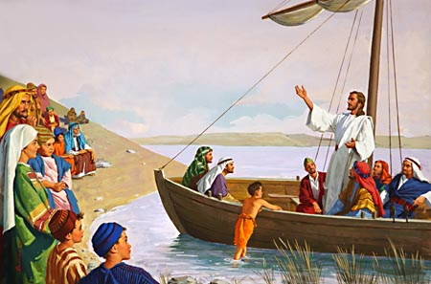
.
Jesus off shore preaching His parables.

Sound travels much better over water than it does over ground. Jesus used this method to teach in order for the Jews to hear Him. The following parable is about the seed and sower.

^{Mk 4:1} Again He began to teach beside the sea. And a very large crowd gathered about Him, so that He got into a boat and sat in it on the sea; and the whole crowd was beside the sea on the land.
^{4:2} And He taught them many things in parables, and in His teaching He said to them:
^{4:3} “Listen! A sower went out to sow.
^{4:4} And as he sowed, some seed fell along the path, and the birds came and devoured it.
^{4:5} Other seed fell on rocky ground, where it had not much soil, and immediately it sprang up, since it had no depth of soil;

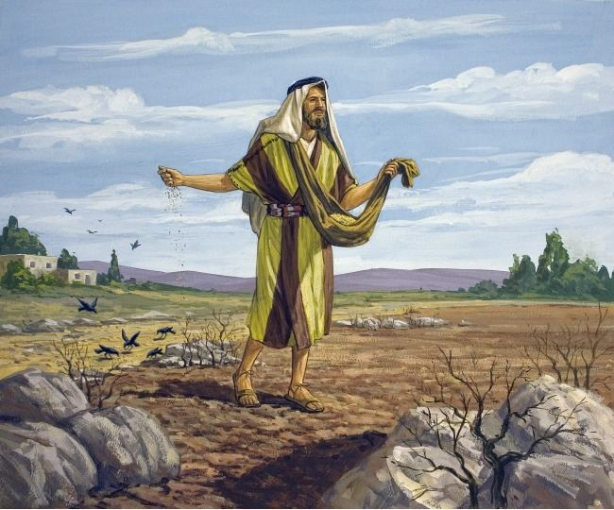

^{Mk 4:6} and when the sun rose it was scorched, and since it had no root it withered away.
^{4:7} Other seed fell among thorns and the thorns grew up and choked it, and it yielded no grain.
^{4:8} And other seeds fell into good soil and brought forth grain, growing up and increasing and yielding thirtyfold and sixtyfold and a hundredfold.”
^{4:9} And He said, “He who has ears to hear, let him hear.”
^{4:10} And when He was alone, those who were about Him with the twelve asked Him concerning the parables.
^{4:11} And He said to them, “To you has been given the secret of the kingdom of God, but for those outside everything is in parables;
^{4:12} so that they may indeed see but not perceive, and may indeed hear but not understand; lest they should turn again, and be forgiven.”
^{4:13} And He said to them, “Do you not understand this parable? How then will you understand all the parables?
^{4:14} The sower sows the word.
^{4:15} And these are the ones along the path, where the word is sown; when they hear, Satan immediately comes and takes away the word which is sown in them.

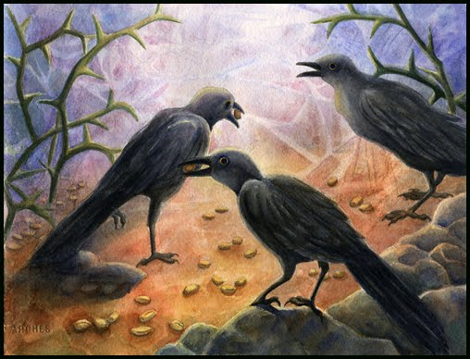

^{Mk 4:16} And these in like manner are the ones sown upon rocky ground, who, when they hear the word, immediately receive it with joy;

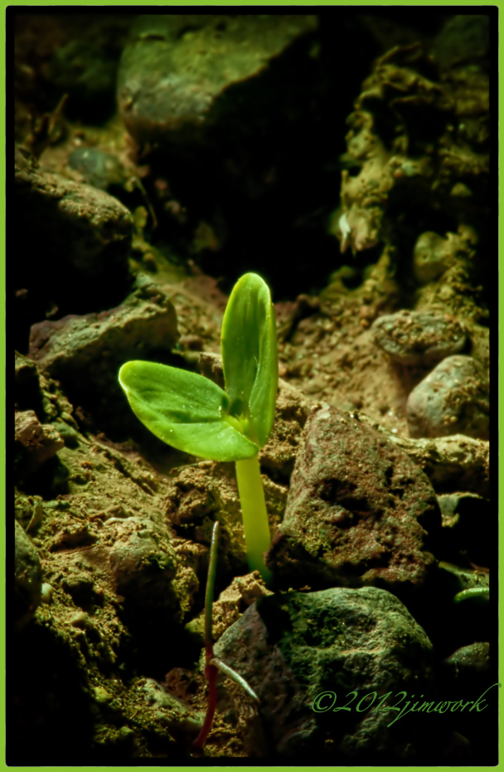
Seed on rocky soil.

^{Mk 4:17} and they have no root in themselves, but endure for a while; then, when tribulation or persecution arises on account of the word, immediately they fall away.
^{4:18} And others are the ones sown among thorns; they are those who hear the word,
^{4:19} but the cares of the world, and the delight in riches, and the desire for other things, enter in and choke the word, and it proves unfruitful.

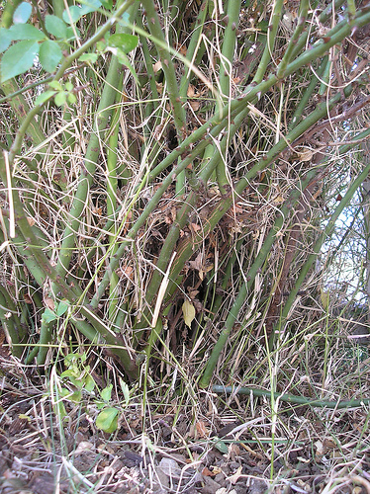
Thorns choking the sown seed.

^{Mk 4:20} But those that were sown upon the good soil are the ones who hear the word and accept it and bear fruit, thirtyfold and sixtyfold and a hundredfold.”

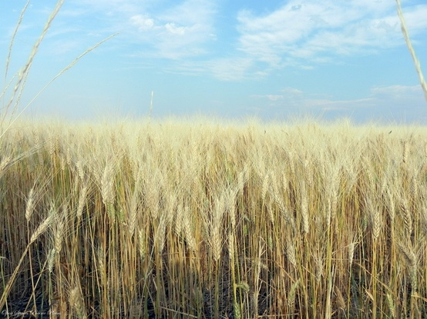

Why does Jesus use a seed in His parable? A seed must die to bring forth life. In the very same way, Jesus had to taste death to give us life. Jesus tasted death by experiencing all the sorrows of man. Jesus was temped with suicidal depression because He felt the massive mountain of depression. Depression is a very serious emotion because it causes a person to want their life to stop and cease to exist. This massive amount of sorrow was experienced by Jesus when He was hanging from the Cross at noon to 3:00 PM on Good Friday. Jesus felt the emotions of all those that wanted death. We must study and contemplate Jesus Passion. We must learn to appreciate how Jesus tasted death. If we learn how to appreciate Jesus tasting death, we will have life. How do we have life you ask? When we are subjected to the Final Test, we will be accused in this valley of darkness, we need to appreciate Jesus' passion in order not to fall into suicidal depression. If we have no appreciation of Jesus tasting death, there is nothing to stop us from falling into suicidal depression. Suicidal depression is death and hell. We must feel that we are loved in order to feel safe. The Final Test will make us feel unloved and we need Jesus' love to stand against the accusations of hate.

Never forget, even if we had no sin, we would still need a Savior. God created within us a spirit of boredom. If our human life span was extended for thousands of years, at some point we would be so bored we would want death. The emotions associated with charity, compassion and mercy will never grow old or boring. Heaven is such a place where we will never be bored because these emotions are in abundance. God's glory is Jesus and His emotions of charity, compassion and mercy. All of this occurred because Jesus took upon Himself the sorrows of all men. His Mother Mary never committed a sin and She clearly understood She needed a Savior.

^{Lk 1:46} And Mary said, “My soul magnifies the Lord,
^{1:47} and My spirit rejoices in God My Savior.

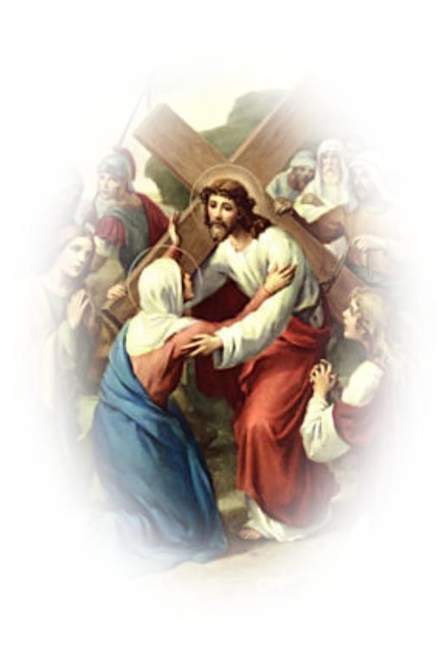
Mary and Her Savior Jesus.

So why is Jesus called our Redeemer? The answer is that He paid our ransom. The term "ransom" is associated with a price or payment made to someone who is holding another captive. In this case, the price paid is the sufferings of Jesus by experiencing the depressions of the damned and the sorrows of the elect. Jesus freed us from the sorrows of depression by giving us a reason to live forever. His Blood causes intoxication in the hearts of all those that appreciate how He experienced the sorrows of mankind. See the lesson on what is love.

1) "And as he sowed, some seed fell along the path, and the birds came and devoured it". Jesus gives part of the answer when He says, "And these are the ones along the path, where the word is sown; when they hear, Satan immediately comes and takes away the word which is sown in them". Jesus informs us that the sower sows the word. That means the seed must be the word. But what "word" is Jesus speaking about? Matthew 7:12 gives us the answer.

^{Mt 7:12} So whatever you wish that men would do to you, do so to them; for this is the law and the prophets.

Jesus is speaking about how all men are taught the Natural Law. God the Father has given every soul the knowledge that treating other in a way they would not want to be treated is a sin. Recognize how this teaching is not over powering but can be likened to a small seed placed within our hearts. In contrast the dopamine attractions that we have is like a loud drum that is constantly beating. This is why it's so easy for satan to come and devour and take away our ability to hear the Natural Law. If we play the hypocrite, we will avoid the light that comes from the Gospel teachings. Jesus said the following:

^{Jn 6:45} It is written in the prophets: ‘They shall all be taught by God.’ Everyone who listens to My Father and learns from Him comes to Me. (Me refers to Jesus.)

1) “They shall all be taught by God”. Behold, the Natural Law was taught to us by the Father.

2) “Everyone who listens to My Father and learns from Him”. Not only must we listen to the Natural Law written on our hearts, we must place the Natural Law into action.

3) “Comes to Me”. All those that violate the Natural Law will reject Christ. My point to you is this; those that are attracted to the Plan of God must be attracted to the Natural Law first.

A hypocrite can be likened to the seed sown on the path eaten by birds.

See the lessons on Natural Law and hypocrite to give a better understanding on the seed taken by the birds (satan).

2) "Other seed fell on rocky ground, where it had not much soil, and immediately it sprang up, since it had no depth of soil;" Jesus gives part of the answer when He says, "And these in like manner are the ones sown upon rocky ground, who, when they hear the word, immediately receive it with joy". and they have no root in themselves, but endure for a while; then, when tribulation or persecution arises on account of the word, immediately they fall away". The following verses from Psalms will help explain this riddle.

^{Ps 1:1} Blessed is the man who walks not in the counsel of the wicked, nor stands in the way of sinners, nor sits in the seat of scoffers;
^{1:2} but his delight is in the law of the Lord, and on His law he meditates day and night.
^{1:3} He is like a tree planted by streams of water, that yields its fruit in its season, and its leaf does not wither. In all that he does, he prospers.
^{1:4} The wicked are not so, but are like chaff which the wind drives away.

All men are forced by God's justice to walk through the valley of death. After physical death all men will be accused by the armies of hell. This day of great distress can be likened to the scourging sun. If the plant or tree does not have deep root, it will fair badly. So what creates deep roots? The answer is given in Psalms. "His delight is in the law of the Lord, and on His law he meditates day and night'. Scripture warnings are real. We must obey the Natural Law and the Written Laws. We do not want to hear the following words from Jesus.

^{Mt 7:21} “Not every one who says to Me, ‘Lord, Lord,’ shall enter the kingdom of heaven, but he who does the will of My Father who is in heaven.
^{7:22} On that day many will say to Me, ‘Lord, Lord, did we not prophesy in Your name, and cast out demons in Your name, and do many mighty works in Your name?’
^{7:23} And then will I declare to them, ‘I never knew you; depart from Me, you evildoers.

^{Prv 12:1} Whoever loves discipline loves knowledge, but he who hates reproof is stupid.
^{12:2} A good man obtains favor from the Lord, but a man of evil devices he condemns.
^{12:3} A man is not established by wickedness, but the root of the righteous will never be moved.

^{Wis 3:15} For the fruit of good labors is renowned, and the root of understanding does not fail.
^{3:16} But children of adulterers will not come to maturity, and the offspring of an unlawful union will perish.

^{Jer 17:7} “Blessed is the man who trusts in the Lord, whose trust is the Lord.
^{17:8} He is like a tree planted by water, that sends out its roots by the stream, and does not fear when heat comes, for its leaves remain green, and is not anxious in the year of drought, for it does not cease to bear fruit.”

^{Eph 3:17} and that Christ may dwell in your hearts through faith; that you, being rooted and grounded in love,
^{3:18} may have power to comprehend with all the saints what is the breadth and length and height and depth,
^{3:19} and to know the love of Christ which surpasses knowledge, that you may be filled with all the fullness of God.

3) "Other seed fell among thorns and the thorns grew up and choked it, and it yielded no grain". Jesus gives part of the answer when He says, "And others are the ones sown among thorns; they are those who hear the word, but the cares of the world, and the delight in riches, and the desire for other things, enter in and choke the word, and it proves unfruitful". God requires our time. The trainer that God has given us called grace requires training. But people involve themselves with the normal routine of life and fail to take time to train with the graces God has given us. See the lesson on grace.

Who are the people that have allowed the thorns of the world to choke their grain? These are the elect that God rescues on their death beds. In the same way that Simon the Cyrene was forced to pickup the Cross of Jesus, souls will lie on their beds with deadly sicknesses. Some of these souls God will give them a spirit to seek forgiveness and ask for His mercy. And a sure sign of God protecting a soul is the Sacrament of Anointing of the Sick. God will have mercy on who He chooses.

^{Rom 9:14} What shall we say then? Is there injustice on God’s part? By no means!
^{9:15} For he says to Moses, “I will have mercy on whom I have mercy, and I will have compassion on whom I have compassion.”
^{9:16} So it depends not upon man’s will or exertion, but upon God’s mercy.
^{9:17} For the Scripture says to Pharaoh, “I have raised you up for the very purpose of showing my power in you, so that My name may be proclaimed in all the earth.”
^{9:18} So then He has mercy upon whomever He wills, and He hardens the heart of whomever He wills.

One of the greatest pains Jesus endured is when His head was crowned with thorns. He knew with great pain how those that would call Him Lord and Redeemer would produce no mature fruit. Consider the thorns in the parable as the same that was on His head.

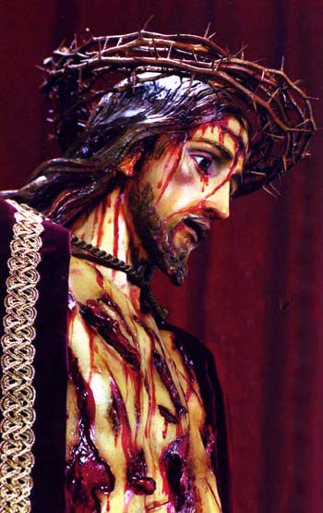

4) "And other seeds fell into good soil and brought forth grain, growing up and increasing and yielding thirtyfold and sixtyfold and a hundredfold.” Jesus gives part of the answer when He says, "But those that were sown upon the good soil are the ones who hear the word and accept it and bear fruit, thirtyfold and sixtyfold and a hundredfold.” Now this is a very hard riddle, where can the answer be found? The Gospel of Matthew gives us the following:

^{Mt 19:27} Then Peter said in reply, “Lo, we have left everything and followed You. What then shall we have?”
^{19:28} Jesus said to them, “Truly, I say to you, in the new world, when the Son of man shall sit on his glorious throne, you who have followed Me will also sit on twelve thrones, judging the twelve tribes of Israel.
^{19:29} And every one who has left houses or brothers or sisters or father or mother or children or lands, for My name’s sake, will receive a hundredfold, and inherit eternal life.
^{19:30} But many that are first will be last, and the last first.

1) Houses

2) Brothers or sisters or father or mother or children.

3) Lands

The answer to 30, 60 and 100 fold is not obvious at first, but notice how Jesus speaks about leaving the 3 categories listed above. "Houses" is referring to luxuries of life. " Brothers or sisters or father or mother or children" is referring to leaving family and denying oneself marriage. Monasteries and Convents would be examples of this. (People have chosen religious life away from the world.) "Land" is referring to business. In other words, if a soul rejects luxuries during his life time, this we be 30 fold. If that soul also rejects family along with luxuries, this is 60 fold. If that soul rejects luxuries, family and business, this is 100 fold. But all must done it in the name of Jesus. That is why Jesus said, "for My name’s sake, will receive a hundredfold, and inherit eternal life".

30 fold means one seed produced 30 new seeds. 60 fold means one seed produced 60 new seeds and 100 fold means one seed produced 100 seeds.

5) “He who has ears to hear, let him hear.” This verses takes another lesson to explain. See lesson on "ears to hear".

This parable is not saying that God has predetermined that certain people have no chance at going to heaven. God is a just God and all people are called to salvation. Seed landing on bad ground is not God damning a person to hell. It's showing the end result of a persons life. Each man has freedom to obey the Natural Law and if we are Christian to obey God's Written Laws.

Questions

1) Jesus uses a seed in His parable. Before the plant grows, what must happen to the seed?

2) We need a reason to live forever. This can be likened to a plant that grows from a seed. In the same way the seed must die, what must happen for us to live forever?

3) How did Jesus pay our "ransom"?

4) If we had never committed a sin we would still need Jesus to pay a ransom. How do we know this is true?

5) Jesus says the seed is the word of God. The seed on the path and was eaten by the birds represent those have sinned against the ________ Law.

6) It's easy for satan to eat the seed because the seed is so small compared the loud drum that beats within us called ________.

7) The term ________ is person that can be described as the seed sowed on the path eaten by birds.

8) Some seed sprang up but had shallow roots. This represents a person who doesn't meditate on the ______ of the Lord.

9) Other seed fell among the thorns. What do the thorns represent? Are they the elect or damned?

10) Jesus experienced the crown of thorns. What pain was Jesus experiencing?

11) Seed fell on good ground and produced 30 fold. Who does this represent?

12) If we gave up luxuries, family and business for the sake of Jesus, we would be represented as __________.

