“Our Lady of Good Counsel”

The history of the church called "Our Lady of Good Counsel".

The story begins many centuries ago in the time of the early Roman Empire, before Constantine made Christianity a religion no longer persecuted. A few miles south east of Rome is a city named Genazzano Italy.
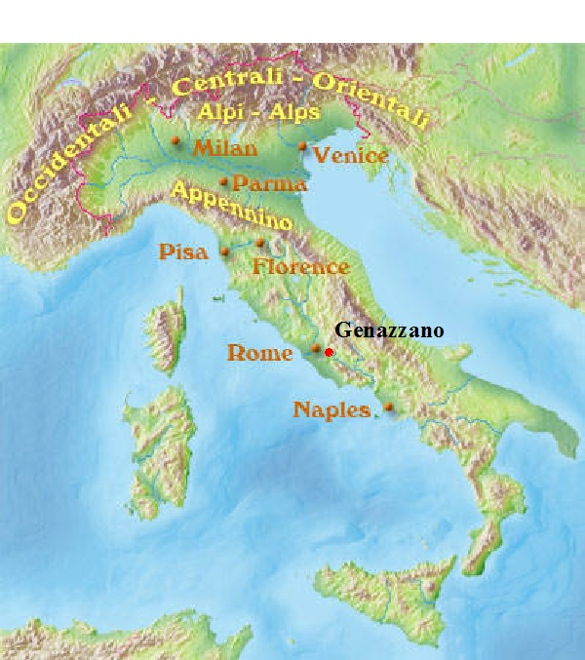

Genazzano is 30 miles from Rome, and thus the city was chosen by many rich people during Roman times as a site for their country homes. The vast gardens surrounding these homes often served as the place for pagan feasts and rituals in honor of the gods to whom the Romans believe gave them fertile fields. One of these celebrations was held every April 25 in honor of the female god Venus. For this event, people of all social classes, those who were free and slaves gathered together for a great feast. This practice gradually came to an end and the temples fell into ruins as people converted to Christianity.

When Pope Sixtus III (432-440 A.D.) called for help in renovating Saint Mary Major, a church located in Rome, the people of Genazzano contributed generously. In appreciation, the Pope gave property to the town. Eventually a church was built with the title Our Lady of Good Counsel.

As the years went by, the city became more populated and the church grew in popularity. During the Middle Ages, the Franciscans and the Augustinians founded monasteries nearby. With the passing of years, the first temple constructed in honor of the Mother of Good Counsel began to show signs of needing repair.
In 1356, the ruler of the town of Genazzano, assigned the church to the care of the Hermits of St. Augustine. (A hermit is a person who lives, to some degree, in seclusion from society.)

Petruccia

A woman named Petruccia had been left a small amount of money following the death of her husband in 1436. Living alone, she gave most of her time to prayer and services in the church of the Mother of Good Counsel. It made Petruccia sad to see the sad state of the church named Mother of Good Counsel. Thus she prayed with great intensity that people of her town would remodel the church. Finally, she decided to take the first step. After obtaining permission from the friars at the church, she donated her money to building a new church in the hope that others would help complete it once it was began.

Friars differ from monks in that they are called to live the counsels (vows of poverty, chastity and obedience) in service to a community, rather than separated from scoiety in a monastery. Whereas monks live isolated away from the world in a self-sufficient community, friars are supported by donations or other charitable support. A monk or nun makes their vows and commits to a particular community in a particular place. A friar in making vows commits to a community spread across a wider geographical area (a province) and so a friar will typically move around spending time in different houses of the community within the province.
Once the foundation of the church was laid, Petruccia, who was already eighty years old, her money ran out with the walls only 3 feet high. To make matters worse, no one came forth to help.

Her friends and neighbors began to make fun of her, and people with many harsh opinions accused her of imprudence and would scold her. Petruccia responded by saying: "My dear children, do not put too much importance on this apparent misfortune. I assure you that before my death the Blessed Virgin and our holy father Augustine will finish the church begun by me."

The Miracle

On April 25, 1467, the feast day of the Saint Mark, for the city had chosen Saint Mark to protect the city, the people of Genazzano celebrated Saint Mark with the Mass. It was Saturday, and the crowd began to gather in front of the church of the Mother of Good Counsel.

At about four in the afternoon, the people began to hear a beautiful melody that seemed to come from heaven. The people looked up toward the towers of the churches and saw a white cloud that shone with a thousand light rays. This cloud gradually neared the amazed crowd with the sound of an exceptionally beautiful melody. The cloud descended over the wall of the unfinished church, which Petruccia had started. Suddenly, the bells of the old church tower began to ring by themselves, and the other bells of the town rang at the same together. The rays that came from the little cloud faded away, and the cloud itself gradually vanished, revealing a beautiful fresco. (Fresco is art on plaster.) It was a painting that represented the Mother of Jesus tenderly holding Her Divine Son in Her arms. Measuring 40 by 45 centimeters or 15.7 inches by 17.7 inches, the Fresco is on a thin layer of plaster or porcelain not much thicker than paper. This was resting on the top of the unfinished wall that was only a few feet high.

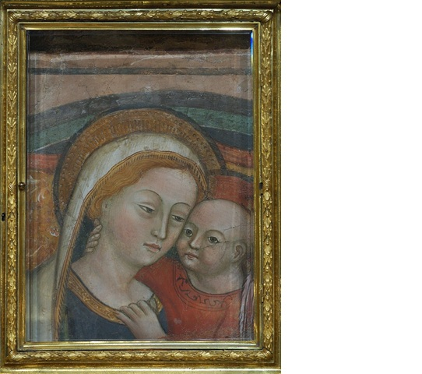

It is said that the figures themselves represent Mother and Child after they had returned from the temple where Mary heard the sad prophesies of Simeon. Mary's eyes are half-veiled as though She were lost in contemplation, taking counsel with Her God. The little Child does not return the gaze of the beholder, as happens in so many pictures, rather He draws our eyes upward to Mary as if to tell us to look for Counsel there, in the very Seat of Wisdom. It is a picture to be loved, a plain and common picture, a pious image to be copied and hung in our homes.

Almost immediately, the Virgin Mary began to cure the sick. The people who were cured were recorded so that future generations would take notice to the importance of the miracle. On record are 171 miracles which occurred from the day the miracle began April 27, 1467 to August 14, 1467. The news of the painting and its miracles spread throughout the territory and beyond, attracting many people. As a consequence numerous contributions were donated as an answer to the prayers of Petruccia.

The Story of The Albanians

Our Holy Mother wished to reveal the true origin of the marvelous fresco. Two foreigners named Giorgio and De Sclavis entered Genazzano among a group of pilgrims that had come from Rome. These two men wore strange clothes and spoke a foreign tongue, saying they had arrived in Rome earlier that year from Albania. While most people in Italy and Rome had refused to believe their story, the people of Genazzano listened.

They began by saying how the Turkish army was very close to defeating Albania where the people were Christian. A city called Scutari in the north of Albania was not strong enough to hold off defeat. Faced with this defeat, Christians began to flee. Giorgio and De Sclavis also studied the possibility of fleeing, but something kept them in Scutari, where there was a small church called the Annunciation which was dedicated to our Holy Mother. Albanians throughout the country would come to this church and giver Her honor.

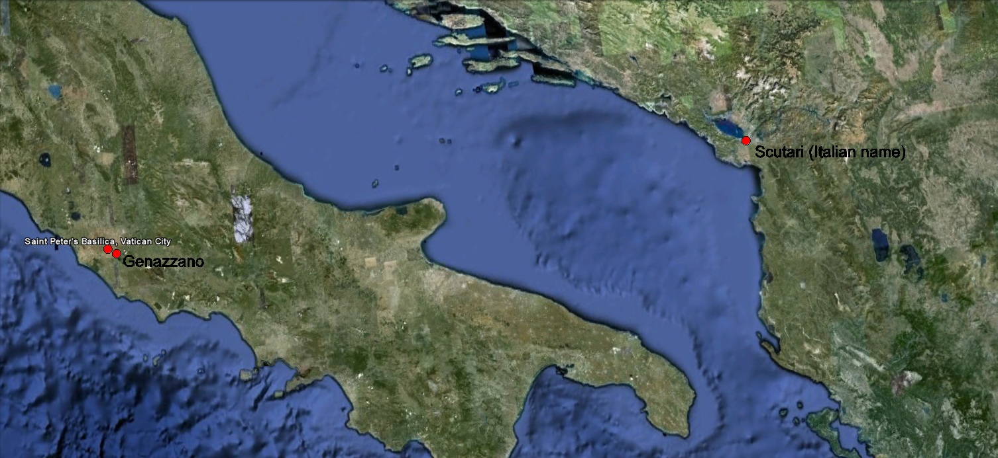

In this church in Albania the faithful gave praise and honor to a picture of Our Lady. Having poured out countless graces over the whole population, its church became the principal center of pilgrimage in Albania. Scanderbeg himself had visited this shrine more than once to ask for victory in battle. Now the shrine was threatened with destruction.

The two Albanians were torn by the idea of leaving the great treasure of Albania in the hands of the enemy. Not knowing what to do, they went to the old church to ask the Blessed Mother for the good counsel they needed. That night, they both had a heavenly dream. Mother Mary commanded them to prepare to leave their country, and never return. She added that the miraculous fresco was also going to leave Scutari for another country to escape the hands of the Turks. Finally, Mary ordered them to follow the painting wherever it went. The next morning, the two friends went to the church. At a certain moment they saw the picture detach itself from the wall on which it had hung for two centuries. Leaving its location, it hovered for a moment and was then suddenly wrapped in a white cloud through which the image continued to be visible. It traveled slowly through the air at a considerable altitude and advanced in the direction of the Adriatic Sea at a speed that allowed the two walkers to follow; after covering some twenty-four miles, they reached the coast. With great confidence, Giorgio and De Scalvis walked on the waves of the Adriatic Sea.

Without stopping, the picture left the land and advanced over the waters while the faithful Giorgio and De Sclavis continued to follow, walking on the waves much like Jesus did at Galilee. When night would fall, the mysterious cloud, which had protected them with its shade from the heat of the sun during the day, guided them by night with light, like the column of fire in the desert that guided the Jews in their exodus from Egypt. They traveled day and night until they reached the Italian coast. There, they continued following the miraculous picture, climbing mountains, crossing rivers and passing through valleys. Finally, they reached the vast plain of Lazio from where they could see the towers and domes of Rome. Upon reaching the gates of the city, the cloud suddenly disappeared before their disappointed eyes.

Giorgio and De Sclavis began to search the city, going from church to church asking if the painting had descended there. All their attempts to find the painting failed, and the Romans disbelieved the two foreigners and their strange story. Shortly thereafter, amazing news came to Rome: a picture of Our Lady had appeared in the skies of Genazzano to the sound of beautiful music and had come to rest over the wall of a church that was being rebuilt. The two Albanians rushed to find their country's beloved Fresco and it was miraculously suspended in the air next to the wall of the chapel where it remains to this day.

Although some inhabitants found the strangers' story difficult to believe, and thus they investigated the story and came to believe the two Albanians.

It must be noted that most of the church was destroyed in World War II. A bomb penetrated the roof and exploded on impact with the floor, the explosion destroyed much of the interior, the main altar was demolished however the altar of the Our Lady remained untouched, the image was miraculously preserved.

On youtube you can watch and see the fresco at the church in which it is displayed.

http://www.youtube.com/watch?v=hZz4HLvsqME

The Popes

Pope Paul II was Pope at the time of the miracle and he ordered two bishops to investigate the miraculous nature of the image and the events surrounding its arrival in Genazzano.

1) The painting which had been done of a thin layer of porcelain or plaster, the thickness of an eggshell, could not have been removed from its original surroundings by human hand.

2) This thin layer of porcelain or plaster stands upright without any support of any kind except for a narrow ledge on which it rests.

3) The image had indeed disappeared from its church of origin and that an empty space of exact dimensions was still present in the Albanian church.

Several Popes have approved the miraculous image. In 1682 Pope Innocent XI had the portrait crowned with gold. On July 2 1753 Pope Benedict XIV approved the Scapular of Our Lady of Good Counsel (the white Scapular.). This scapular was presented to the Pope by the hermits of Saint Augustine who were taking care of the church where the image is suspended in air. (Hermit is a man that that retires from society and lives in solitude especially for religious reasons.) , and was the first to wear it. In 1884 a special Mass and Office of the Feast of Our Lady of Good Counsel was approved by Pope Leo XIII. Pope John XXIII prayed at Genazzano before the opening of the Second Vatican Council, placing the work of the bishops under Mary’s protection.

What is the purpose of this miracle?

Our purpose on earth is to experience how to love others in the way Jesus loved us. The Mother of Jesus is by far the best Saint that imitated Her Son. We need to appreciate how they both loved us. We gain peace and intoxication when we place a high value on Christ's love. Printed words can never come close to the actual emotions. The Final Test is so terrible of a day that it will be then that we will actually understand how important Jesus and Mary's love for us is.

