“The First Eucharist Miracle”

Northeast of Rome Italy, about 100 miles by airplane, is a town named Lanciano. The Italian word Lanciano means lance in english. This location was not always called Lanciano but the habitants of the town changed the name to give honor to the Roman soldier that trust the lance into the side and passing into the heart of Jesus. His name was Longinus and he had poor eyesight, and after having touched his eyes with the Water and Blood from the side of Jesus, Longinus eyesight was restored. Because records were not kept like today, its only a tradition that the centurion Longinus was born and grew up in this town. Even though there is no proof that Longinus was from there, the city is definimtely named for the lance that pierced the heart of Jesus. It was here that the first Eucharistic miracle occured.

Around 700 A.D, the exact date and detailed information lost, a priest was assigned to celebrate the Mass in the small Church named St. Legontian. He Celebrated Mass using leavened bread, (Bread with yeast, today Catholic Church uses non leavened bread.) and this Priest had doubts about the real presence of Jesus Christ in the Holy Eucharist.

During the Mass, when the priest said the words of consecration (This is My Body. This is My Blood), with the doubt in his soul, the priest saw the bread change into living Flesh and the wine change into live Blood. He was frightened and confused by the miracle and thus he stood there while, but eventually he turned his face to the congregation, and said "behold the Flesh and the Blood of our most beloved Christ."

It must remembered that written records 1300 years ago are either lost or can't be colaborated as being truthful. Thus we must rely on God to lead the Catholic Church through tradition. Most importantly, God will reveal truths through the Catholic Popes.

In November of 1970, the Catholic Church decided to have this miracle examined scientifically. The task was given to Professor Doctor Odoardo Linoli, head of the hospital in Arezzo. (His qualifications were professor of anatomy, histology, chemistry and clinical microscopy.)

On March 4th 1971, professor presented a detailed account of the various studies done. Here are the main conclusions:
1) The miracle Eucharist is truly Flesh. It's Flesh from the Heart muscle; tissue of the middle muscular layer of the heart wall. The Heart Muscle tissue is marked by transverse dark and light bands. (elongated multinuclear fibers.)

2) The Blood is real Blood: Using a process called chromatographic the analysis showed that the Miracle Blood was Real Human Blood.

3) The study showed that Flesh and Blood belonged to the same blood type AB showing that the Flesh and Blood belonged to the same person.

5) No sign of outside substances that could cause preservation of the Flesh and Blood.

In 1973, the Board of Governors of the World Health Organization, was invited by Catholic Church to verify the tests ran by Doctor Linoli. The examines lasted 15 months with a total of 500 exams. Conclusions were the same as those made by Doctor Linoli.

It most be noted that the vases that contain the Body and Blood do not stop air, light, and parasites. The Board of Governors of the World Health Organization declared without doubt that it is a living tissue that responds quickly to all their clinical reactions of living beings.

The Catholic Church has recognized the Eucharistic Miracle in Lanciano. On June 25, 1672, Pope Clement X declared the altar of the Eucharistic Miracle a privileged altar on the Octave day (8th day) of the deceased (death) and on all Mondays of the year. In 1887, the Archbishop of Lanciano, obtained from Pope Leo XIII, a plenary indulgence to those who venerate the Eucharistic Miracle during the 8 days preceding the annual feast day, which falls on the last Sunday in October. Plenary indulgence means remission of the debt which men have to suffer in purgatory for sins forgiven in confession. For more information on indulgences, go to:

http://www.newadvent.org/cathen/07783a.htm

The Church of the Eucharistic Miracle has a website.

http://www.miracoloeucaristico.eu/
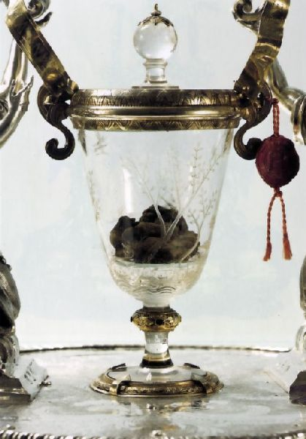
The Chalice with wine changed to the Blood of Christ.

