David and Bathsheba

regarded the Samaritans as a people to themselves, in spite of an obviously

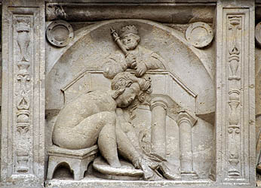
.

In the previous lesson it was pointed out that the stories found in the Scriptures must be treated like dreams and visions. These stories have a dream like quality. We all dream and we know that dreams have people and places in them that we recognize. Most of the time the events in our dreams are new and never happened in real life. If biblical stories are analyzed in this way, then bible theologians and commenter's wouldn't try to make the stories fit as if the bible was a true history. The purpose of the bible is to "open the ears of men" and "terrify men with warnings".

^{Jb 33:14} For God speaks in one way, and in two, though man does not perceive it.
^{33:15} In a dream, in a vision of the night, when deep sleep falls upon men, while they slumber on their beds,
^{33:16} then He (God) opens the ears of men, and terrifies them with warnings,
^{33:17} that He (God) may turn man aside from his deed, and cut off pride from man;
^{33:18} He (God) keeps back his soul from the Pit, his life from perishing by the sword.

The purpose of dreams and visions:

1) "Opens the ears of men". The ear symbolizes our minds. And the mind stores facts. So God is giving us spiritual facts in dreams and visions. But the facts come many times in riddles.

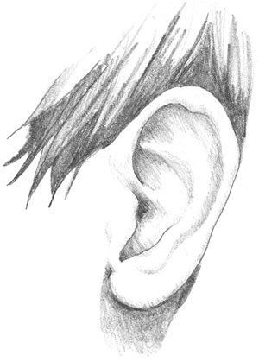 equals 

2) "Terrifies them with warnings". God gives men terrifying dreams to turn them away from their sins. Because sin leads to the pit called hell. And the sword is to escape their accusers at their Final Tests.

God used dreams and visions to write the Scriptures. After Apostle John died, visions have been used by God to give us additional graces. Example is the book called City of God written by Mary of Agreda.

The next story that will be discussed is the story of David and Bathsheba. By reading the story and analyzing it the story will show dream like qualities. And the story contains a hidden mystery that effects each and everyone of us. This story will reveal the reasons why all men must walk through the valley of the shadow of death after we physically die.

In second book of Samuel: David and Bathsheba.

^{2 Sm 11:1} In the spring of the year, the time when kings go forth to battle, David sent Joab, (Joab was David's general) and his servants with him, and all Israel; and they ravaged the Ammonites, and besieged Rabbah. But David remained at Jerusalem.

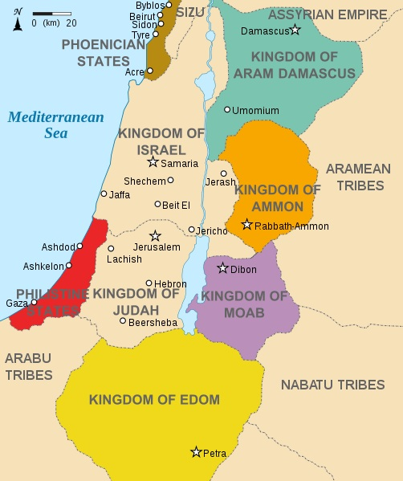

^{2 Sm 11:2} It happened, late one afternoon, when David arose from his couch and was walking upon the roof of the king’s house, that he saw from the roof a woman bathing; and the woman was very beautiful.
^{11:3} And David sent and inquired about the woman. And one said, “Is not this Bathsheba, the daughter of Eliam, the wife of Uriah the Hittite?”

The Hittites are listed as one of the peoples that occupied the Promised Land and God promised Abraham that his descendents would be given this land.

^{Gn 15:18} On that day the Lord made a covenant (promise) with Abram, saying, “To your descendants I give this land, from the river of Egypt (Nile) to the great river, the river Euphrates,
^{15:19} the land of the Kenites, the Kenizzites, the Kadmonites,
^{15:20} the Hittites, the Perizzites, the Rephaim,
^{15:21} the Amorites, the Canaanites, the Girgashites and the Jebusites.”

Thus Uriah was descendent of the people who occupied the land before the Israelites arrived.

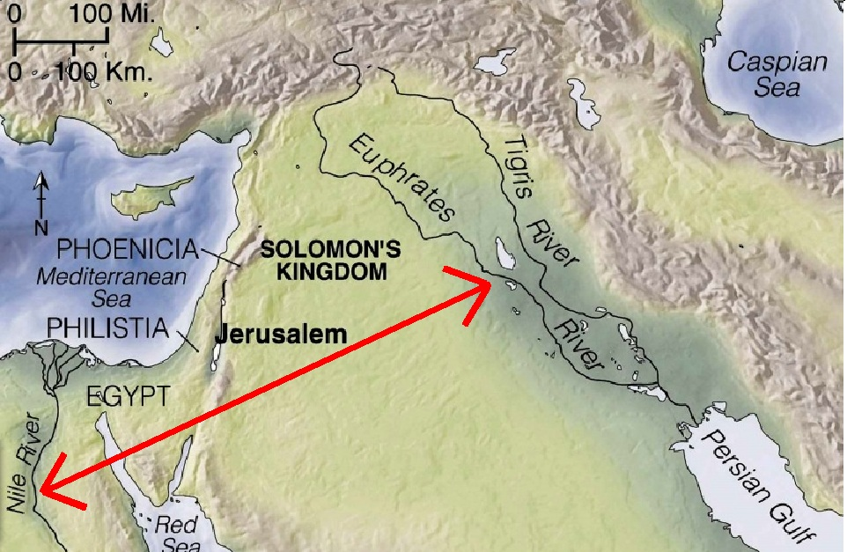

^{2 Sm 11:44} So David sent messengers, and took her; and she came to him, and he lay with her. (Now she was purifying herself from her uncleanness, her period.) Then she returned to her house.
^{11:45} And the woman conceived; and she sent and told David, “I am with child.”
^{11:6} So David sent word to Joab, “Send me Uriah the Hittite.” And Joab sent Uriah to David.
^{11:7} When Uriah came to him, David asked how Joab was doing, and how the people fared, and how the war prospered.
^{11:8} Then David said to Uriah, “Go down to your house, and wash your feet.” And Uriah went out of the king’s house, and there followed him a present from the king.
^{11:9} But Uriah slept at the door of the king’s house with all the servants of his lord, and did not go down to his house.
^{11:10} When they told David, “Uriah did not go down to his house,” David said to Uriah, “Have you not come from a journey? Why did you not go down to your house?”
^{11:11} Uriah said to David, “The ark and Israel and Judah dwell in booths; and my lord Joab and the servants of my lord are camping in the open field; shall I then go to my house, to eat and to drink, and to lie with my wife? As you live, and as your soul lives, I will not do this thing.”
^{11:12} Then David said to Uriah, “Remain here today also, and tomorrow I will let you depart.” So Uriah remained in Jerusalem that day, and the next.
^{11:13} And David invited him, and he ate in his presence and drank, so that he made him drunk; and in the evening he went out to lie on his couch with the servants of his lord, but he did not go down to his house.
^{11:14} In the morning David wrote a letter to Joab, and sent it by the hand of Uriah.
^{11:15} In the letter he wrote, “Set Uriah in the forefront of the hardest fighting, and then draw back from him, that he may be struck down, and die.”
^{11:16} And as Joab was besieging the city, he assigned Uriah to the place where he knew there were valiant men.
^{11:17} And the men of the city came out and fought with Joab; and some of the servants of David among the people fell. Uriah the Hittite was slain also.
^{11:18} Then Joab sent and told David all the news about the fighting;
^{11:19} and he instructed the messenger, “When you have finished telling all the news about the fighting to the king,
^{11:20} then, if the king’s anger rises, and if he says to you, ‘Why did you go so near the city to fight? Did you not know that they would shoot from the wall?
^{11:21} Who killed Abimelech the son of Jerubbesheth? Did not a woman cast an upper millstone upon him from the wall, so that he died at Thebez? Why did you go so near the wall?’ then you shall say, ‘Your servant Uriah the Hittite is dead also.’”

^{Jdg 9:52} And Abimelech came to the tower, and fought against it, and drew near to the door of the tower to burn it with fire.
^{9:53} And a certain woman threw an upper millstone upon Abimelech’s head, and crushed his skull.

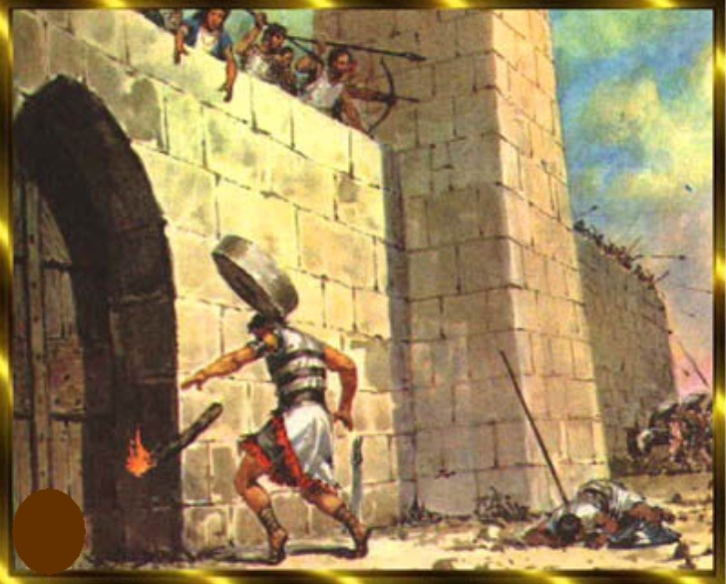

^{2 Sm 11:22} So the messenger went, and came and told David all that Joab had sent him to tell.
^{11:23} The messenger said to David, “The men gained an advantage over us, and came out against us in the field; but we drove them back to the entrance of the gate.
^{11:24} Then the archers shot at your servants from the wall; some of the king’s servants are dead; and your servant Uriah the Hittite is dead also.”
^{11:25} David said to the messenger, “Thus shall you say to Joab, ‘Do not let this matter trouble you, for the sword devours now one and now another; strengthen your attack upon the city, and overthrow it.’ And encourage him.”
^{11:26} When the wife of Uriah heard that Uriah her husband was dead, she made lamentation for her husband.
^{11:27} And when the mourning was over, David sent and brought her to his house, and she became his wife, and bore him a son. But the thing that David had done displeased the Lord.

^{2 Sam 12:1} And the Lord sent Nathan to David. He came to him, and said to him, “There were two men in a certain city, the one rich and the other poor.
^{12:2} The rich man had very many flocks and herds;
^{12:3} but the poor man had nothing but one little ewe lamb, (Refers adult female sheep.) which he had bought. And he brought it up, and it grew up with him and with his children; it used to eat of his morsel, and drink from his cup, and lie in his bosom, and it was like a daughter to him.
^{12:4} Now there came a traveler to the rich man, and he was unwilling to take one of his own flock or herd to prepare for the wayfarer who had come to him, but he took the poor man’s lamb, and prepared it for the man who had come to him.”
^{12:5} Then David’s anger was greatly kindled against the man; and he said to Nathan, “As the Lord lives, the man who has done this deserves to die;
^{12:6} and he shall restore the lamb fourfold, because he did this thing, and because he had no pity.”
^{12:7} Nathan said to David, “You are the man. Thus says the Lord, the God of Israel, ‘I anointed you king over Israel, and I delivered you out of the hand of Saul;
^{12:8} and I gave you your master’s house, and your master’s wives into your bosom, and gave you the house of Israel and of Judah; and if this were too little, I would add to you as much more.

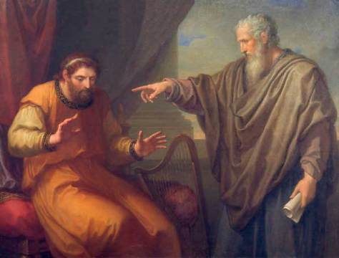

^{2 Sm 12:9} Why have you despised the word of the Lord, to do what is evil in his sight? You have smitten Uriah the Hittite with the sword, and have taken his wife to be your wife, and have slain him with the sword of the Ammonites.
^{12:10} Now therefore the sword shall never depart from your house, because you have despised Me, and have taken the wife of Uriah the Hittite to be your wife.’
^{12:11} Thus says the Lord, ‘Behold, I will raise up evil against you out of your own house; and I will take your wives before your eyes, and give them to your neighbor, and he shall lie with your wives in the sight of this sun.
^{12:12} For you did it secretly; but I will do this thing before all Israel, and before the sun.’”
^{12:13} David said to Nathan, “I have sinned against the Lord.” And Nathan said to David, “The Lord also has put away your sin; you shall not die.
^{12:14} Nevertheless, because by this deed you have utterly scorned the Lord, the child that is born to you shall die.”
^{12:15} Then Nathan went to his house.
And the Lord struck the child that Uriah’s wife bore to David, and it became sick.
^{12:16} David therefore besought God for the child; and David fasted, and went in and lay all night upon the ground.
^{12:17} And the elders of his house stood beside him, to raise him from the ground; but he would not, nor did he eat food with them.
^{12:18} On the seventh day the child died. And the servants of David feared to tell him that the child was dead; for they said, “Behold, while the child was yet alive, we spoke to him, and he did not listen to us; how then can we say to him the child is dead? He may do himself some harm.”
^{12:19} But when David saw that his servants were whispering together, David perceived that the child was dead; and David said to his servants, “Is the child dead?” They said, “He is dead.”
^{12:20} Then David arose from the earth, and washed, and anointed himself, and changed his clothes; and he went into the house of the Lord, and worshiped; he then went to his own house; and when he asked, they set food before him, and he ate.
^{12:21} Then his servants said to him, “What is this thing that you have done? You fasted and wept for the child while it was alive; but when the child died, you arose and ate food.”
^{12:22} He said, “While the child was still alive, I fasted and wept; for I said, ‘Who knows whether the Lord will be gracious to me, that the child may live?’
^{12:23} But now he is dead; why should I fast? Can I bring him back again? I shall go to him, but he will not return to me.”

The stories in the Old Testament have a dream or vision like quality. It's very strange that Uriah would sleep outside rather than sleeping with his wife. People do not behave like this. Adultery does happen in the lives of men, but this story says that David who has no history of sinful behavior easily falls to this temptation. Did this really happen? Did God punish the child for their parents sin? Did Joab go along with the murder of Uriah? How did Nathan know that God forgave David immediately after David asked for mercy? The answers to these questions can't be answered unless God reveals the facts. But the purpose of the story can be known. Read the lesson on pearls and swine to understand how the Scriptures can be understood.

1) "In the spring of the year, the time when kings go forth to battle, David sent Joab, and his servants with him, and all Israel; and they ravaged the Ammonites, and besieged Rabbah. But David remained at Jerusalem". This is a very interesting verse. Most people would read this and not notice anything special. The spring of the year would be the first month after the equinox. (Equinox occurs twice a year, when the tilt of the earth's axis is inclined neither away from or towards the sun, the center of the sun being in the same plane as the Earth's equator. Night and day, at all earth locations, are about equal and thus is called equinox.) A possible interpretation of the "spring time for battle" could be related to seeking God in our youth. The Book of Ecclesiastes says:

^{Eccl 12:1} Remember also your Creator in the days of your youth, before the evil days come, (Refers to Final Test.) and the years draw near, when you will say, “I have no pleasure in them”.

From the Book of Wisdom,

^{Wis 8:1} She (wisdom) reaches mightily from one end of the earth to the other, and she orders all things well.
^{8:2} I loved her and sought her from my youth, and I desired to take her for my bride, and I became enamored of her beauty.

From the book of Sirach,

^{Sir 6:18} My son, from your youth choose instruction, and until you are old you will keep finding wisdom.
^{6:19} Come to her like one who plows and sows, and wait for her good harvest. For in her service you will toil a little while, and soon you will eat of her produce.

What is meant by going to "war"? We can liken our daily lives as "war". The "war" is this, we must do battle with our flesh (dopamine) and practice the virtues using the trainer called grace. We can not do as we feel. Jesus said to us in the Gospel of Luke,

^{Lk 14:27} Whoever does not bear his own cross and come after Me, cannot be My disciple.

The cross is a symbol of doing battle. We are doing battle with ourselves. Saint Paul uses the word "war" to describe his body.

^{Rom 7:22} In my inmost self I dearly love God’s law,
^{7:23} but I see in my members another law (This law is dopamine.) at war with the law (God's law) of my mind and making me captive to the law of sin which dwells in my members.
^{7:24} Wretched man that I am! Who will deliver me from this body of death?

Saint Peter says,

^{1 Pet 2:11} Beloved, I urge you as aliens and sojourners (People on a journey to heaven.) to keep away from worldly desires that wage war against the soul.

Who are the Ammonites? Spiritually speaking the Ammonites represent the sin of arrogance (pride). The Ammonites will be discussed in a future lesson along with the other nations that surround Israel. (Edomites, Moabites, Philistines, Phoenicians, the people of Aram and the people who live in the open country called Arabia. Each of these nations represent one of the seven deadly spirits.)

We must go into battle and war against the deadly spirit of arrogance. What is arrogance? Arrogance is the opposite of humility. A humble man never stops asking and learning about God and His will. An arrogant man feels strongly he knows God and applies little effort in trying to know him better. In the Book of Wisdom it says,

^{Wis 15:3} For to know You (God) well is complete justice, and to know Your might is the root of immortality. (Immortality refers to passing the Final Test.)

As king David was chosen by God, we are also chosen in a similar way. There are so many sins in the world that the number of souls that are baptized as children are so few. God has chosen us as He chose David. So few parents will baptize their children and teach them Catholic theology. Consider it a great blessing and invitation to be chosen to be baptized Catholic. There are many in the protester religions (Protestants.) that require kids to be old enough to chose Jesus before they are baptized. Did Saint Peter and Paul chose Jesus? No, Jesus called the twelve Apostles and Paul.

We can liken ourselves as kings that most go to battle in our youths. We must fight against ourselves and seek the will of the Father and place the will of the Father into action and do His will with the emotions of the Holy Spirit. (Seven Spirits of God). We need the trainer grace to know the Lord and His will. See the lessons about arrogance and grace to understand this lesson with clarity.

The number of people who seek God and His will are very few. Most will not fight their passions (dopamine) and make the journey and seek the Lord. People do as they feel. Unlike a deer that can climb the heights, men would rather act like the pig rolling in the mud. (See lesson pearls and swine.) Men are happy with the joys of their hearts and have no true desire to understand God. In other words people have no desire to fight their arrogance. In fact, people are unaware they are being arrogant.

^{Eccl 2:4} I made great works; I built houses and planted vineyards for myself;
^{2:5} I made myself gardens and parks, and planted in them all kinds of fruit trees.
^{2:6} I made myself pools from which to water the forest of growing trees.
^{2:7} I bought male and female slaves, and had slaves who were born in my house; I had also great possessions of herds and flocks, more than any who had been before me in Jerusalem.
^{2:8} I also gathered for myself silver and gold and the treasure of kings and provinces; I got singers, both men and women, and many concubines, man’s delight.
^{2:9} So I became great and surpassed all who were before me in Jerusalem; also my wisdom remained with me.
^{2:10} And whatever my eyes desired I did not keep from them; I kept my heart from no pleasure, for my heart found pleasure in all my toil, and this was my reward for all my toil.

^{Lk 16:14} The Pharisees, who were lovers of money, heard all this, and they scoffed at Jesus.
^{16:15} But He said to them, “You are those who justify yourselves before men, but God knows your hearts; for what is exalted among men is an abomination in the sight of God.

People do not like to quote this verse. "For what is exalted among men is an abomination in the sight of God". When men try to be exalted themselves in sports, science or business, in God's sight, this is a sin.

2) "So David sent messengers, and took her (Bathsheba); and she came to him, and he lay with her". In this verse, it has been revealed that King David commits adultery. (Having relations with another man's wife.) In the same way that a man takes another man's wife, God judges all men as adulterers when they make anything more important than God. The First Commandment says:

^{Ex 20:1} And God spoke all these words, saying,
^{10:2} “I am the Lord your God, who brought you out of the land of Egypt, out of the house of bondage.
^{20:3} “You shall have no other gods before Me".

It does not take much to sin against the First Commandment. Jesus said the following:

^{Mk 8:36} For what does it profit a man, to gain the whole world and forfeit his life?
^{8:37} For what can a man give in return for his life?
^{8:38} For whoever is ashamed of Me and of My words in this adulterous and sinful generation, of him will the Son of man also be ashamed, when he comes in the glory of his Father with the holy Angels.

When a soul fails his Final Test he will forfeit his life. In other words the damned will fall into suicidal depression and curse God forever. They are considered by God to be adulterous because they did not value Jesus Passion and His words.

^{Lk 14:25} Now great multitudes accompanied Jesus; and He turned and said to them,
^{14:26} “If any one comes to Me and does not hate his own father and mother and wife and children and brothers and sisters, yes, and even his own life, he cannot be My disciple.

It most be understood that even our relationships with our own families can violate the First Commandment. Thus anything that keeps us from knowing God we should hate. Violate the First Commandment and God has labeled us as adulterers.

3) "Why have you despised the word of the Lord, to do what is evil in his sight? You have smitten Uriah the Hittite with the sword, and have taken his wife to be your wife, and have slain him with the sword of the Ammonites". Nathan has revealed that king David has killed Uriah by using the sword of the Ammonites. Clearly understand this, in the same way that king David committed adultery and murder, God judges us a murders when we commit adultery by making anything more important than God. Complete justice is to know God Wis (15:3), but if we violate the First Commandment, we are not going to know Him very well. How can we tell other about the good news called the Gospel when we are busy with pleasures of the world? The answer is simply we can't. God has made us responsible for one another. If we fail this responsibility, God will hold us for the death of those that fail their Final Tests. In the Book of Ezekiel it says,

^{Ez 3:17} “Son of man, I have made you a watchman for the house of Israel; whenever you hear a word from My mouth, you shall give them warning from Me.
^{3:18} If I say to the wicked, ‘You shall surely die,’ and you give him no warning, nor speak to warn the wicked from his wicked way, in order to save his life, that wicked man shall die in his iniquity; but his blood I will require at your hand.
^{3:19} But if you warn the wicked, and he does not turn from his wickedness, or from his wicked way, he shall die in his iniquity; but you will have saved your life.
^{3:20} Again, if a righteous man turns from his righteousness and commits iniquity, and I lay a stumbling block before him, he shall die; because you have not warned him, he shall die for his sin, and his righteous deeds which he has done shall not be remembered; but his blood I will require at your hand.
^{3:21} Nevertheless if you warn the righteous man not to sin, and he does not sin, he shall surely live, because he took warning; and you will have saved your life.”

In the story found in Genesis, when Cain killed his brother Abel, God called out to Cain and asked him where was his brother. Cain responded by saying “I do not know; am I my brother’s keeper?” And the Lord said, “What have you done? Gn (4:9) The voice of your brother’s blood is crying to Me from the ground". God didn't respond to the statement "Am I my brother's keeper", but the Catholic Church does consider this to be true, we must love one another. Saint Paul said the following,

^{1 Cor 9:16} For if I preach the Gospel, that gives me no ground for boasting. For necessity is laid upon me. Woe to me if I do not preach the Gospel!

Saint Paul clearly sees his obligation to preach the Gospel. In fact, he knows if he didn't, he would be held to great judgment. This applies to Christians as well. Some of us have greater responsibilities depending upon how much we have been given.

4) "Now therefore the sword shall never depart from your house, because you have despised Me, and have taken the wife of Uriah the Hittite to be your wife.’ Thus says the Lord, ‘Behold, I will raise up evil against you out of your own house;' The story about David and Bathsheba is to inform us the reasons why God has all men walk in the valley of the shadow of death after physical death. The Final Test is a real event that happens to all. The Catholic Church reveals this event in the book called the Dialogue written by Saint Catherine of Siena. See the lesson on death and read the details that Catherine gave us. The sword of accusation will rise against us after we die. Since we are our brother's keeper, our own family will be our accusers, only if they failed their Final Tests. Jesus said the following:

^{Mt 10:34} “Do not think that I have come to bring peace on earth; I have not come to bring peace, but a sword.
^{10:35} For I have come to set a man against his father, and a daughter against her mother, and a daughter-in-law against her mother-in-law;
^{10:36} and a man’s foes will be those of his own household.

The Scriptures contain 35,528 verses and many of them reveal the details about this event called the Final Test. Future lessons will contain hundred's verse showing how this event will take place. This lesson is to reveal the reasons why God has chosen a sword of accusation against us. As far as king David is concerned, the Scriptures reveal how his son Absalom rises up against him to take his kingdom from him. In the same way, our actions, which is our sins will be the reasons why we have so many accusers.

5) "David said to Nathan, “I have sinned against the Lord.” And Nathan said to David, “The Lord also has put away your sin; you shall not die". Rather amazing how quickly king David is forgiven. The previous king named Saul sinned against God. Saul repented but God eventually removed Saul from kingship. Saul and the spiritual meaning about him will be discussed in another lesson.

At our Final Tests, all men will be shown the damage their sins have caused. The elect will see their sin and ask forgiveness. The damned will see their sin and fall into suicidal depression. The foundation of how we react to our Final Test is our faith. Read the lessons on faith in order to understand how faith can cause a very different emotion compared to a person with no faith.

The story about King David and Bathsheba reads more like a dream or vision than an actual event. Very strange that Uriah would sleep outside rather than in his wife's bed. In the previous stories, nothing in king David's back ground would reveal such a terrible crime of adultery or cold blooded murder. Very cold hearted indeed to send a friend to his death. It's safe to say that king David and Bathsheba existed because they are part of the lineage (family tree) of Jesus. But as far as the actual event as stated, it's a good question to ask God if it really happened. But the actual purpose of the story is to reveal the reasons why God will force all men to walk in the valley of the shadow of death.

Questions.

1) God used dreams and visions to write the _________. After Apostle's Johns death, God continues to use visions for the purpose of giving us additional _________.

2) Name the city in the kingdom of Ammon that Joab, King David's general, attacked?

3) Bathsheba had a husband who was a Hittite, what was his name?

4) God told Abraham that his descendents would occupy the land between the Nile and Euphrates. Name the ten nations that occupied this land?

5) King David was in Jerusalem instead of fighting the Ammonites. He lusted after the woman named ___________. He committed the sin of ________ with her and conceived a child. In order to hide his sin, king David committed another sin called __________.

6) God did not speak directly with king David about his sins, but rather told the prophet named _________. This prophet foretold the future of king David by saying that his sin will be punished. The prophet said to king David that the _______ shall never depart from his house and God will raise up ______ against him out of his own _______.

7) When the length of night and day at all locations on the earth are equal, this is called the _______ and happens _____ a year.

8) In the spring we all must go to war. The spring time represents what? Going to war represents what?

9) The Ammonites are the people of the country of Ammon and represent what?

10) A _____ man never stops asking and learning about God and His will. An _________ man feels strongly he knows God and applies little effort in trying to know him better.

11) Which book in the Bible does it say that complete justice is to know God well?

12) What Gospel did Jesus say "What is exalted among men is an abomination in the sight of God"?

13) The First Commandment says “You shall have no other gods before Me". If we break this Commandment, God judges us as ____________.

14) Complete justice is to know the Lord. But if we violate the First Commandant, we are not going to know God very well. If we do not know God very well, we can't preach the Gospel and warn others about the danger. And thus God will hold us responsible for another person's death at their Final Tests. What question did God ask Cain about his brother? What was Cain's response?

15) Who said "woe to me if I do not preach the Gospel"?

16) The sword of accusation will rise against all of us after we physically die. God will hold us responsible for the death of all those that fail their ______ _______. God has given us two reasons why he has empowered the armies of hell to accuse us. Name both reasons.

17) The story of David and Bathsheba reads more like a dream than an actual event. The purpose of the story is to reveal why all men are forced to walk in the ____ of the ______ of ______.

