“Jesus' Hands and Feet Nailed to the Cross”

The human body has many parts. The ear, eye, feet and hands have spiritual significances.

- The ear represents our memories. When we listen to God’s word, we place His words in our memories.

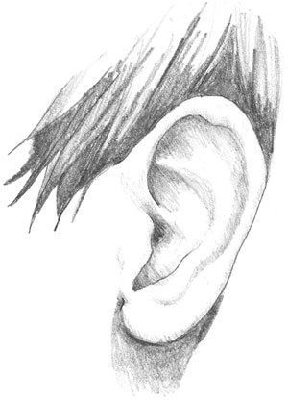

It's true our eye reads God's words. But when we read, we hear our voices in our minds as we read the words in silence.

- The "eye" can see the emotions of Jesus. The 144,000 and those in the second and third watches can see the beauty of God’s Seven Spirits. The elect in the fourth watch are blind and thus do not understand Jesus emotions. As light has seven parts (rainbow), God’s Spirit has seven parts. Rev (3:1) Wisdom, understanding, counsel, strength, knowledge, Holy Fear and My delight of Holy Fear. Is (11:2)

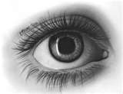

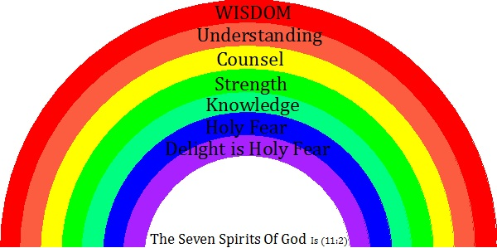

Scripture describes Jesus, the Word became Man, as a light.

^{﻿Jn 1:9﻿} The true light that enlightens every man was coming into the world.
^{1:﻿10﻿} He (Jesus) was in the world, and the world was made through Him, yet the world knew him not.

Colors have always been associated with human emotions. For instance yellow represents being a coward. Green with envy, or red with anger. When God shares His grace with a soul, the soul can see the Seven emotions of Jesus.

- The feet represent our hearts. Clearly it’s our feet that take us to where our hearts desire. Only the 144,000 have the eyes to see the colors (emotions) of God’s Seven Spirits. Their feet carry them too places of charity.

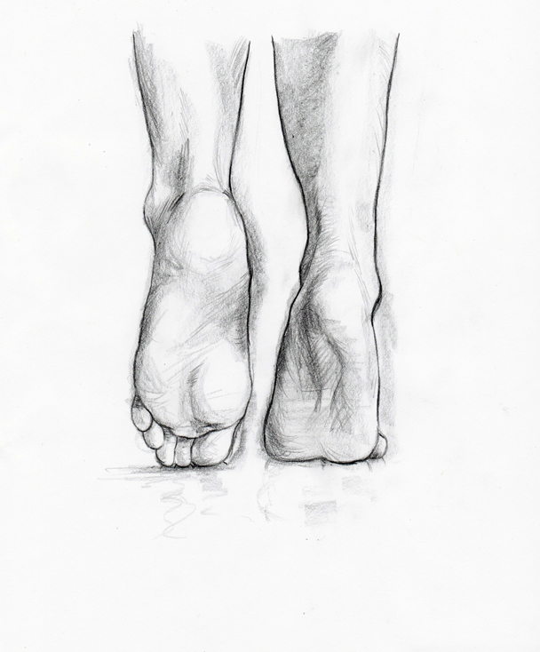
- The hands represent charity. When we give charitable assistance to others, it’s our hands that give that assistance. But only the 144,000 and those in the second and third watch have perfect charity. With their spiritual eyes, the 144,000 imitate the emotions of Jesus by praying and giving physical assistance to others.

Jesus feet and hands are nailed to the Cross to represent His love for the elect and damned. The horizontal beam represents the arrogance of the elect. His saving right hand, in charity, lifts the elect from the valley of death at their Final Tests. His feet represents His hearts desire to save all men, including the damned. But the damned are not saved because the God's will requires all men to appreciate the actions of Jesus. The feet of Jesus can't save souls, only is hands can save souls from the valley of death.

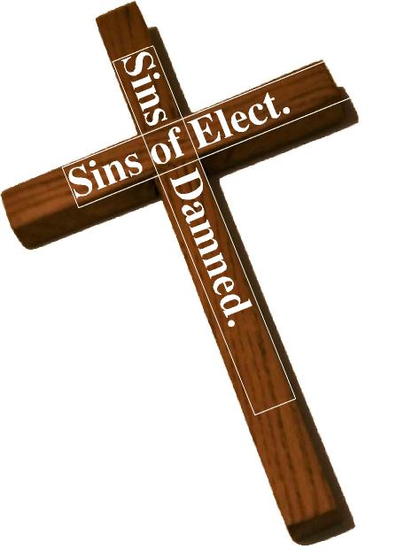

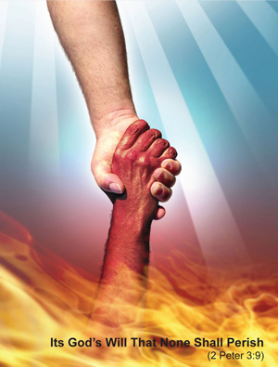

Again, it must be said, the feet of Jesus can't save a man's soul. The right hand of Jesus can only save those who appreciate the actions of Jesus.

Brothers, it’s easy to overlook, but our emotions that occur to us daily match the events that occur to us. At our Final Tests, men will fall into suicidal depression because they do not have an emotion to appreciate the sorrows of Jesus. In order to appreciate Jesus Passion, we must have some experience in caring about the sorrows of others. The damned do not have such experiences. In fact the damned have a long history in causing sorrow to others.

