Children's bread not given to dogs.

regarded the Samaritans as a people to themselves, in spite of an obviously

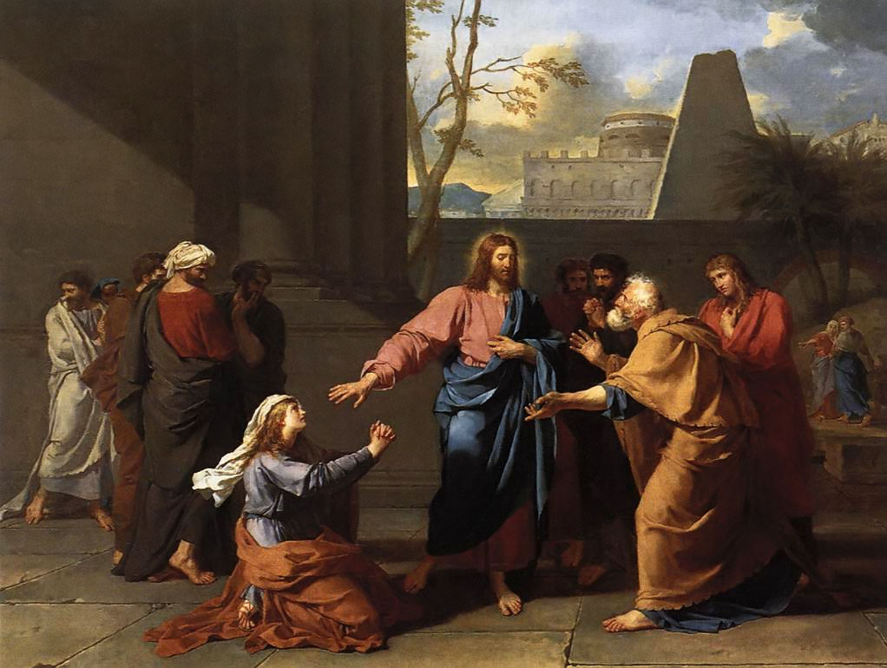
The Canaanite women begging Jesus.

^{Mt 15:21} And Jesus went away from there and withdrew to the district of Tyre and Sidon.
^{15:22} And behold, a Canaanite woman from that region came out and cried, “Have mercy on me, O Lord, Son of David; my daughter is severely possessed by a demon.”
^{15:23} But he did not answer her a word. And His disciples came and begged Him, saying, “Send her away, for she is crying after us.”
^{15:24} He answered, “I was sent only to the lost sheep of the house of Israel.”
^{15:25} But she came and knelt before Him, saying, “Lord, help me.”
^{15:26} And He answered, “It is not fair to take the children’s bread and throw it to the dogs.”

regarded the Samaritans as a people to themselves, in spite of an obviously

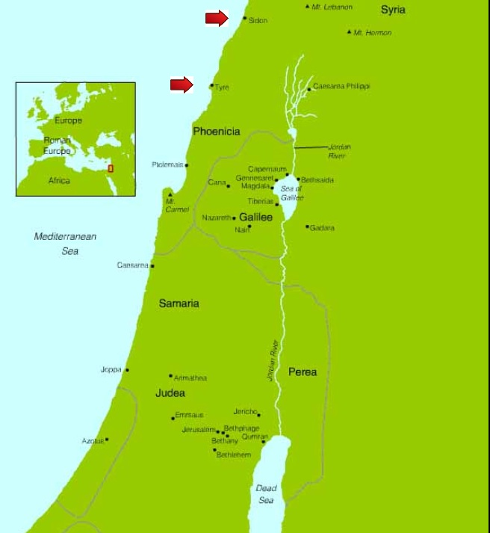

^{Mt 15:27} She said, “Yes, Lord, yet even the dogs eat the crumbs that fall from their masters’ table.”
^{15:28} Then Jesus answered her, “O woman, great is your faith! Be it done for you as you desire.” And her daughter was healed instantly.

In order to understand Scripture's parables or stories, it's best to take each important word and define it using other Scripture verses. In the parable above, dog, lost, Israel, sheep, bread, food and crumbs are defined.

One of the first benefits of mediating, contemplating and pondering Scripture is the fact that words like "dog" have definitions and can be found in the verses. "Dog" is the symbol of a man that goes back to his sins over and over again.

^{Prv 26:11} Like a dog that returns to his vomit is a fool that repeats his folly.



What message is Jesus teaching us? We know the meaning of the dog. What is the meaning of the lost sheep of Israel? The answer can be found in the following verses from the Gospel of Luke.

^{Lk 19:1} Jesus entered Jericho and was passing through.
^{19:2} And there was a man named Zacchaeus; he was a chief tax collector, and rich.
^{19:3} And he sought to see who Jesus was, but could not, on account of the crowd, because he was small of stature.
^{19:4} So he ran on ahead and climbed up into a sycamore tree to see Him, for He was to pass that way.
^{19:5} And when Jesus came to the place, He looked up and said to him, “Zacchaeus, make haste and come down; for I must stay at your house today.”
^{19:6} So he made haste and came down, and received Jesus joyfully.
^{19:7} And when they saw it they all murmured, “He has gone in to be the guest of a man who is a sinner.”
^{19:8} And Zacchaeus stood and said to the Lord, “Behold, Lord, the half of my goods I give to the poor; and if I have defrauded any one of anything, I restore it fourfold.”
^{19:9} And Jesus said to him, “Today salvation has come to this house, since he also is a son of Abraham.
^{19:10} For the Son of man came to seek and to save the lost.”

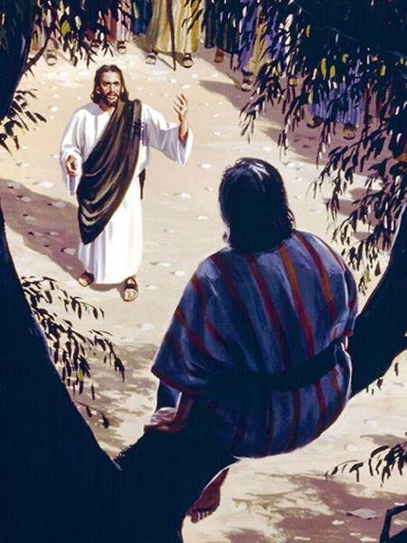

Zacchaeous is considered by Jesus as lost. Jesus went to his home and Zacchaeous heart was moved to give a large sum to the poor and if he committed any crime by taxing the Jews more than He was required, he would restore the amount and add 3 times more to make restitution. Jesus responded by saying 'Today salvation has come to Zacchaeus and Zacchaeus actions are likened to His ancestor Abraham'. Jesus places great weight on giving to the poor and correcting past sins.

Does a "lost" person mean he will go to hell? The following verses in the Gospel of John will define "lost". Jesus is praying to the Father on the night He was betrayed.

^{Jn 17:12} While I (Jesus) was with them, I kept them in Your name, which You have given Me; I have guarded them, and none of them is lost but the son of perdition, that the Scripture might be fulfilled.

Jesus is speaking about Judas. The word perdition means "a state of final spiritual ruin" or damnation. This is proof from the Lord's own words that Judas is in hell. Below are the Scripture verses that prove that Psalms 109 are the verses.

^{Acts 1:15} In those days Peter stood up among the brethren (the company of persons was in all about a hundred and twenty (120)), and said,
^{1:16} “Brethren, the Scripture had to be fulfilled, which the Holy Spirit spoke beforehand by the mouth of David, (Referring to the 109 Psalms.) concerning Judas who was guide to those who arrested Jesus.
^{1:17} For Judas was numbered among us, and was allotted his share in this ministry.
^{1:18} Now this man bought a field with the reward of his wickedness; and falling headlong he burst open in the middle and all his bowels gushed out. (Referring to how Judas hanged himself.)
^{1:19} And it became known to all the inhabitants of Jerusalem, so that the field was called in their language Akeldama, that is, Field of Blood.)
^{1:20} For it is written in the book of Psalms, ‘Let his habitation become desolate, and let there be no one to live in it’; and ‘His office let another take.’

^{Ps 109:1} Be not silent, O God of my praise!
^{109:2} For wicked and deceitful mouths are opened against me, speaking against me with lying tongues.
^{109:3} They beset me with words of hate, and attack me without cause.
^{109:4} In return for my love they accuse me, even as I make prayer for them.
^{109:5} So they reward me evil for good, and hatred for my love.
^{109:6} Appoint a wicked man against him; (The wicked man is an accuser which will be sent to this man after he dies.) let an accuser bring him to trial.
^{109:7} When he is tried, let him come forth guilty; let his prayer be counted as sin!
^{109:8} May his days be few; may another seize his goods! (Refers to the Apostles appointing Mathias as an Apostle.)
^{109:9} May his children be fatherless, and his wife a widow!
^{109:10} May his children wander about and beg; may they be driven out of the ruins they inhabit! (Children refers to his actions.)
^{109:11} May the creditor seize all that he has; may strangers plunder the fruits of his toil! (Refers to his accusers at his Final Test.)
^{109:12} Let there be none to extend kindness to him, nor any to pity his fatherless children!
^{109:13} May his posterity (Family) be cut off; may his name be blotted out in the second generation!
^{109:14} May the iniquity (Sins) of his fathers be remembered before the LORD, and let not the sin of his mother be blotted out!
^{109:15} Let them be before the LORD continually; and may his memory be cut off from the earth!
^{109:16} For he did not remember to show kindness, but pursued the poor and needy and the brokenhearted to their death.
^{109:17} He loved to curse; let curses come on him! He did not like blessing; may it be far from him!
^{109:18} He clothed himself with cursing as his coat, may it soak into his body like water, like oil into his bones!
^{109:19} May it be like a garment which he wraps round him, like a belt with which he daily girds himself!
^{109:20} May this be the reward of my accusers from the LORD, of those who speak evil against my life!

Having read the meaning of "lost" which refers to those going to hell, why did Jesus use the words "lost sheep of Israel"? Does Israel refer to Jews only or all people? The next verses are from the Gospel of John.

^{Jn 3:16} For God so loved the world that He gave His only Son, that whoever believes in Him should not perish but have eternal life.
^{3:17} For God sent the Son into the world, not to condemn the world, but that the world might be saved through Him.
^{3:18} He who believes in Him is not condemned; he who does not believe is condemned already, because he has not believed in the name of the only Son of God.

God the Father sent the second Person of the Holy Trinity into the world. Jesus is God, not an Angel. Jesus came to save the world, not just the "lost" Jews. The Scripture verses are stories after stories of riddles. The "Jews" is referring to all men when Jesus says "lost sheep of Israel". There will many that will disagree with this statement, and this relates directly to the reason why Jesus calls men sheep. Sheep are very weak and stupid because they easily stray into danger and can't protect themselves. As sheep need protection from predators, man needs protection from the devil. The elect, those written in the Book of Life, the case can be made that the elect are symbolized as Israel.

^{Is 53:6} We had all gone astray like sheep; each following his own way; and the LORD has laid on Him the guilt of us all.

^{Jer 4:22} “For My (God is speaking.) people are foolish, they know Me not; they are stupid children, they have no understanding. They are skilled in doing evil, but how to do good they know not.”

The next word to define is "bread".

^{Mt 4:1} Then Jesus was led up by the Spirit into the wilderness to be tempted by the devil.
^{4:2} And He fasted forty days and forty nights, and afterward He was hungry.
^{4:3} And the tempter came and said to Him, “If you are the Son of God, command these stones to become loaves of bread.”
^{4:4} But Jesus answered, “It is written, ‘Man shall not live by bread alone, but by every word that proceeds from the mouth of God.’”

Bread is defined as "every word of God". From God's words we receive our trainer called grace. We are required by God to use our trainer grace to practice the virtues and learn about His Son Jesus. The next verse from the Gospel of John reveals the food of Jesus.

^{Jn 4:34} Jesus said to them, “My food is to do the will of Him who sent Me, and to accomplish His work.

Our food should also be to do the will of God. It takes our trainer grace to do God's will.

When Jesus spoke to the Canaanite women the riddle is this. God will not give sinners the grace in order to be saved from their Final Test. The "dogs" will only receive crumbs from God's table of bread. God says it is not right that He gives His graces meant for the children of God and give them to sinners.

Let us review the following verse from the lesson on the Natural Law.

^{Jn 6:45} It is written in the prophets, ‘And they shall all be taught by God.’ Every one who has heard and learned from the Father comes to Me. (Jesus spoke these words.)

As we have seen, sinners are represented as "dogs". All men are taught by God the Natural Law and those who disobey it are called "dogs". By not obeying the Natural Law, men will not be given the desire to come to Jesus. Sinners will not have the spirit to come to Jesus and thus will not be given the "bread" of God's words. Sinners can also be likened to the seed that fell upon the path where the birds come and eat it. (See the lesson on parable of the seed.)

So what are the crumbs that the dogs eat? Those that sin against the Natural Law suppresses their consciences and not look to heaven and fail to remember the punishments that come with sin. Dan (13:9) But many of these "dogs" know about the bible, Jesus and Christianity. Christmas and Easter are known to most people. During life many people have read parts of the Scriptures. Many will have a working knowledge that Jesus came into the world to save sinners. But the "dogs" have no real understanding of the Scriptures or grace.

This is a very important warning. Disobeying the Natural Law, God will not feed us His words of saving grace. This is a huge curse because the sinner has no idea the danger he is in. By training with the graces Jesus has given us, we come to understand the great danger of sin and the punishments that comes to all those that are "dogs" in the sight of God. Hell is real and lasts forever because their is no escape.

King Herod

King Herod that killed John the Baptist is a great example of a dog.

Jesus therefore came into the presence of Herod, against whom the blood of John the Baptist was calling more loudly than the blood of Abel. (Cain killed his brother Abel. Gn (4:25)) But the unhappy murderer, ignorant of the terrible judgment against him, mockingly greeted our Lord with laughter. Herod began to examine and question Jesus. He thought he could induce Jesus to work some miracle to satisfy his curiosity. But the Lord of wisdom and prudence, standing with a humble reserve before His most unworthy judge, answered Herod not a word. For on account of his evil doing he well merited the punishment of not hearing the words of life, which Herod would certainly have heard if he had been disposed to listen to them with reverence.

^{Lk 23:9} Herod questioned Him at length, but Jesus gave him no answer.

The following verses reinforces the fact that God will not speak to sinners.

^{Tb 13:6} When you turn back to the Lord with all your heart, to do what is right before Him, then He will turn back to you, and no longer hide His face from you.

1) "No longer hide His face from you". Realize this is very hard to do. If God is not speaking to us, how can we turn towards Him? If a person's conscience is badly damaged and no longer barks when the person sins against the Natural Law, how does he turn back? The answer is that few turn back. That is why so few baptized souls are in heaven.

^{Jb 8:20} Behold, God will not cast away the upright; neither will He take the hand of the wicked.

^{Jb 35:12} When they cry out, He (God) answers not against the arrogance of the wicked.

^{Ps 66:18} Were I cherished evil in my heart, the Lord would not hear.

^{Prv 1:29} The LORD is far from the wicked, but the prayer of the just He hears.

^{Prv 28:9} When one turns away his ear from hearing the law, even his prayer is an offensive.

1) “When one turns away his ear from hearing the law”. Men fail to realize that when they stop studying the law, their prayers are offensive.

^{Wis 1:1} ....think of the LORD in goodness, and seek Him in integrity of heart;
^{1:2} Because He is not found by those who test Him, nor does He show Himself to those who do not believe in Him.
^{1:3} For SELF-WILLED counsels separate a man from God, and His power, put to the proof, rebukes the foolhardy.

1) "For SELF-WILLED counsels separate a man from God". In the Old Testament, Samuel the prophet said that "presumption is a sin of idolatry". 1 Sam (15:23) The reason why we have so many opinions on the meaning of Scripture is because of the sin of presumption and SELF-WILLED counsels. God will separate Himself from men who presume. That is why we have countless numbers of Christian denominations. Only Catholics and the Greek Orthodox Churches have 7 Sacraments and thus the protesters called Protestants have separated themselves from God.

^{Is 1:11} ...I have had enough of whole-burnt rams and fat of fatlings; in the blood of calves, lambs and goats I find no pleasure.
^{1:12} Trample My courts (justice) no more! Bring no more worthless offerings; your incense (prayers) is loathsome to Me.
^{1:15} When you spread out your hands, I close My eyes to you; though you pray the more, I will not listen. Your hands are full of blood.
^{1:16} Wash yourselves clean! Put away your misdeeds from before My eyes; cease doing evil;
^{1:17} learn to do good. Make justice your aim: redress the wronged,

^{Is 59:2} … it is your crimes that separate you from your God, it is your sins that make Him hide His face so that He will not hear you.

^{Ez 14:3} Son of man, these men have the memory of their idols fresh in their hearts, (Refers to breaking the First Commandment.) and they keep the occasion of their sin before them. Why should I allow Myself to be consulted by them?

^{Ez 39:23} The nations shall know that because of its sins the house of Israel went into exile; for they transgressed against Me, and I hid My face from them and handed them over to their foes, so that all of them fell by the sword. (Refers to the Final Test.)
^{39:24} According to their uncleanness and their transgressions I dealt with them, hiding My face from them.

^{Mi 3:4} When they cry to the LORD, He shall not answer them; (Refers to Final Test.) rather shall He hide His face from them at that time, because of the evil they have done.

Isaiah's prophesy

^{Mt 13:14} With them indeed is fulfilled the prophecy of Isaiah which says: ‘You shall indeed hear but never understand, and you shall indeed see but never perceive.
^{13:15} For this people’s heart has grown dull, and their ears are heavy of hearing, and their eyes they have closed, lest they should perceive with their eyes, and hear with their ears, and understand with their heart, and turn for me to heal them.’

The "crumbs" which fall to the dogs are revealed by the verses above. Sinners hear and see God's words but they are unable to understand what they are seeing and hearing. Since they can't understand God's words, they fail to change their lives and come to Jesus to be healed. Isaiah first spoke this prophesy in the Old Testament, then Jesus repeated it and in Acts of the Apostles Saint Paul spoke them again. Is (6:9), Mt (13:14), and Acts (28:27) When we see verses repeated, we must take notice of the message's importance. Another way to explain it is this, sinners are drunk on the dopamine pleasures that they seek every day. In the physical world a drunk staggers about and the world is a blur. It's impossible for an earthly drunk to learn anything because his senses can't focus. A sinner behaves in the same way. The word of God to a "drunk" is boring and he is not able to focus on the Words importance.

Questions

1) A Canaanite women came to Jesus and wanted Jesus to do what?

2) A dog is a symbol of who?

3) What was the occupation Zacchaeous?

4) Name the two promises Zacchaeous made to Jesus?

5) A 'lost" person refers to a man destined for ______.

6) Jesus came to save only the Jews. True or false?

7) What Gospel writer tells us who Jesus came to save?

8) Sheep are helpless to defend themselves from wolves and lions. Sheep are also ________.

9) Bread represents what?

10) What is Jesus food?

11) In order to disobey the Natural Law a person would need to suppress his ________ and not look to heaven and fail to remember the ___________ that come with sin.

12) Sin separates us from God. God will not listen to our prayers and will not give us the trainer grace. This is a huge curse because the sinner has no idea the _______ he is in.

13) Sinners hear and see God's words but they are unable to __________ what they are seeing and hearing.

14) The pleasures of the world are caused because dopamine is released within our brains. This can be likened to being _______.

