“The Shepherds” (Mary of Agreda)

489. After the Angels of heaven had thus celebrated the birth of God made Man near the entrance of Bethlehem, some of the Angels were immediately dispatched to different places, in order to announce the happy news to those, who according to God's will were able to appreciate it. Michael the Angel went to the holy Patriarchs in limbo and announced to them, how the Only Son of the eternal Father was already born into the world and was resting, humble and meek, as they had prophesied, in a manger between two beasts. (Ass and ox)

Example of Patriarchs are Abraham, Isaac, Jacob, Moses and David. (They represent fathers of the people.)

The word Limbo comes from the Latin word limbus which means edge or boundary. Limbo refers the edge of hell where the elect waited until the death of Jesus on the Cross. Limbo is only understood when heaven and hell are understood.

Michael congratulated Joachim and Anne (The parents of Mary who were physically dead and were waiting in Limbo.) in the name of the blessed Mother, that their Daughter now held in Her arms the Savior, who had been foretold by all the Patriarchs and Prophets.

^{﻿Is 7:14﻿} Therefore the Lord himself will give you a sign. Behold, a young woman shall conceive and bear a son, and shall call His name Immanuel.

^{﻿Is 9:6﻿} For to us a child is born, to us a Son is given; and the government will be upon His shoulder, and His name will be called “Wonderful Counselor, Mighty God, Everlasting Father, Prince of Peace.”
^{﻿9:7﻿} Of the increase of His government and of peace there will be no end, upon the throne of David, and over his kingdom, to establish it, and to uphold it with justice and with righteousness from this time forth and for evermore. The zeal of the Lord of many will do this.

It was the most consoling and joyful day for the just souls and saints gathered in Limbo. All of them acknowledged Jesus as God and Man and their Savior. They created and sang new songs of adoration and worship in His praise. Saint Joachim and Anne asked the messenger Michael to return a message to Mary their Daughter to worship in their name the divine Child, the blessed Fruit of Her womb. Mary heard the prayer of Her parents and prayed before the Christ Child. Mary listened with great jubilee to all that the Michael reported concerning the Patriarchs of Limbo.
490. Another of the holy Angels that attended and guarded the heavenly Mother was sent to saint Elisabeth and her son John. On hearing this news of the birth of the Redeemer, the prudent women and her son, age 3 months old, prostrated themselves upon the earth and adored their God made Man in spirit and in truth.

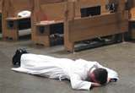
Prostrated

^{﻿Jn 4:23﻿} But the hour is coming, and now is, when the true worshipers will worship the Father in spirit and truth, for such the Father seeks to worship him.

The child John the Baptist which had been chosen to prepare God's people, was renewed interiorly with a spirit more inflamed than that of the prophet Elijah, causing new admiration and jubilation in the Angels themselves. John the Baptist and his mother requested our Queen through the Angels, that She in the name of them both, adore Her most holy Son and offer Him their services; all of which
the heavenly Queen immediately fulfilled.
491. Having thus been informed of what had happened, Saint Elisabeth hurried and sent one of her servants to Bethlehem with presents for the blessed Mother and the infant God. They consisted in some money, some linen and other things for the comfort of the newly born and of his poor Mother and Her spouse. The servant went on the way with no other instruction than that he visit the blessed Virgin and saint Joseph and take notice of what they needed, so that he might bring back certain information of their circumstances and well-being. He had no other knowledge of the holy event, except what he himself could see with his own eyes. This servant was touched by an interior and divine force, thus he came back and in wonderful jubilee and described to Saint Elisabeth the poverty and the charming grace of her Cousin Mary, of the Child and of Saint Joseph. If it had not been for the will of God, that the secret of Jesus birth should be preserved, Elisabeth could not have restrained herself from visiting the Virgin Mother and the newborn God. Of the things sent by Elisabeth, Mary used some for ease their extreme poverty, while She distributed the rest to the poor.
492. Other Angels were delegated to bring the news to, Zachary, (Father of John the Baptist.) Simeon and Anne and to some other just and holy people. These people were worthy to be trusted with this new mystery of our Redemption; for as the Lord found them prepared to receive this news with gratitude and with benefit to themselves. God considered it a just due to their virtue not to hide from them the blessing given to the human race. Although not all the just people upon earth were informed of this holy event; yet in all of them were given certain divine emotions in the hour in which the Savior of the world was born. For all the just men on earth felt in their hearts a new and supernatural joy, though they were ignorant of its cause. In addition, the sun accelerated its course; the stars shone in greater brightness. Many trees began to bloom and others to produce fruit. Some temples of the idols were overthrown; and in others the idols were hurled down and their demons put to flight. These wonders and other happenings in the world on that day men accounted for in different ways. Only among the just men of the earth, who by divine impulse suspected or believed that God had come into the world; yet no one knew it with certainty, except those to whom it was revealed. Among these were the three Magi, to each of whom in their separate Oriental kingdoms. Angels were sent to inform them by interior and intellectual enlightenment that the Redeemer of the human race had been born in poverty and humility. At the same time they were inspired with the sudden desire of seeking Him and adoring Him and immediately they saw the star as a guide to Bethlehem, as I will relate farther on.

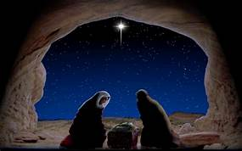

493. Among all these, the shepherds of that region, who were watching their flocks at the time of the birth of Christ, were especially blessed. The shepherds, being poor and humble, and despised by the world, they belonged in sincerity and uprightness of heart to those Israelites, who fervently hoped and longed for the coming of the Messiah, speaking and discussing of Him among themselves many times. The shepherds were like Christ, as they were removed from the riches, vanity and showing the world their vanity and far from it’s demonic planning to cheat others. Hence the shepherds merited to be called and invited, as the first fruits of the saints by the Savior Himself, to be the very first ones, to whom the eternal and God made Man shown Himself and by whom He wished to be praised, served and adored. Hence the archangel Gabriel was sent to the shepherds as they watched on the field, appearing to them in human form and with great splendor.

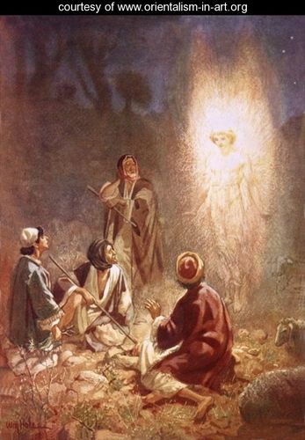

494. The shepherds found themselves suddenly enveloped and bathed in the heavenly light of the Angel, and at His sight, being little versed in such visions; they were filled with great fear. The holy prince reassured them and said: "You upright men, be not afraid: for I announce to you tidings (news) of great joy, which is, that for you is born today the Redeemer Christ, our Lord, in the city of David. And as a sign of this truth, I announce to you, that you shall find the Infant wrapped in swaddling-clothes and placed in a manger".

^{﻿Lk 2:8﻿} And in that region there were shepherds out in the field, keeping watch over their flock by night. ﻿
^{2:9﻿} And an Angel of the Lord appeared to them, and the glory of the Lord shone around them, and they were filled with fear.
^{2:﻿10﻿} And the Angel said to them, “Be not afraid; for behold, I bring you good news of a great joy which will come to all the people;
^{2:﻿11﻿} for to you is born this day in the city of David a Savior, who is Christ the Lord.
^{2:﻿12﻿} And this will be a sign for you: you will find a babe wrapped in swaddling cloths and lying in a manger.” ﻿
^{2:13﻿} And suddenly there was with the Angel a multitude of the heavenly Angels praising God and saying, ﻿
^{2:14﻿} “Glory to God in the highest, and on earth peace among men with whom he is pleased!”

Because the shepherds were out in a field late at night with their sheep, some men do not believe Jesus was born December 25. They reason the shepherds would not be with their flocks in fields during the winter. Mary of Agreda nor do the Scriptures explain why the shepherds were in the fields in the winter. Since God has not given us an explanation, but has given us the date of December 25, we can consider this another stumbling block for those who want to believe in their thoughts.

At these words of the Angel, suddenly appeared a great multitude of Angels, who in voices of sweet harmony sang to the Most High these words: "Glory to God in the highest and on earth peace to men of good will". Singing this song a number of times, so new to the world, the holy Angels disappeared. All this happened in the fourth watch of the night. By this vision of the Angels the humble and fortunate shepherds were filled with divine enlightenment and were moved by a strong longing to make certain of this blessing and to go and witness with their own eyes the most high mystery of which they had been informed.
495. The appearance of the Angels was necessary. For the Child Jesus lie in a manger and to be wrapped in swaddling-clothes, would not have been convincing proof of the majesty of a king, if these shepherds had not been given by divine light and been permitted to penetrate the mystery. As they were free from the arrogant wisdom of the world, they were easily made skilled in the heavenly wisdom. Discussing among themselves the thoughts excited by this message, they decided to hurry in all speed to Bethlehem and see the wonder made known to them by the Lord. They departed without delay and entering the cave, they found Mary and Joseph, and the Infant lying in a manger. Seeing all this they recognized the truth of what they had heard of the Child.

^{﻿Lk 2:15﻿} When the Angels went away from them into heaven, the shepherds said to one another, “Let us go over to Bethlehem and see this thing that has happened, which the Lord has made known to us.” ﻿
^{2:16﻿} And they went with haste, and found Mary and Joseph, and the babe lying in a manger.
^{2:﻿17﻿} And when they saw it they made known the saying which had been told them concerning this child;
^{2:﻿18﻿} and all who heard it wondered at what the shepherds told them.
^{2:﻿19﻿} But Mary kept all these things, pondering them in Her heart.
^{2:﻿20﻿} And the shepherds returned, glorifying and praising God for all they had heard and seen, as it had been told them.

The shepherds upon seeing the Word made flesh; Jesus also glanced at them, emitting from His face a great brilliance, which wounded the shepherds with love. Grace changed the shepherds and renewed them, filling them with an exalted knowledge of the divine mysteries of the Word became Man and the Redemption of the human race.
496. Prostrating themselves on the earth they adored the Word made flesh. Not any more as ignorant shepherds, but as wise and prudent men they adored Him, acknowledged and magnified Him as true God and Man, as Restorer and Redeemer of the human race. The heavenly Lady and Mother of the Child took notice of all that they did interiorly and exteriorly; for She saw into their in most hearts.

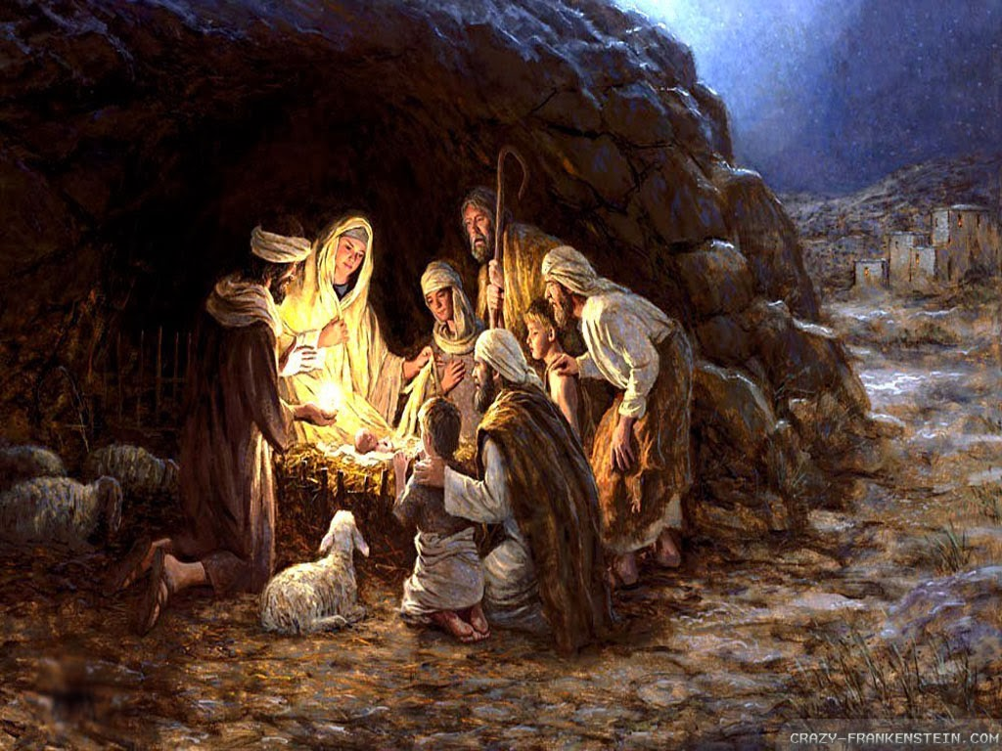

In highest wisdom and prudence She preserved the memory of all these happenings and pondered them in Her soul, comparing them with the other mysteries and with the holy prophecies and sayings of the Scriptures. As She was then the instrument of the holy Spirit and the representative of the Infant, She spoke to the shepherds, instructing and encouraging them to persevere in divine love and in the service of the Most High. The shepherds also discussed with Her on their part and showed by their answers that they understood many of the mysteries. They remained in the cave from the beginning of dawn until mid-day, when, having given them something to eat, our great Queen sent them off full of heavenly grace and consolation.
497. During the days in which most holy Mary, the Child and Saint Joseph remained in the gates of Bethlehem, these holy shepherds returned a few times and brought such presents as in their poverty they could spare. The shepherds were unable to spread the news of the Messiah because people who heard the shepherds speaking about this matter didn't believed them, for they held them to be uncultured and ignorant people. These shepherds however were saints and were filled with divine knowledge until they died. However there was one man that believed them, his named was Herod. Although not because of any reverence, but on account of Herod's worldly and wicked fear of losing his kingdom. Among the children, who were sacrificed by Herod were some who belonged to these shepherds.

Words of Wisdom from the Blessed Virgin.

498. My daughter, forgetfulness and inattention regarding the works of the Redeemer are as blameworthy as they are common and frequent among men. Yet these works are most mysterious, loving, merciful and instructive. You have been called and chosen to receive knowledge and enlightenment for avoiding such dangerous and gross laziness; therefore I wish that in the mysteries you have just written, you take notice of and ponder over the burning love of My most holy Son in showing Himself to men as soon as He was born, in order to make them immediate sharers of the joyful fruit of His coming. Men do not know of this obligation, because few of them penetrate to the significance of this great blessing, just as there were few who saw the Word at His Birth and thanked Him for His arrival. They are not aware of the cause of their evil state and of their blindness, which is not the fault of God or to any fault in His love, but to the sins and the bad dispositions of men. If their own bad dispositions would not stop or make them unworthy of this favor, the same light, which was given to the just, to the shepherds and to the kings, would have been given to all or to many. That there should be so few, will make you understand in what an unhappy condition the world was at the time of the coming of the child Jesus; and also the unhappiness of the present times, when these mysteries have become so evident and when grateful memory of them is become so scarce.
499. Consider the wicked disposition of mortals in the present age, in which the light of the Gospel has been spread out and shown by so many miracles given by God in His Church. In spite of all this there are so few, who are perfect and who seek to dispose themselves for greater participation in the fruits and benefits of the Redemption. Although the number of fools is so great and the addictions are become so many, there are those who think, that also the perfect are numerous, because, men do not so openly dare to act in opposition to God. There are fewer than one thinks, and many less than there should be, seeing that God is so much offended by unbelievers and continually desires to give the treasures of grace in His Church according to the merits of His only Son our Lord. Be mindful, dearest, of the obligation imposed upon you by your clear knowledge of these truths. Live cautiously, with great attention and watchfulness correspond to His graces, losing no time, occasion or circumstance for acting in the most holy and perfect manner known to you. For you can not fulfill your duty otherwise. Remember what I tell you, command and urge upon you, that you receive such great favor and not use it; do not allow your grace and light to be without profit, but make use of them in the perfection of thankfulness.

Questions

1) Were the parents of Mary alive upon the earth when the baby Jesus was born?

2) What is the name of John the Baptist mother?

3) How old was John the Baptist when Jesus was born?

4) John the Baptist was no ordinary baby. By special miracle that occurred in the womb of his mother when Mary pregnant with Jesus visited her, John was able to understand clearly and adore God. When the Angel announced the birth of Jesus to John the Baptist and his mother, both _______ themselves upon the earth.

5) God only informed those who were prepared to receive the news of Jesus birth with _____ and with benefit to themselves.

6) Jesus was born at midnight. The Angel named ______ went to the shepherds during the _____ watch of the night.

