“The Birth Of Jesus in Bethlehem” (Mary of Agreda)

468. God the Father, referring to God's Will or Plan, had chosen an insignificant cave, to which most holy Mary and Joseph found after they had been denied all hospitality and the most ordinary kindness by their fellowmen. This place was held in such contempt that though the town of Bethlehem was full of strangers in want of night shelter, none would degrade himself so far as to make use of it for a lodging. For there was none who thought it suitable for such a purpose, except the Teachers of humility and poverty, Christ our Savior and His purest Mother. On this account the wisdom of the Father had reserved it for Them, blessing it in all its bareness, loneliness and poverty as the first temple of light.
469. Most holy Mary and Saint Joseph entered the cave thus provided for them and by the light of the ten thousand Angels of their guard they could easily see its poverty and loneliness. They valued this place as a favor and welcomed with tears of peace and joy. Without delay the two holy travelers fell on their knees and praised the Lord, giving Him thanks for His benefit, which they knew had been provided by His wisdom for His own plans. Mary ask the Lord to bless with a liberal hand all the inhabitants of the Bethlehem, because by rejecting Her they had given occasion to the vast favors, which She awaited in this neglected cavern. It was formed entirely of the bare and coarse rocks, without any natural beauty or artificial adornment; a place intended merely for the shelter of animals. Yet the Father had selected it for the shelter and dwelling-place of His own Son.
470. The Angels, who guarded their Queen, formed themselves into groups as you would find in a royal palace. They showed themselves in their visible forms also to Saint Joseph; for on this occasion it was good that he should enjoy such a favor. Seeing the Angels eased his sorrow by allowing him to behold this poor lodging beautified by the Angels presence. Seeing the Angels also encouraged Joseph for the birth of the Son of God. Our Holy Mother set about cleaning with Her own hands the cave, which was so soon to serve as the Nativity. She wanted to exercise Her humility and give praise to Her Son the worship and reverence by preparing and cleansing of His temple.
471. Saint Joseph ask Mary not to deprive Him of this work, which he considered as his alone; and he hurried to set about cleaning the floor and the corners of the cave, although the humble Queen continued to assist him. As the holy Angels were then present in visible forms, they admired at such eagerness for humiliation, and they joined in this work. In the shortest time possible they had cleansed and set in order that cave, filling it with holy fragrance. Saint Joseph started a fire with the material which he had brought for that purpose. As it was very cold, they sat at the fire in order to get warm. They ate of the food which they had brought. Our Holy Mother was so absorbed and taken up with the thought of the Her Divine delivery, that She would not have partaken of food if She had not been urged by Her spouse.
472. After their supper, they gave thanks to the Lord as was their custom. Having spent a short time in this prayer and conferring about the mysteries of the Word of God become Man, the most prudent Virgin felt the beginning of the most blessed Birth. She requested Joseph to rest and sleep as the night was already far advanced. Joseph yielded to the request of his Spouse and urged Her to do the same. He arranged and prepared a place for Her with clothing they had brought. Leaving most holy Mary in the portion of the cave thus furnished, Saint Joseph retired to a corner of the entrance, where he began to pray. He was immediately visited by the divine Spirit and felt a most sweet and extraordinary influence, by which he was overwhelmed with peace and joy. During this sleep, Joseph was shown all that passed during that night in this blessed cave; for he did not return to consciousness until his heavenly Spouse called him. Such was the sleep which Saint Joseph enjoyed in that night, more exalted and blessed than that of Adam in paradise.
473. The Mother of Jesus was called from Her resting-place by a loud voice of the Most High, which strongly and sweetly raised Her above all created things and caused Her to feel new effects of God's divine Spirit. Immediately also She was filled with new enlightenment and divine influences, until She was elevated to a face to face and vision of the Divinity. The veil fell and She saw Holy Trinity in such glory and abundance of insight, as no man and Angels could fully understand. All the knowledge of the Divinity and humanity of Her most holy Son, which She had ever received in former visions were refreshed and, moreover, other deep thoughts of God were revealed.
474. The Word of God (Jesus) announced to His Virgin Mother, that the time of His coming into the world had arrived. The most prudent Lady understood in this vision the purpose and fullness of the birth of Son of God, as far as how His birth would affect mankind. She humbled Herself before the throne of God's Divinity and gave thanks and praise for Herself and for all creatures. At the same time She asked for new light and grace in order to be able worthily to undertake the service and worship and the rearing up of the Word made flesh, whom She was to bear in Her arms and nourish. This request the heavenly Mother brought forward with the deepest humility, as one who understood the greatness of this event. She held Herself unworthy of the office of Mother and conversing as a Mother with God become Man of which even the highest seraphim (Angel) are not capable. Prudently and humbly did the Mother of wisdom ponder and weigh this matter. And because She humbled Herself to the dust and acknowledged Her nothingness in the presence of the Almighty, therefore His Majesty raised Her up and approved the title of Mother of God. He commanded Her to exercise Motherhood as the true Mother of God; that She should treat Him as the Son of God the Father and at the same time the Son of Her womb.
475. The most holy Mary remained in the presence of the Divinity of God for over an hour immediately preceding Her divine delivery. At the moment when She left the presence of the Divinity, She regained the use of Her bodily senses and She realized that the Body of the infant God began to move in Her virginal womb. The infant Jesus freed Himself from the place which He had occupied for nine months, and He now prepared to issue forth from Holy Mary. This movement did not cause any pain or hardship, as happens with the other daughters of Adam and Eve in their childbirths. Mary was filled with incomparable joy and delight, causing in Her Soul and in Her Virginal Body such exalted and divine effects that they exceed all thoughts of men. Her Body became so spiritualized with the beauty of heaven that She seemed no more a human and earthly creature. Her face emitted rays of light, like the sun and shone in great majesty, all inflamed with the highest love. She was kneeling in the manger, Her eyes raised to heaven, Her hands joined and folded at Her breast, Her soul wrapped in the Divinity and She Herself was entirely God like. In this position, the most exalted Lady gave to the world the only Son of the Father, and at the same time Her own Son.

December 25 at 12:01 AM on a Sunday!

Thus our Savior Jesus, true God and Man, at the hour of midnight, on a Sunday, in the year of the creation of the world five thousand one hundred and ninety-nine (5199), which is the date given in the Roman Church, and which date has been revealed to me as the true and certain one. (Adam and Eve were created 5199 years before the birth of Jesus.)
476. (The superiors of sister Mary of Agenda, the author of this book, ask questions in which she added the next paragraphs.)
477. The Son of God left the womb of Mary untouched in Her virginal integrity and purity and making Her more God like and forever sacred. For Jesus did not divide, but penetrated the virginal chamber as the rays of the sun penetrate the crystal shrine, lighting it up in prism like beauty. The divine Child was born pure, without the protecting shield that surrounds other children. We must disconnect our ideas of Jesus and of His Mother Mary in any way related to any sin, original or actual. It was God's Plan not to lessen or impair the dignity of Mary as the Queen of heaven and as true Mother of Christ. The imperfections of nature were not necessary or required for the Word of God to be truly Human or to be Savor or to be our Teacher.
478. Mary's motherhood would not spoil Her virginity in Jesus conception and birth through operation of the Holy Spirit. Although She could have lost Her virginity in child birth by Jesus passing in a natural manner without incurring any fault, yet the Holy Trinity chose to preserve the virginity of Holy Mary. Likewise the divine Child could have been born with this covering in which others are born; yet this was not necessary in order to be born a natural Son of the blessed Mother. Thus He could chose not to take it with Him from the virginal womb, just as He chose not to pay to nature other tributes of impurity, which other human beings do pay at their coming into the light. It was degreed that the Word of God made Man should not be subject to all the laws of the sons of Adam. His miraculous Birth would be exempt and free from all uncleanness. Thus also this covering was not to fall prey to corruption outside of the virginal womb, because it had been so closely connected and attached to His most holy Body and because it was composed of the Blood and substance of His Mother. In like manner it was not advisable to keep and preserve it outside of Her, nor was it necessary to give it the same privileges and importance as to His divine Body in coming forth from the Body of His most holy Mother.
479. The infant God therefore was brought forth from the virginal womb detached by any material substance foreign to Himself. But He came forth glorious and transfigured in the same way as He appeared at His Transfiguration on Mount Tabor in the presence of the Apostles. Matt (17:2) It was the will of God that the most blessed Virgin should look upon the Body of Her Son, God and Man, for this first time in a glorified state for two reasons. The one was in order that by this divine vision the most prudent Mother should treat with highest reverence the greatness of Him whom She was to treat as Her Son. Although She was already informed of His double nature, God and Man, God the Father chose that She experience new graces by witnessing the transfiguration of Jesus. The second reason was to reward Holy Mary because of Her faithfulness and holiness. She had turned away from all earthly things for love of God, thus She experienced Her Son's glory.

^{﻿Lk 2:7﻿} And She (Mary) gave birth to Her first-born Son (Jesus) and wrapped Him in swaddling cloths, and laid Him in a manger, because there was no place for them in the inn.

480. The Gospel writer Saint Luke tells us that Mary, having brought forth Her first begotten Son, wrapped Him in swathing clothes and placed Him in a manger. He does not say that She received Him in Her arms from Her virginal womb; for this did not pertain to the purpose of his narrative. But the two great Angels, saint Michael and saint Gabriel, were the assistants at the birth of Jesus. They stood by at proper distance in human forms at the moment when the Word was Man, penetrating the womb by divine power, issued forth to the light, and Michael and Gabriel received Him in their hands with perfect reverence. These two Angels presented to the divine Mother Her glorious Son. All this happened in a short space of time. In the same moment in which the holy Angels presented the divine Child to his Mother, both Son and Mother looked upon each other, and in this look, She was wounded with love. From the arms of the holy princes the child Jesus spoke to His holy Mother: "Mother, become like unto Me, since on this day of My human existence, which You have today given Me, I will exalt your life with grace and combine Your life to the likeness of Me, who am God and Man." The most prudent Mother answered: "Raise Me, elevate Me, Lord, and I will run after You in the aroma of your perfumes".

^{﻿Sg 1:3﻿} your anointing oils are fragrant, your name is oil poured out; therefore the maidens (virgins) love you. (Virgins represent faithfulness to God.)

In the same way many of the hidden mysteries of the book Song of Songs were fulfilled; and other sayings which passed between the infant Jesus and His Mother had been recorded in that book of songs, as for instance:

^{﻿Sg 2:16﻿} My beloved is Mine and I am His, He pastures His flock among the lilies.

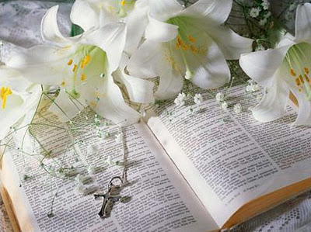
Lilies

481. The words, which Mary heard from the mouth of Her Son Jesus, served to make Her understand that His interior actions and prayers of His Soul was united with the Divinity; in order that by imitating them She might become like unto Him. This was one of the greatest blessings She received at the hands of Her Son, the true God and Man. The life of Jesus gave Her the means of copying His perfect life as faithfully as was possible to a mere man. At this time Mary felt the presence of the Holy Trinity, and She heard the voice of the God the Father saying: "This is My beloved Son, in whom I am greatly pleased and delighted". Mt (17:5). Our Lady answered "Eternal Father and exalted God, Lord and Creator of the universe, give Me your permission and blessing to receive in My arms the Savor of nations; and teach Me to fulfill as Your unworthy Mother and lowly slave, Your holy will". Immediately She heard a voice, which said: "Receive Your Only Son of God, imitate Him and rear Him; and remember, that You must sacrifice Him when I shall demand it of You".

The reader must realize that Mary was created with the emotions to oppose Her Son’s sacrifice. This gave Her the opportunity to practice obedience to the Father’s will.

Our Holy Mother answered: "Behold the creature of Your hands, beautify Me with Your grace so that Your Son and My God receive Me for His slave; and if You
will come to My help with Your power, I shall be faithful in His service; and count Myself as insignificant".
482. After this interchange of words, so full of deep emotions, the Child Jesus suspended the miracle of His transfiguration, or rather He began another miracle, that of suspending the effects of glory in His Body, confining His glory to His soul. He now assumed the appearance of one capable of suffering. In this form, His Mother now saw Him. Still remaining in a kneeling position and adoring Him with profound humility and reverence, She received the child Jesus in Her arms from the hands of the holy Angels. And when She saw Him in Her arms, She spoke to Him and said: "My sweetest Love and light of My eyes and the life of My soul, You have arrived in good hour into this world as the Sun of justice, in order to disperse the darkness of sin and death! Truly You are God, save Your servants and let all flesh see Him, who shall draw upon His salvation. Receive Me Your servant as Your slave and supply My deficiency, in order that I may properly serve You. Make Me such as You desire Me to be in Your service". Then Mary turned toward God the Father to offer up His only Son, saying: "Exalted Creator of all the Universe, here is the altar and the sacrifice acceptable in Your eyes". From this hour on, O Lord, look upon the human race with mercy. We have deserved Your anger, it is now time that You be soothed in Your Son and Mine. Let Your justice now come to rest, and let Your mercy be exalted; for on this account the Word has clothed itself in the likeness of sinful flesh and became a Brother of mortals and sinners.

^{﻿Rom 8:3} For God has done what the law, weakened by the flesh, could not do: sending His own Son in the likeness of sinful flesh and for sin, He (Jesus) condemned sin in the flesh,

^{﻿Phil 2:5} Have this mind among yourselves, which was in Christ Jesus, ﻿
^{2:6﻿} who, though He was in the form of God, did not count equality with God a thing to be grasped,
^{2:﻿7﻿} but emptied Himself, taking the form of a servant, being born in the likeness of men. ﻿
^{2:8﻿} And being found in human form He humbled Himself and became obedient unto death, even death on a Cross.

In the year 431 AD at the council of Chalcedon, approved by the Pope, they declared that Jesus is the fullness of God and Fully Man. Christ, being both Human and Divine, had 2 wills, Human and Divine.

His Human will desired all men to be saved and protected at their Final Tests, but the Divine will required men had to be tested and found worthy to receive eternal life. Thus the Human will of Jesus was opposed to the Divine Will. This created the opportunity for Jesus to be obedient. This fulfills the words above from Saint Paul, “became obedient unto death, even death on the Cross.” This will be explained deeper in other lessons.

In this title I (Mary) recognize them as brothers and I intercede for them from My inmost soul. You, Lord, have made Me the Mother of Your only Son without My merit, since this dignity is above all merit of a creature. But I partly owe to men the occasion of this supreme good fortune; since it is on their account that I am the Mother of the Word made Man and Redeemer of them all. I will not deny them My love, or delay My care and watchfulness for their salvation. Receive, immortal God, My wishes and petitions for that which is according to Your pleasure and good will".
483. Mary also turned toward all men and addressed them, saying: "Be consoled all who are afflicted and rejoice all who are depressed, rise all who have fallen, come to rest all who are agitated. Let the just be gladdened and the saints be rejoiced; let the Angels break out in new jubilee, let the Prophets and Patriarchs of limbo draw new hope.

Example of prophets are Elijah, Isaiah, Jeremiah, Ezekiel, Daniel and John the Baptist. Prophets foretell the events after death.

Example of Patriarchs are Abraham, Isaac, Jacob, Moses and David. (They represent fathers of the people.)

Mary continued by saying, "Let all the generations praise and honor the Lord, who renews His wonders. Come, come all who are poor in spirit; approach all who are little in your own sight, without fear, for in My arms I bear the Lion made a lamb, the Almighty, become weak, the Invincible subdued. Come to draw life, hurry to obtain salvation, approach to gain eternal rest, since I have all this for all, and it will be given to you freely and given to you without envy. Do not be slow and heavy of heart, all you sons of men".

Looking at Her Son Jesus, "O sweetest joy of My soul, give Me permission to receive from You that kiss desired by all creatures". The most blessed Mother applied Her most pure and heavenly lips to receive the loving affection of the divine Child, who on His part, as Her true Son, had desired them from Her.
484. Holding Him in Her arms She thus served as the altar and holy place, where the ten thousand Angels adored in visible human forms their Creator made Man. And as the most blessed Trinity assisted at the birth of the Word, heaven was as it were emptied of its inhabitants, for the whole heavenly court had brought itself to that blessed cave of Bethlehem and was adoring the Creator. And in their concert of praise the holy Angels sang the new song:

^{Lk 2:7﻿} And suddenly there was with the Angel a multitude of the heavenly host (army) praising God and saying, ﻿
^{2:14﻿} “Glory to God in the highest, and on earth peace among men with whom He is pleased!”

In sweetest harmony they repeated it, motionless in wonder at the new miracles at the prudence, grace, humility and beauty of that very young Maiden of fifteen years old, who had become the worthy Mother of the infant God.
485. It was now time to call saint Joseph, the faithful spouse of Mary. As I have said above (No. 472) Joseph was wrapped in great gladness, in which he was informed by divine revelation of all the mysteries of this sacred Birth that occurred during this night. But he should in his human senses be present and experience, adore and reverence the Word made flesh. For Joseph had been chosen to act as the faithful guardian of this blessed event. At the desire of the Mother of Jesus he came forth, on being awakened, the first sight of his eyes was the divine Child in the arms of the Virgin Mother. The infant Jesus was reclining against Her sacred face and breast. There Joseph adored Him in deepest humility and in tears of joy. He kissed the feet of Jesus in great joy and admiration which would have taken away and destroyed his life if divine power had not preserved his life. When saint Joseph had begun to adore the Child, the most prudent Mother asked leave of her Son to arise (for until then She had remained on her knees) and, while saint Joseph handed Her the child Jesus clothes, which She had brought, She clothed Him with great reverence, devotion and tenderness. Having thus swathed and clothed Him, his Mother, with heavenly wisdom, laid Him in the crib. For this purpose She had arranged some straw and hay upon a stone in order to prepare for the God-Man his first resting-place upon earth.

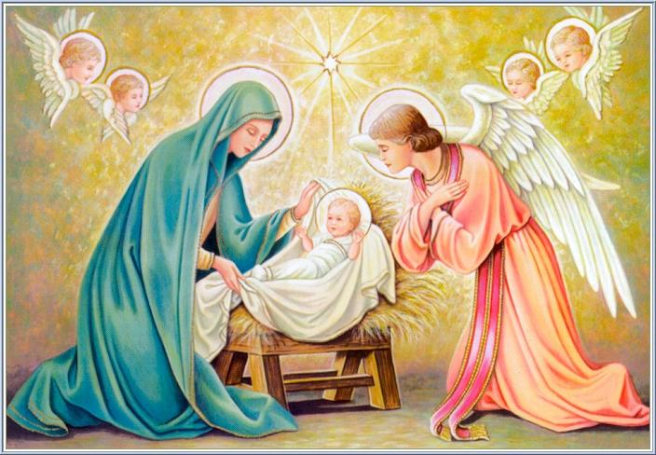

According to the God's plan an ox from the neighboring fields ran up in great haste and, entering the cave, joined the ass brought by Mary and Joseph. The blessed Mother commanded the animals to show reverence as far as their animal nature was possible. The animals obeyed Mary and prostrated themselves before the Child, warming Him with their breath and rendering Him the service refused by men. And thus the God made Man was placed between two animals, wrapped in swaddling-clothes and fulfilling the prophecy:

^{﻿Is 1:3﻿} The ox knows its owner, and the ass its master’s crib; but Israel does not know, My people does not understand.”

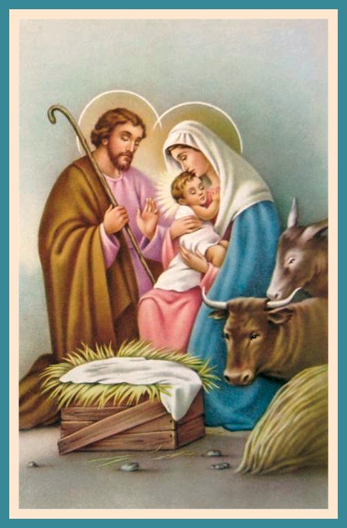

Words of Wisdom from the Blessed Virgin.

486. My daughter, if men would keep their heart disengaged and if they would rightly and worthily consider this great event of the Most High towards men, it would be a powerful means of leading them in the pathway of life and subjecting them to the love of their Creator and Redeemer. Men are capable of reasoning (soul), if they would only make use of their freedom to treat the Word become Man with the reverence due to its greatness. Who would be so hardened as not to be moved to tenderness at the sight of their God become man, humiliated in poverty, despised, unknown, entering the world in a cave, lying in a manger surrounded by beastly animals, protected only by a poverty-stricken Mother, and foster father? Who will dare to love the vanity and pride, which was openly hated and condemned by the Creator in His actions? Few there are who stop to consider this truth and example. On account of this disgusting ingratitude only the few will reap the fruit of these great events.
487. Ponder well how much you are bound to co-operate with this knowledge. I remind and encourage You to forget all that is of this earth. Seek nothing, or interact with nothing except what can help you to withdraw and detach yourself from the world and its people. With a heart freed from all earthly delights, you are free to celebrate in your life the beauty of the poverty, humility and divine love of the Word became Man. Learn from My example the reverence, fear and respect with which you must treat Him, remembering how I acted, when I held Him in My arms. Follow My example, whenever you receive Him in your heart in the sacrament of the holy Eucharist. This Sacrament contains the same God-Man, who was born of My womb. In this holy Sacrament you receive Him and posse Him as I possessed Him and conversed with Him.
488. I desire that you go even to extremes in this holy reverence and fear. And I wish that you take notice and be convinced, enter into your heart the words of Jesus, "Become like unto Me". His coming down from heaven, His being born in humility and poverty, His living and dying in humility and poverty, giving such rare example of the distaste of the world and its lies. All these things should be for you like living voices, which you must listen to and write into the interior of your heart. These privileges have all been granted to you in order that you carefully use this knowledge to their fullest extent. Understand how thankful you must be to My most holy Son and Lord. Strive to make a return for His goodness, as if He had come from heaven to redeem you alone and as if He had instituted all His doctrines in the holy Church for no one else but you.

Questions

1) The town of Bethlehem was filled with people because of the census. Mary and Joseph were unable to find a place to stay the night. Where did they go?

2) Where was saint Joseph and what was he doing when the child Jesus was born?

3) Holy Mary experience a most beautiful event before the birth of Jesus. What was this event?

4) Before the Mother of Jesus gave birth, She asked what in prayer?

5) When Mary the Mother of God gave birth to Her Son, She was _______ in the manger, Her eyes _____ to heaven, Her hands joined and ______ at Her breast.

6) What day and hour did Mary give birth to infant Jesus?

7) Jesus was born pure, without the protecting shield that surrounds other children. We must disconnect our ideas of Jesus and of His Mother Mary in any way related to any sin, _____ or actual. The imperfections of nature were not necessary or required for the Word of God to be truly ______ or to be ______ or to be our ______.

8) Although Mary could have lost Her virginity in child birth by Jesus passing in a natural manner without incurring any fault, yet the Holy Trinity chose to preserve the _______ of Holy Mary. Likewise the divine Child could have been born with this covering in which others are born; yet this was not necessary in order to be born a natural Son of the blessed Mother. It was degreed that the Word of God made Man should not be subject to all the laws of the sons of ______. His miraculous Birth would be exempt and free from all __________.

9) Jesus came forth glorious and transfigured in the same way as He appeared at His Transfiguration on Mount ______ in the presence of the Apostles. Matt (17:2)

10) What were the names of the Angels that assisted at the birth of Jesus?

11) The first spoken by the new born Jesus to His Mother were, "Mother, become _____ unto Me, since on this day of My human existence, which You have today given Me, I will exalt your life with grace and combine Your life to the likeness of Me, who am God and Man."

12) Jesus gave Mary the means of copying His perfect life as faithfully as was possible to a mere human in order that by imitating them She might become _____ unto Him.

13) Was the Mother of Jesus sitting, standing, or kneeling down when She received Jesus in Her arms?

14) Mary heard the voice of God the Father: "Receive Your Only Son of God, ______ Him and rear Him;

15) Name five men who are called Patriarchs.

16) How old was the Mother of Jesus?

