“The Death and Assumption of Mary into Heaven” (Mary of Agreda)

732. And now, as God has planned all things, the day had approached in which Mary would leave the earth. In the same way that Solomon placed the ark into the temple, the true and living Ark, the Virgin Mary, was to be placed in the temple of the heavenly Jerusalem. Her entrance into heaven would be with a greater glory and higher celebration than by Solomon placing the ark beneath the wings of the cherubim.

When king Solomon placed the ark into the Temple is to describe how the Mother of Jesus was to enter heaven.

^{﻿1 Kgs (1:1)﻿} Then Solomon assembled the elders of Israel and all the heads of the tribes, the leaders of the fathers’ houses of the people of Israel, before King Solomon in Jerusalem, to bring up the ark of the covenant of the Lord out of the city of David, which is Zion. ﻿
^{1:2﻿} And all the men of Israel assembled to King Solomon at the feast in the month Ethanim, which is the seventh month. (September-October)
^{1:﻿3﻿} And all the elders of Israel came, and the priests took up the ark. ﻿
^{1:4﻿} And they brought up the ark of the Lord, the tent of meeting, and all the holy vessels that were in the tent; the priests and the Levites brought them up.
^{1:﻿5﻿} And King Solomon and all the congregation of Israel, who had assembled before him, were with him before the ark, sacrificing so many sheep and oxen that they could not be counted or numbered. ﻿
^{1:6﻿} Then the priests brought the ark of the covenant of the Lord to its place, in the inner sanctuary of the house, in the most holy place, underneath the wings of the cherubim. ﻿
^{1:7﻿} For the cherubim spread out their wings over the place of the ark, so that the cherubim made a covering above the ark and its poles. ﻿
^{1:8﻿} And the poles were so long that the ends of the poles were seen from the holy place before the inner sanctuary; but they could not be seen from outside; and they are there to this day.
^{1:﻿9﻿} There was nothing in the ark except the two tables of stone which Moses put there at Horeb, where the Lord made a covenant with the people of Israel, when they came out of the land of Egypt.
^{1:﻿10﻿} And when the priests came out of the holy place, a cloud filled the house of the Lord, ﻿
^{1:11﻿} so that the priests could not stand to minister because of the cloud; for the glory of the Lord filled the house of the Lord.

1) “Ark of the LORD” is described in the Book of Exodus, and it was covered on all sides with gold. Inside the ark, when it was placed in Solomon's temple, there were two tablets that contain the Ten Commandments. Heb (9:4)

  - The two tablets symbolize Christ and His Mother. They are the two witnesses of the Law. During their lives they fulfilled the Law by placing the Law into action.
  - Covenant means promise or contract.

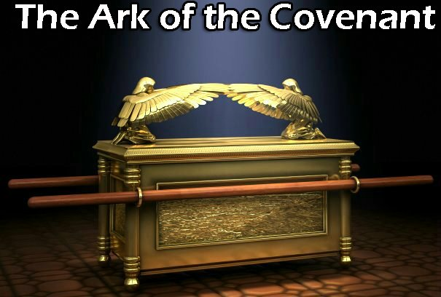

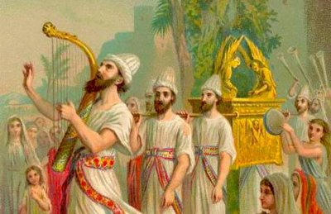

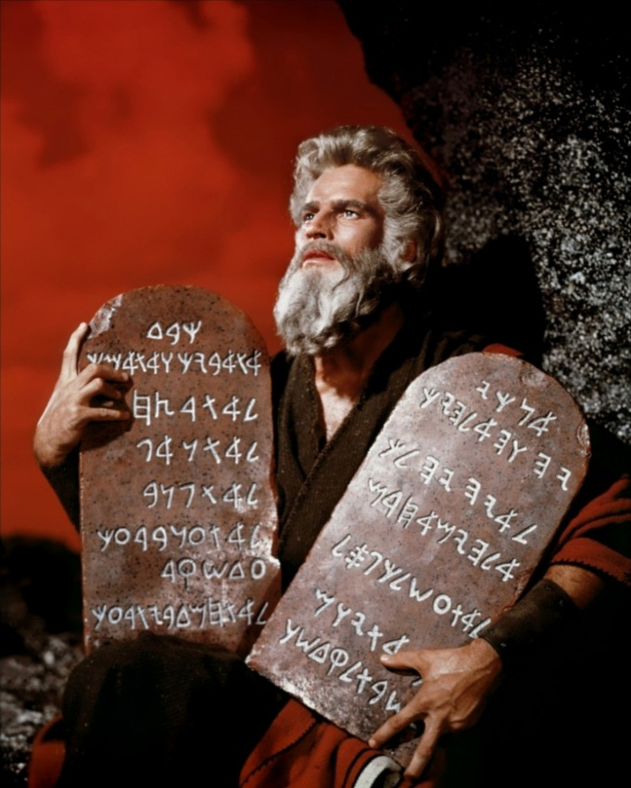

The Ten Commandments given to Moses from God.

regarded the Samaritans as a people foreign to themselves, in spite of an obviously shared heritage of Jacob as their

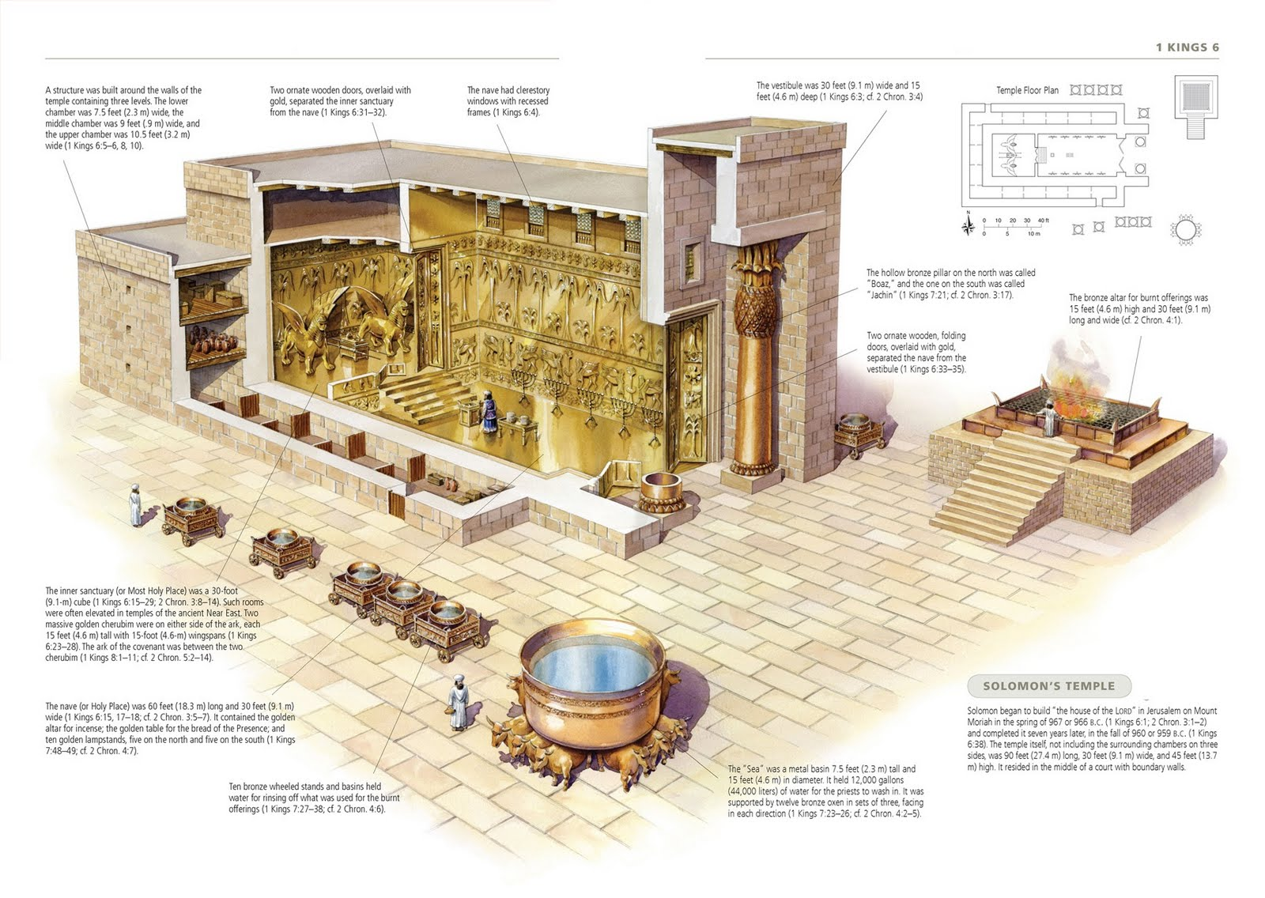

For larger picture of Solomon’s Temple go to
http://www.4kingdoms.com/Solomon-Temple.html

The interior of Solomon's Temple.

Very helpful is a DVD on Solomon's Temple. Can be found by a simple search on internet. AnimMan Studios www.animmanstudios.com

Three days before the happy death of Mary, the Apostles and disciples were gathered in Jerusalem and in the Cenacle. (Cenacle was the home where the Last Supper occurred.) The first one to arrive was saint Peter, who was transported from Rome by the hands of an Angel. In Rome the Angel appeared to him and told him that the passing away of the most blessed Mary was near and that Jesus required him to go to Jerusalem. Thereupon the Angel took him up and brought him from Italy to the Cenacle.

The Mother of Jesus had retired, somewhat weakened in body by the force of Her most perfect love; for since She was so near to Her end, She was subjected more completely to love's effects.
733. The great Lady came to the entrance of Her room in order to receive Peter. Peter was the head of the Church who was given the keys from Christ our Savior. Mt (16:19) Kneeling at His feet She asked Peter's blessing and Mary said: "I give thanks and praise to the Almighty, that Jesus has brought you to Me, the holy Father of the Church, for assisting Me in the hour of My death". Then came saint Paul, to whom the Queen showed the same reverence and pleasure at seeing him. The Apostles addressed Her as the Mother of God, as their Queen and as Mistress of all creation. But with a sorrow equal to their reverence, because they knew that they had come to witness Her death. After these Peter and Paul came the other Apostles and disciples.

Three days later, they all again assembled in the Cenacle. The heavenly Mother received them all with deepest humility, reverence and love, asking each one to bless Her. All of them complied, and addressed Her with greatest reverence.
734. Some of Apostles had been informed by the Angels of the purpose of their coming. They were seized with a tender grief and shed abundant tears at the thought of losing their only protection and comfort. Some of the Apostles were as yet ignorant of their approaching loss, especially the disciples, who had not been informed by the Angels, but were moved by interior inspirations to come to Jerusalem. All those who had not be informed immediately asked saint Peter, desirous of knowing the occasion of their meeting; for all of them were convinced, that if there had been no special occasion, Christ would not have urged them so strongly to come. The Apostle Peter, as the head of the Church, called them all together in order to tell them of the cause of their coming, and spoke to the assembly: "My dearest children and brethren, the Lord has called and brought us to Jerusalem from remote regions not without a cause that is most urgent and sorrowful to us. The Most High wishes now to raise up to the throne His most blessed Mother, our Queen, our comfort and protection. His Plan is that we all be present at Her most happy and glorious Transition from this life to glories of Heaven. When our Master and Redeemer Jesus ascended to the right hand of His Father, although He left us orphaned of His most delightful presence, we still possessed His most blessed Mother. As our glorious light Mary now leaves us, what shall we do? What help or hope have we to encourage us on our journey here on earth? I find none except the hope that we all shall follow Her in due time".
735. Saint Peter could speak no farther, because uncontrollable tears and sighs interrupted him. Neither could the rest of the Apostles answer for a long time, during which, amid numerous and tenderness tears, they released the groans of their inmost hearts. After some time Peter recovered himself and added: "My children, let us seek the presence of our Mother and Lady. Let us spend the time left of Her life in Her company and ask Her to bless us". They all went to the room of the great Queen and found Her kneeling upon a couch, on which She used to recline for short rests. They saw Her full of beauty and celestial light, surrounded by the thousand Angels of Her guard.
736. The natural condition and appearance of Her sacred and virginal Body were the same as when She was thirty-third year. For, as I have already stated, from age 33 onward, Her Body experienced no change. It was not affected by the passing years, showing no signs of age, no wrinkles in Her face or body, nor giving signs of weakening or fading, as in other children of Adam, who gradually fall away and drop from the natural perfection of early man or womanhood. This unchangeableness was the privilege of the most blessed Mary alone. This harmonizes with the stability of Her purest soul, because it was the natural consequence of Her freedom from the sin of Adam. The effects of original sin never touched Her sacred Body nor Her purest soul. The Apostles and disciples all of them preserving in extreme reverence in Her presence.

Saint Peter and saint John placed themselves at the head of the couch. The great Lady looked upon them all with Her accustomed modesty and reverence and spoke to them as follows: "My dearest children, give permission to your Servant to speak in your presence and to disclose My humble desires". Apostle Peter answered that all listened with attention and would obey Her in all things. Peter begged Mary to seat Herself upon the couch, while speaking to them. It seemed to saint Peter that She was exhausted from kneeling so long and that She had taken that kneeling position in order to pray to the Lord, and that in speaking to them, it was proper She should be seated as their Queen.
737. But She, who was the Teacher of humility and obedience practiced both when She answered that She would obey by asking of them their blessing, and ask them to allow Her the joy to continue to kneel. With the permission of saint Peter She left the couch and, kneeling before the Apostle, said to him: "My lord, I ask you, as head of the holy Church, to give Me your blessing in your own name and as head of the Church. Pardon Me your Servant for the smallness of the service I have rendered in My life. Grant that John dispose of My clothing, the two tunics, giving them to the two poor maidens, who have always helped Me by their charity". She then prostrated Herself and kissed the feet of saint Peter as head of the Church. (Peter holds the keys given to him by Christ.) By Her abundant tears caused admiration and tears in Peter and of all the bystanders. From saint Peter, Mary went to saint John, and kneeling likewise at his feet and said: "Pardon, My son and My master, by not having fulfilled toward you the duties of a Mother as I ought and as the Lord had commanded Me, when from the Cross He appointed you as My son and Me as your Mother. Jn (19:27) I humbly and from My heart thank you for the kindness which you have shown Me as a son. Give Me your blessing for entering into the company of Him who created Me".
738. The sweetest Mother proceeded in speaking to each of the Apostles in particular and to some of the disciples; and then to all the assembly together; for there were a great number. She rose to Her feet and addressed them all, saying: "Dearest children and My masters, always have I kept you in My soul and written you in My heart. I have loved you with that tender love and charity, which was given to Me by My divine Son. In obedience to His holy and eternal will, I now go to the eternal mansions, where I promise you as a Mother I will look upon you by the clearest light of the Divinity. I entrust unto you My Mother, the Catholic Church, the glorification of the name of the Most High, the spread of the new law of grace, the honor and adoration of the words of My divine Son, the memory of His Passion and Death, the practice of His doctrine. My children, love the Church, and love one another with that bond of charity, which your Master has always instructed you.

^{﻿Jn 13:34﻿} A new commandment I give to you, that you love one another; even as I have loved you, that you also love one another. ﻿
^{13:35﻿} By this all men will know that you are My disciples, if you have love for one another.”

Mary continued by saying, "To you, Peter, holy Father of the Church, I give My son John and all the rest".

Brothers, the word Pope to describe the head of the Catholic Church comes from the Latin word "papa" which means father.

739. The words of the most blessed Mary, like arrows of a divine fire, penetrated the hearts of all the Apostles and hearers. And as She ceased speaking, all of them were dissolved in streams of tears and seized with incurable sorrow, cast themselves upon the ground with sighs and groans. All of them wept, and with them wept also the sweetest Mary, who could not resist this bitter and well-founded sorrow of Her children. After some time She spoke to them again, and asked them to pray with Her and for Her in silence, which they did. During this quietness Jesus descended from heaven on a throne of incredible glory, accompanied by all the saints and countless Angels, and the house of the Cenacle was filled with the glory of heaven. The most blessed Mary adored Her Son and kissed His feet. Prostrated before Him She made the last and most profound act of faith and humility in Her life upon the earth. On this occasion the most pure Mary, the Queen of the heavens, shrank within Herself and lowered Herself to the earth more deeply than all men together. Her divine Son gave Her His blessing and in the presence of all in heaven spoke to Her these words: "Dearest Mother, whom I have chosen for My dwelling place, the hour is come in which You are to pass from the world into the glory of My Father and Mine, where You shall possess the throne prepared for You at My right hand and enjoy it through all eternity. And since, by My power and as My Mother, I have caused You to enter the world free and exempt from sin, therefore also death shall have no right or permission to touch You at Your exit from this world. If You wish not to pass through it, come with Me now to partake of My glory, which You have merited".
740. The most prudent Mother prostrated Herself at the feet of Her Son and with a joyous face answered: "My Son and My Lord, I ask You let Your Mother and Your Servant enter into eternal life by the common way of natural death, like the other children of Adam. You, who are My true God, has suffered death without being obliged to do so. It is proper that, as I have followed You in life, so I follow You also in death". Christ the Savior approved of the decision and the sacrifice of His most blessed Mother, and agreed to its fulfillment. Then all the Angels began to sing in heavenly harmony some of the verses of the Songs of Solomon and other new ones. (Song of Solomon is one of the Books in the Old Testament.) Although only saint John and some of the Apostles were enlightened as to the presence of Christ the Savior, yet the others felt in their interior its divine and powerful effects. But the music was heard as well by the Apostles and disciples, as by many others of the faithful there present. A divine fragrance also spread about, which penetrated even to the street. The house of the Cenacle was filled with a wonderful brilliance of light, visible to all, and the Lord allowed that many people of Jerusalem gathered in the streets as witnesses to this new miracle.
741. When the Angels began their music, the most blessed Mary laid back upon Her couch or bed. Her tunic was folded about Her sacred body, Her hands were joined and Her eyes fixed upon Her divine Son, and She was entirely inflamed with the fire of divine love. And as the Angels sang these verses of the second chapter of the Song of Songs:

^{﻿﻿Sgs 2:9} My beloved speaks and says to me: “Arise, my love, my fair one, and come away; ﻿
^{2:11﻿} for lo, the winter is past, the rain is over and gone. ﻿
^{2:12﻿} The flowers appear on the earth, the time of singing has come, and the voice of the turtledove is heard in our land. ﻿
^{2:13﻿} The fig tree puts forth its figs, and the vines are in blossom; they give forth fragrance. Arise, my love, my fair one,
and come away.

Then She closed Her virginal eyes and expired. The sickness which took away Her life was love, without any other weakness or accidental intervention of whatever kind. She died at the moment when the divine power suspended the assistance, which until then had counteracted the passions of Her burning love of God. As soon as this miraculous assistance was withdrawn, the fire of Her love consumed the life of Her heart and thus caused the end of Her earthly existence.
742. Then the most pure Soul passed from Her virginal Body to be placed in boundless glory, on the throne at the right hand of Her divine Son. Immediately the music of the Angels seemed to withdraw to the upper air; for the whole procession of Angels and saints accompanied the King and Queen to the heavens.

The sacred Body of the most blessed Mary, which had been the temple of Jesus in life, continued to shine with an brilliant light and breathed forth such a wonderful and unheard of fragrance, that all the bystanders were filled with interior and exterior sweetness. The thousand Angels of Her guard remained to watch over the treasure of Her virginal Body. The Apostles and disciples, amid the tears and the joy of the wonders they had seen, were absorbed in admiration, and then sang many hymns and psalms in honor of the most blessed Mary now departed. This glorious Transition of the great Queen took place in the hour in which Her divine Son had died, at three o’clock on a Friday, the thirteenth day of August, she being seventy years of age, (70) less the twenty-six days intervening between the thirteenth of August, on which She died, and the eighth of September, the day of Her birth. The heavenly Mother had lived twenty-one (21) years, four months and nineteen days after the death of Jesus.

1) Mary was 70 years old when She died.
2) Her death was on August 13.
3) Mary lived 21 years, 4 months and 19 days after Jesus died.
4) Mary was born September 8 and Her Immaculate Conception which means when Her Soul was created and placed in Her Body was December 8.
5) Mary was 15 years old, 3 months and 17 days when Jesus was born.
6) Jesus lived 33 years, 3 months.
7) Mary was 48 years old, 6 months and 17 days when Jesus was crucified.

743. Great wonders happened at the precious death of the Queen; for the sun was eclipsed and its light was hidden in sorrow for some hours. Many birds of different kinds gathered around the Cenacle, and by their sorrowful clamors and groans caused the bystanders themselves to weep. All Jerusalem was in commotion, and many astonished residents gathered confessing loudly the power of God and the greatness of His works. Others were astounded and as if beside themselves. The Apostles and disciples with others of the faithful broke forth in tears and sighs. Many sick persons came, all were cured. The souls in purgatory were released. But the greatest miracle was that three persons, a man in Jerusalem and two women living in the immediate neighborhood of the Cenacle, died unremorseful of their sins and were subject to eternal damnation; but when their cause came before the court of Christ, His sweetest Mother interceded for them and they were restored to life. They so mended their conduct, that afterwards they gained grace and were saved. This privilege was not extended to others that died on that day in the world, but was restricted to those three who happened to die in that hour in Jerusalem.

INSTRUCTION WHICH THE GREAT QUEEN OF HEAVEN,
MOST HOLY MARY, GAVE ME.

744. My daughter, besides what you have understood and written of My glorious Transition, I wish to inform you of another privilege, which was conceded to Me by My divine Son in that hour. You have already recorded, that the Lord offered Me the choice of entering into heaven either with or without passing through the doorway of death. If I had preferred not to die, the Most High would have conceded this favor, because sin had no part in Me, and hence also not its punishment, which is death. Thus it would also would have happened for My divine Son, and with a greater right, if He had not taken upon Himself the satisfaction of the justice for men through His Passion and Death. Hence I chose death freely in order to imitate and follow Him, as also I did during His sorrowful passion. Since I had seen My Son and true God die, I would not have satisfied the love I owe Him, if I had refused death, and I would have left a great gap in My conformity to and My imitation of my Lord God and Man. He wished Me to bear a great likeness to Him in His most sacred Humanity. As I would thereafter never be able to make up for such a defect, My soul would not enjoy the highest delight if I failed to die as did My Lord and God.
745. Hence My choosing to die was so pleasing to Him, He immediately conceded to Me a singular favor for the benefit of the children of the Church and agreeable to My wishes. It was this, that all those devoted to Me, who should call upon Me at the hour of death, allowing Me as their Advocate in memory of My happy Transition and of My desiring to imitate Him in death, shall be under My special protection in that hour, shall have Me as a defense against the demons, as a help and protection, and shall be presented by Me before the court of His mercy and there experience My intercession. In consequence the Lord gave Me a new power and appointment. He promised to give great helps of His grace for a good death and for a cleaner life on all those who in veneration of this mystery of My precious death, should invoke My aid. Hence I desire you, My beloved daughter, from this day on to keep in your inmost heart a devout and loving memory of this mystery, and to bless, praise, and magnify God, because He gave such sacred miracles for Me and for all men. By this watchfulness you will urge the Lord and Me to come to your aid in that last hour.
746. And since death follows upon life, therefore the sure pledge of a good death is a good life; a life in which the heart is freed and detached from earthly love. In that last hour sin oppresses the soul and which is like a heavy chain restraining its liberty and preventing it from rising above the things loved in this world.

O My daughter! How greatly do mortals don't understand this truth, and how far they error in their actions! The Lord gives them life in order that they may free themselves from the effects of original sin, so as to be unhampered by them at the hour of their death. The ignorant and miserable children of Adam spend all their life in loading upon themselves new burdens and chains, so that they die slaves of their passions and in the power of the devil. (Mary is speaking about Final Test.) I had no share in original sin and none of its effects had any power over My senses. Nevertheless I lived in the greatest constraint, in poverty and detached from earthly things, most perfect and holy. Consider then, My daughter, and be mindful of this living example. Free your heart more and more each day, so that with advancing years you may find yourself more free, more detached and removed from visible things, and so that when the Spouse shall call you to His wedding, you will not need to seek in vain the required freedom and prudence.

THE BURIAL OF THE SACRED BODY OF THE MOST BLESSED
MARY.

747. The Apostles, disciples and the other faithful were deeply oppressed with sorrow and grief caused by the passing away of the most blessed Mary. For they felt that their loss was impossible to regain, as the most sweet, loving great Queen had left them. But Jesus secretly gave them His encouragements and thus they set about the fitting burial of the sacred Body of His Mother.
748. The Apostles held a conference concerning Her burial. They selected for that purpose a new tomb, which had been prepared mysteriously by Her divine Son Jesus. They remembered how the deified Body of Jesus had been anointed with precious ointments and spices and wrapped in the sacred burial cloths. Jn (19:39) They thought not of doing otherwise with the virginal Body of His most holy Mother. Accordingly they called the two maidens who had assisted the Queen during Her life and who had been designated by Mary as inheritors of Her tunics. The Apostles instructed them to anoint the Body of the Mother of God with highest reverence and modesty and wrap it in the winding-sheets before it should be placed in the casket. With great reverence and fear the two maidens entered the room, where the Body of the blessed Lady lay upon its couch. But the bright light issuing from Her Body stopped and blinded them in such a manner that they could neither see nor touch the Body, nor even determine in what particular place it rested.
749. In fear and reverence the maidens left the room; and in great excitement and wonder they told the Apostles what had happened. Peter and John came to the conclusion, that this sacred Ark of the covenant (Mary) was not to be touched or handled in the common way. Then saint Peter and saint John entered into the room and also witnessed the bight light surrounding the Body of Mary. And at the same time they heard the heavenly music of the Angels who sang: "Mary, full of grace, the Lord is with You". Then another group of Angels would responded: "Virgin before childbirth, in childbirth and after childbirth". From that time on the faithful people would express their devotion toward the most blessed Mary in these same words of praise. These words have been handed down to the holy Catholic Church. The two Apostles, saint Peter and saint John were for a time lost in admiration at what they saw and heard of their Queen. In order to decide what to do, they sank on their knees, asking Jesus to make known His will. Then they heard a voice saying: "Let not the sacred Body be either uncovered or touched"
750. Having thus been informed of the will of God, they brought a bier. (A bier is a stand on which Her Body laid.) The brilliant light diminished somewhat and thus they approached the couch. With their own hands, with reverence, they took hold of the tunic at the two ends. Thus, without changing the posture of Mary, they raised the sacred Treasure and placed it on the bier in the same position as it had occupied on the couch. They could easily do this because of the miracle. Peter and John felt no more weight than that of the tunic. On this bier the brilliant light from the Body moderated still more. All of them for their comfort, by approval of Jesus, could now see and study the beauty of the face of Mary and of Her hands. As for the rest, God protected His heavenly dwelling, so that neither in life nor in death any one should behold any other part except what is common in ordinary conversation. Thus Her most inspiring face, by which She had been known, and Her hands, by which She had labored could be seen.
751. So great was the care for His most blessed Mother, that He used not this precaution in regard to His own Body, as that of the most pure Virgin. In Her Immaculate Conception, He made Her like to Himself. Likewise Mary's birth didn't take place in the common and natural manner of other men. In addition, Jesus preserved His Mother from impure temptations and thoughts. Jesus kept Her virginal Body entirely concealed. In fact the most pure Lady during Her life had asked Jesus that no one should be permitted to look upon it in death.

The Apostles made the decision to light many candles. The faithful in Jerusalem brought many candles to be lighted at the bier. A miracle happened that all the candles burned throughout that day and the two following days without any of the candles being consumed or wasted in any shape or manner.
752. By the power of God, Jesus inspired all the inhabitants of Jerusalem to be present at the burial of His most blessed Mother. There was scarcely any person in Jerusalem, even of the gentiles, who were not attracted by the novelty of Mary's burial. The Apostles took upon their shoulders the sacred Body, in an orderly procession from the Cenacle, and brought Her to the nearby valley of Josaphat.

But besides the Jerusalem's residents, many came from heaven too. The thousand Angels of the Queen accompanied the burial procession. These Angels were singing angelic songs, and they were heard by the Apostles and disciples and many others. They continued their songs for three days. In addition to these Angels many other Angels had descended from heaven, along with the Patriarchs and Prophets of the Old Testament. Among heaven's court came saint Joachim, saint Anne, (The parents of Mary.) saint Joseph, (The husband of Mary.) saint Elisabeth, (Mary's cousin and the Mother of John the Baptist.) John the Baptist and numerous other saints. All were sent by Jesus to assist at the burial of His most blessed Mother.
753. As Apostles carried along the sacred Body, great miracles occurred. In particular all the sick were entirely cured. Many of the possessed were freed from the demons. For the evil spirits did not dare to wait until the sacred Body came near the persons thus afflicted. Greater still were the miracles of conversions wrought among many Jews and gentiles, for on this occasion were opened up the treasures of divine mercy, so that many souls came to the knowledge of Christ our Savior. Thus they loudly confessed Him as the true God and Redeemer, demanding Baptism. Many days thereafter the Apostles and disciples labored in catechizing and baptizing those, who on that day had been converted to the holy faith. The Apostles in carrying the sacred Body felt wonderful effects of divine light and peace, and so did the disciples. The people were seized with astonishment at the fragrance all about, the sweet music and the other signs. They proclaimed God great and powerful in the creation of Mary the Mother of Jesus. In their testimony, they struck their breasts in sorrow and contrition.
754. When the procession came to the holy grave in the valley of Josaphat, the same two Apostles, saint Peter and saint John, who had laid the holy Treasure from the couch onto the bier, with joyful reverence placed Her in the tomb and covered Her Body with a linen cloth. The hands of the Angels performing more of these last rites than the hands of the Apostles. They closed up the tomb with a large stone, according to custom at other burials. The holy Angels returned to heaven, while the thousand Angels of the Queen continued their watch, guarding the sacred Body and continued the music. As the gathering of the people lessened, the holy Apostles and disciples in intender tears returned to the Cenacle. During the next year a beautiful fragrance that had been emitted by the Body of the Queen was noticeable throughout the Cenacle, and in Her personal room. The Cenacle remained a place of refuge for all those that were burdened with labor and difficulties; all found miraculous assistance. Miracles continued for years in the Cenacle, but the sins of Jerusalem caused the Cenacle to be destroyed. (In the year 70 AD the Roman Empire destroyed the Temple and Jerusalem.)
755. Having again gathered in the Cenacle, the Apostles came to the conclusion that they would post men to watch the tomb of their Queen. Others would attend to the affairs of the Church in the instruction and baptizing the new converts. Saint Peter and saint John, how ever, were more zealous in their attendance at the tomb, coming only a few times to the Cenacle and immediately returning to where was laid the treasure of their heart. Nor were the animals missing at the tomb. Innumerable large and small birds gathered in the air, and many animals and wild beasts rushed from the mountains toward the tomb. The birds singing sorrowfully and the other animals making groans. All of the animals showing grief in their movements. Only a few unbelieving Jews, more hardened than the rocks, failed to show sorrow at the death of their Co-Redeemer, (Mary) as they had failed to do also at the death of Jesus.

INSTRUCTION WHICH THE QUEEN OF HEAVEN, MOST HOLY
MARY, GAVE ME.

756. My daughter, in honoring My natural death and My burial, I wish that you also die and be buried to all worldly things. Giving up the world is your fruit (reward) and the principal result of your having known and written My life. Many times in the course of your writings I have shown this as My desire and as My will, lest you waste this singular favor shown to you by Jesus and by Me. It is a great offense in any Christian, if, after dying to sin and after being reborn in Christ by Baptism, knowing that the Lord died for him, he returns again to the same sins. And this will be a still greater wickedness in those souls, who are called by special grace to be the most dear friends of the Lord.
757. In these souls their sins cause horror in heaven itself, because the pride, the presumption, the lack of humility, the lack of mortification, the anger, the love of worldly things, the conscious impurities and other wickedness in such souls force the Lord and the saints to withdraw from their sight. Therefore God rejects many who sin that carry the name of religious and leaves them to their own bad counsels, because they have so disloyally broken the faithfulness promised to God and to Me in their vocation. But all souls must fear this terrible unfaithfulness. Consider well, My daughter, what abomination (source of disgust.) in the sight of God, if you were guilty of such disloyalty. It is time that you die to the visible things, and that your life be buried in your self-knowledge and self-abasement, while your soul sinks into the presence of God. The days of your life in this world are coming to a close; and I shall be the judge to execute the sentence when you separate from life and from the world. I have pleaded many times how the writings of My life should be your seal to die too the world. I remind you how you have agreed with Me and promised repeatedly with heartfelt tears that you will comply.
758. I wish your dieing to the world to be the proof of My doctrine and of its effectiveness. Do not permit this Book to be discredited in you to My dishonor, but let heaven and earth see the force of its truth and of My example in your works. Do not depend upon your understanding or upon your will, and still less upon your desires and passions, because My life is now your example. Your law must be the will of God and My own, and let obedience be your guide. And in order that you may never mistake the most holy, the most perfect and God-pleasing way, Jesus has provided direction, lavishing upon you His own care, and My care. Do not cite ignorance, coward ness, or weakness, nor fear. Weigh your obligation, estimate your debt, attend to the light; operate with the grace you receive, so that among all these benefits there be no cross so heavy, no death so bitter that you can't handle. All trials should seem to you as light and acceptable. In trials you have the opportunity to practice good, and in trials should be your delight. If you do not succeed in dying to all things, you shall not reach the perfection God desires, nor the state to which My Son Jesus calls you.
759. If the world will not forget you, you forget it. If it will not leave you alone, remember that you have left it, and that I have separated you from the world. If the world follows you, fly. If the world praise you, despise it. If the world condemns you, suffer. And if the world seeks you, let it not find you except in so far as it will allow you to practice charity. But as regards all the rest, you must not keep the world in your mind. Be like the living who never remembers the dead. I desire that you have no more conversation with this world, than the dead have with the living. I have repeated so often this doctrine to you, throughout the writing of this Book, thus ponder how important it is to practice it. Consider, my dearest, what persecutions the devil has roused against you. Remember how great is the treasure which you carry in a fragile vessel, and that all hell plots and rises up against you. You live in mortal flesh, surrounded and attacked by cleaver enemies. Be a Spouse of Christ, My divine Son, and I shall be you Mother and Teacher. Recognize, then, your need and your weakness, and correspond with Me as a dearest daughter, as an obedient and perfect disciple in all things.

THE SOUL OF THE MOST HOLY MARY ENTERS THE HIGHEST HEAVEN

760. In describing the glory and happiness of the saints in the presence of God in heaven saint Paul and the prophet Isaiah say: that neither have mortal eyes seen, nor ears heard, nor can it enter into the heart of man what God has prepared for those who love Him and who hope in Him.

^{﻿1 Cor 2:71﻿} But we impart a secret and hidden wisdom of God, which God decreed before the ages for our glorification. ﻿
^{2:8﻿} None of the rulers of this age understood this; for if they had, they would not have crucified the Lord of glory. ﻿
^{2:9﻿} But, as it is written, “What no eye has seen, nor ear heard, nor the heart of man conceived, what God has prepared for those who love Him,”

^{﻿Is 64:4} From of old no one has heard or perceived by the ear, no eye has seen a God besides You, who works for those who wait for Him.

In accordance with this Catholic truth, saint Augustine, (Born 354, died 430) the great light of the Church, that, in setting out to write a book on the glory of the blessed, he was visited by his friend, saint Jerome, (Born 347, died 420) who had just died and entered into his glory. Jerome came to reprimand Augustine, because Augustine was attempting to write about heaven. Saint Jerome came to inform Augustine that no tongue or pen of man could describe the least part of the blessings enjoyed by the saints in heaven. Even though our intellect may grow with graces from God, it will never comprehend eternity; and since heaven is infinite and boundless, it is never ending and impossible for our minds to understand. Just as God created all things without being exhausted, and even if He had created numerous worlds over and over again, God would remain still infinite. Although seen and enjoyed by countless saints, God will remain an infinite source of new knowledge and love. For in creation and in glory all souls participate in Him only to a limited extent, each according to its condition, while He in Himself is without limitation or end.
761. The glory of the least saint is not capable of being expressed in words, what shall we say of the glory of the most blessed Mary. Among the saints, She is the most holy and She by Herself is more like to Her Son than all the saints together. This truth can and should be believed; but in mortal life it cannot be understood, or the least part of it be explained properly. For the deficiency of our words and expressions tend to hide than to set forth its greatness. Let us in this life apply our labor, not in seeking to comprehend it, but in seeking to merit to see Her glory in heaven. We shall experience more or less of heaven and its happiness according to our works.
762. Our Redeemer Jesus entered heaven leading the purest soul of His Mother at His right hand. She alone of all the mortals deserved exemption from particular judgment. Because She had no sin, She had no judgment. No account was asked or demanded of Her for what She had received. For such was the promise that had been given to Her, when She was exempted from the common guilt and chosen as the Queen privileged above the laws of the children of Adam.

Brothers, every man must give an account of his actions. The parable below illustrates this point.

^{﻿﻿Mt 25:14:} “For it will be as when a man going on a journey called his servants and entrusted to them his property; ﻿
^{25:15﻿} to one he gave five talents, to another two, to another one, to each according to his ability. Then he went away. ﻿
^{25:16﻿} He who had received the five talents went at once and traded with them; and he made five talents more.
^{25:﻿17﻿} So also, he who had the two talents made two talents more.
^{25:﻿18﻿} But he who had received the one talent went and dug in the ground and hid his master’s money. ﻿
^{25:19﻿} Now after a long time the master of those servants came and settled accounts with them. ﻿
^{25:20﻿} And he who had received the five talents came forward, bringing five talents more, saying, ‘Master, you delivered to me five talents; here I have made five talents more.’ ﻿
^{25:21﻿} His master said to him, ‘Well done, good and faithful servant; you have been faithful over a little, I will set you over much; enter into the joy of your master.’ ^{﻿25:22﻿} And he also who had the two talents came forward, saying, ‘Master, you delivered to me two talents; here I have made two talents more.’
^{25:﻿23﻿} His master said to him, ‘Well done, good and faithful servant; you have been faithful over a little, I will set you over much; enter into the joy of your master.’ ^{﻿25:24﻿} He also who had received the one talent came forward, saying, ‘Master, I knew you to be a hard man, reaping where you did not sow, and gathering where you did not winnow;
^{25:﻿25﻿} so I was afraid, and I went and hid your talent in the ground. Here you have what is yours.’
^{25:﻿26﻿} But his master answered him, ‘You wicked and slothful servant! You knew that I reap where I have not sowed, and gather where I have not winnowed?
^{25:﻿27﻿} Then you ought to have invested my money with the bankers, and at my coming I should have received what was my own with interest. ﻿
^{25:28﻿} So take the talent from him, and give it to him who has the ten talents. ﻿
^{25:29﻿} For to every one who has will more be given, and he will have abundance; but from him who has not, even what he has will be taken away. ﻿
^{25:30﻿} And cast the worthless servant into the outer darkness; there men will weep and gnash their teeth.’

Instead of Mary being judged with the rest, She shall be seated at the right hand of the Judge to judge with Him all His people. In the first instant of Her Conception She was the brightest Saint. With the rays of the sun of the Divinity, Mary was beyond all the brightness of the most exalted seraphim. In Her entrance into heaven, She was still further illumined by the presence of the Word, who obtained His humanity from Her. It follows that She should be His Companion for all eternity, possessing such a likeness to Him, that none greater can be possible between God and a soul. The Redeemer Himself (Jesus) presented Her before the throne of the Divinity. Speaking to the eternal Father in the presence of all the blessed, who were overcome with emotion at this wonder. Jesus said these words. "Eternal Father, My most beloved Mother, Your beloved Daughter and the cherished Spouse of the Holy Spirit, now comes to take possession of the crown and glory, which We have prepared as a reward for Her merit. She is the one who was born as the rose among thorns, untouched, pure and beautiful.

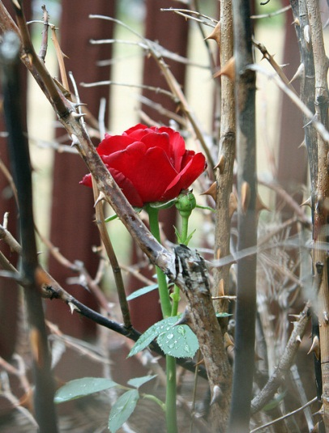

She is worthy of being embraced by Us and of being placed upon a throne to which none of our creation can ever attain, and to which those conceived in sin cannot accomplish. This is Our chosen and Our only One, distinguished above all else, to whom We shared Our grace and Our perfections beyond the measure given to other souls. In Her We have deposited the treasure of our Divinity and its gifts. She most faithfully preserved and made fruitful the talents which were given to Her. She never deviated from our will, and She found grace and pleasure in Our eyes. It is right that My Mother be given the reward. During Her whole life and in all Her works She was as like to Me as is possible for a soul to be. Let Her also be as like to Me in glory and on the throne of our Majesty, so that where holiness is found, there it may also be found in its highest participation".
763. This decree of the Word who became Man was approved by the Father and the Holy Spirit. The most holy Soul of Mary was immediately raised to the right hand of Her Son and true God, and placed on the royal throne of the most holy Trinity, which neither men, nor Angels nor the seraphim themselves attain, and will not attain for all eternity. This is the most exalted privilege of Our Queen and Lady, that She is seated on the throne with the Three Divine Persons and holds Her place as Queen, while all the rest are set as servants and ministers to the highest King. She enjoys above all and more than all the infinite God, which the other blessed enjoy in an endless variety of degrees. She knows, penetrates and understands much deeper the eternal Being and God's infinite characteristics. She lovingly delights in God's mysteries and His most hidden secrets, more than all the rest of the blessed. But it also must be understood that between the glory of the divine Persons and that of the most holy Mary there is an infinite distance. As Saint Paul says God is inaccessible and in Him alone dwells immortality and glory by His own self.

^{﻿Tim 6:14﻿} I charge you to keep the commandment unstained and free from reproach until the appearing of our Lord Jesus Christ; ﻿
^{6:15﻿} and this will be shown at the proper time by the blessed and only Sovereign, the King of kings and Lord of lords, ﻿
^{6:16﻿} who alone has immortality and dwells in unapproachable light, whom no man has ever seen or can see. To Him be honor and eternal dominion. Amen.

The most holy soul of Christ without measure exceeds in His gifts compared to those of His Mother; yet the great Queen surpasses all the saints in glory. She has a likeness to that of Christ, which cannot be understood in this life.
764. It's hard to explain the extra joy which the habitants of heaven experienced in celebrating the glory of His Daughter, Mother and Spouse. For in Her He had lifted up all the works of His powerful right hand. The Trinity couldn't come to new glory, because He possesses infinite glory throughout all eternity. Yet the exterior showings of God's pleasure and satisfaction at the fulfillment of His Plans were greater on that day. From the throne God, the Father responded, saying: "In the glory of Our beloved and most loving Daughter, the pleasure of Our holy will is fulfilled to Our entire satisfaction. To all the souls We have given existence, creating them out of nothing, in order that they may participate in our infinite goods. Our cherished Daughter alone had no part in the disobedience or deviated from the truth, and She has earned what the unworthy children of hell have despised. Our heart has not been disappointed in Her at any time or moment. To Her belong the rewards We had prepared for the disobedient angels and for their followers among men. She has repaid Us for their falling away by Her humility and obedience. She has pleased Us in all Her operations and has merited a seat on the throne of our Majesty".
765. On the third day after the most pure soul of Mary had taken possession of Her glory never to leave it, the Lord revealed to heaven's habitants His divine will, that She should return to the world and restore Her sacred Body and unite Herself with it. This occurred so She might in Body and Soul be again raised to the right hand of Her divine Son without waiting for the general resurrection of the dead. The appropriateness of this favor belongs with the others received by the most blessed Queen because of Her likeness to Her Son.

When the time for this wonder had arrived, Christ our Savior descended from heaven bringing with Him at His right hand the Soul of His most blessed Mother and accompanied by many legions of Angels, the Patriarchs and ancient Prophets. They came to the tomb in the valley of Josaphat, and all being gathered in sight of the Body of Mary, the Lord spoke the following words to the saints.
766. "My Mother was conceived without stain of sin, in order that from Her virginal Body I might purely clothe Myself in the humanity in which I came to the world and redeemed it from sin. My flesh is Her flesh. She co-operated with Me in the works of the Redemption thus I must raise Her. Just as I rose from the dead, She will be raised at the same time and hour. For I wish to make Her like Me in all things. "All the ancient saints of the human race then gave thanks for this new favor in songs of praise and glory to the Lord. Those that especially distinguished themselves in their thanks were our first parents Adam and Eve, saint Anne, saint Joachim and saint Joseph. Then the purest soul of the Queen, at the command of the Lord, entered the virginal Body, restored it and raised it up, giving it a new life of immortality and glory and communicating to it the four gifts of clearness, impassibility, agility and subtlety, corresponding to those of the soul and overflowing from it into the Body.

1) Clearness- unhampered by restriction.
2) Impassibility- incapable of suffering or of experiencing pain.
3) Agility- moving with easy movement.
4) Subtlety- keen insight and ability to penetrate deeply.

767. Endowed with these gifts the most blessed Mary issued from the tomb in Body and Soul, without raising the stone cover and without disturbing the position of the tunic and the mantle that had covered Her sacred Body. Since it is impossible to describe Her beauty and glory, I will not make the attempt. It is sufficient to say, that just as the heavenly Mother had given to Her divine Son the form of Man, pure, unstained and sinless, for the Redemption of the world, so in return the Lord, in this resurrection gave to Her a glory and beauty similar to His own.
768. Then from the tomb was started a most reverent procession, accompanied by heavenly music, the procession went to heaven. This happened in the hour immediately after midnight, in which also the Lord had risen from the grave. (At 12:01 AM, August 15.) Not all of the Apostles were witness of this miracle, but only some of them who were present and watching at the tomb. The saints and Angels entered heaven in the order in which they had come down from heaven. And in last place came Christ our Savior and at His right hand the Queen, clothed in the gold, and so beautiful that She was the admiration of all in heaven. All heaven's inhabitants turned toward Her to look upon Her and bless Her with new joy and songs of praise. Thus were heard the words by Solomon: "Come, daughters of Zion, to see your Queen, who is praised by the morning stars and celebrated by the sons of the Most High. Who is She that comes from the desert, like a column of all the aromatic perfumes? Who is She, that rises like the daybreak, more beautiful than the moon, elect as the sun, formidable as many razor sharp armies? Who is She that comes up from the desert resting upon Her Beloved and spreading forth abundant delights? Who is She in whom the Deity itself finds so much pleasure and delight above all other creatures and whom He exalts above them all in the heavens! O novelty worthy of the infinite Wisdom! O miracle of His Greatness, which so magnifies and exalts Her!

^{﻿Sg 3:5﻿} I charge you, O daughters of Jerusalem, by the gazelles or the hinds of the field, do not rouse, do not wake my beloved before she pleases.
^{﻿﻿3:6} Who is that coming up from the wilderness, like a column of smoke, carrying with myrrh and frankincense, with every exotic powders (spices and perfumes) of the merchant?
^{3:7﻿} Behold, it is the litter of Solomon! (A covered and curtained couch used for carrying a single passenger.) About it are sixty mighty men the warriors of Israel,
^{3:﻿8﻿} all wearing with swords and expert in war, each with his sword at his thigh, against in the watches of the night.

^{﻿﻿Sg 6:9} My dove, My perfect one, is only one, She is the darling of her mother, flawless to her that gave birth to her. The maidens saw her and called her happy; the queens and concubines also, and they praised her.
^{6:10﻿} “Who is this that looks forth like the dawn, fair as the moon, bright as the sun, formidable as an army with banners?”

^{﻿Sg 8:5﻿} Who is that coming up from the wilderness, leaning upon her beloved? Under the apple tree I awakened you, where your mother conceived you, where she who bore you conceived you.

769. Amid this glory the most blessed Mary arrived Body and Soul at the throne of the most blessed Trinity. And the three divine Persons received Her on it with an
embrace forever indissoluble. The eternal Father said to Her: "Ascend higher, My Daughter and My Dove". The Word of God (Jesus) spoke: "My Mother, of whom I have received human being and full return of My work in Your perfect imitation, receive now from My hand the reward You have merited". The Holy Spirit said: "My most beloved Spouse, enter into the eternal joy, which corresponds to the most faithful love; do You now enjoy your love without anxiety; for past is the winter of suffering for You have arrived at our eternal embraces". There the most blessed Mary was absorbed in the contemplation of the three divine Persons. Thus Mary was overwhelmed in the boundless ocean and abyss of the Divinity. The saints were filled with wonder and new accidental delight.

INSTRUCTION WHICH THE QUEEN OF HEAVEN, MOST HOLY
MARY, GAVE ME.

770. My daughter, heartbreaking and inexcusable is the ignorance of men in forgetting the eternal glory, which God has prepared for those who dispose themselves to merit it. I wish that you bitterly mourn and grieve this harmful forgetfulness. For there is no doubt, that whoever forgets the glory and happiness of heaven is in evident danger of losing it. No one is free from this guilt, not only because men do not apply much labor or effort in seeking and possess the remembrance of this happiness; but they labor with all their powers in things that make them forget the end for which they were created. Undoubtedly this forgetfulness arises from their entangling themselves in the vanities of life, the covetousness of the eyes, and the desires of the flesh. They employ their forces and faculties of their soul to these things. They have no care or attention for the thoughts of eternal life. Let men acknowledge and confess, whether this costs them more labor than to follow their blind passions, seeking after honors, possessions or the temporary pleasures, and which, after much striving and labor, men do not, and can never attain.
771. How much easier is it for mortals to avoid such corruption, especially for the children of the Church, since they have at hand the easy means of faith and hope for attaining the truth! This detestable foolishness you must see and cry with tears, my daughter, if you will consider the world in which you live. How the world is disturbed by wars; how many unhappy people the world contains, who are headed for death because they seek vain honor, vengeance and other most horrible advantages. They do not think or care for eternal life and act like irrational animals. It would be a blessing for men if they could be like animals, then they could end when they physically die. But as it is most men act against justice, and others, who still seek to be just, live in forgetfulness of their end, both will acquire the eternal death.
772. This is a sorrow beyond all sorrows, and a misfortune without equal and without remedy. Afflict yourself, weep and grieve without being consoled over the ruin of so many souls. All souls have been bought by the Blood of My divine Son. I assure you, My dearest, that, if men would not make themselves so unworthy of it, My charity would urge Me, in heaven's glory, to send forth a voice through the whole world saying: "Mortal and deceived men, what are you doing? For what purpose are you living? Do you realize the purpose of life is to see God face to face, and to participate in His glory and share His company? Of what are you thinking? Who has disturbed and influenced your judgment? What will you seek when you have lost this true blessing and happiness, since there is no other? The labor is short, the reward is infinite glory, and the punishment is eternal".
773. In connection with this sorrow, which I am trying to provoke, seek to labor earnestly in order to escape the danger. A living example you have in My life, which was a continual suffering such as you have not known. When I came to My reward all of My suffering seemed as nothing, and I forgot it as if it Had not occurred. Resolve, My dear, to follow Me in My labor. Your labor may seem to exceed that of all men, look upon it as most insignificant. Let nothing seem to you difficult or hard, or bitter, even if you pass through fire and sword. Extend your hand to great things, and shield the senses with double vestments, against hardships and sufferings using the powers of your soul.

^{﻿Prv 31:19﻿} She puts her hands to woman's work, and her hands hold the spindle. ﻿
^{31:20﻿} She opens her hand to the poor, and reaches out her hands to the needy.
^{31:﻿21﻿} She is not afraid of snow for her household, for all her household are clothed in scarlet.

At the same time I wish you to be free from another error, that of men who say : let us secure salvation: greater or less glory does not matter; we shall all be together in that life. By this false principle, My daughter, eternal life is not made secure, but rather put at hazard; since it arises from great foolishness and want of divine love. Who seeks to make such a bargain with God, offends Him, and tempts Him to permit such souls to live in continued danger of perdition. Human weakness always tends to do less good than it desires to do; and when this desire is small, then it will execute very little, and hence risks losing all.
774. He who allows himself to work for the lowest virtue, always leaves in his will and in his passions an opening for earthly affections and love of the passing things. Such an opening is contrary to divine love and therefore causes the loss of the latter. When the creature resolves to love God from all its heart and with all its powers, as He commands, Lk (10:27) God overlooks its human defects and shortcomings, and is pleased with their resolve to reap the highest rewards. But to despise them or undervalue them shows not the love of children or of true friends, but the base fear of slaves, who are content to live and be let alone. If the saints could return to merit some additional degree of glory by suffering to the day of judgment, they would doubtlessly return. They have a true and perfect knowledge of the value of the reward and they love God with a perfect charity. It is not proper that this privilege be granted to the saints; but it was conceded to Me, as you have recorded in this history. (See Ascension of Jesus into heaven.) It also reproves the foolishness of those, who, in order to avoid suffering and the Cross of Christ, are looking for a smaller reward, one which is contrary to the inclination of God's goodness and contrary to his desire of seeing souls multiply their merits and gain generous rewards in the eternal peace.

Brothers, Pope Pius XII on November 1, 1950 wrote and confirmed that the Mother of Jesus was Bodily assumed into heaven. He wrote:

By the authority of our Lord Jesus Christ, of the Blessed Apostles Peter and Paul, and by our own authority, we pronounce, declare, and define it to be a divinely revealed dogma: that the Immaculate Mother of God, the ever Virgin Mary, having completed the course of her earthly life, was assumed body and soul into heavenly glory.

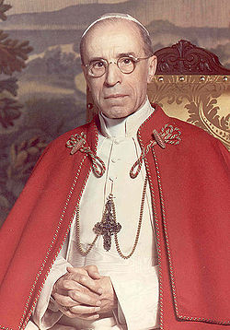

Pope Pius XII was pope from 3/2/1939 to 10/9/1958. He was 82 years old when he died.

Questions

- What city did the Mother of Jesus die in?
- What city was Peter in when the Angel brought Peter to Mary?
- The Mother of Jesus stopped aging at what age?
- The ark that Solomon placed in the Temple represents who?
- Because Mary was without sin, Jesus told Her that She did not have to die, but rather go straight to heaven. Mary requested She must die like the other children of Adam. What was Her reason for passing through death?
- What caused Mary’s physical death?
- What day of the week and time did she die?
- How old was Mary when She died?
- How many years after Jesus died did Mary live here upon the earth?
- The Three persons of the holy Trinity had decided that Mary didn’t have to wait for Her Body to be reunited at the General Resurrection. God had determined that Her Body be reunited with Her Soul at the same day and hour of the week as Jesus was. Name this day and hour.
- Mary was buried outside the walls of Jerusalem in a _______ and the door of the grave was a ______.

