Chapter One

THE SEVEN DEADLY SPIRITS 2
Giving authority to your own ideas is called arrogance (pride). 5
Questions. 5

THE SEVEN DEADLY SPIRITS

Relying on prosperity is called arrogance (pride).

^{Sir 11:25} In the day of prosperity, adversity is forgotten, and in the day of adversity, prosperity is not remembered.

1) “Prosperity” is the pleasure of the eye finding satisfaction with its daily activities.
2) “The Day of adversity”. This Day is the Final Test. On this Day the power of serving oneself comes to an end.

^{Jer 22:21} I (God) spoke to you in your prosperity, but you said, ‘I will not listen.’ This has been your way from your youth, that you have not obeyed My Voice.

- “I spoke to you in your prosperity”. God warns us through many kinds of punishment that prosperity is the wrong path to take.

Brothers, just imagine if we found perfect pleasure and painless rest in the world! We would never look for God or care about His will.

^{Ps 10:6} They say in their hearts, “We will never fall; never will we see misfortune.”

- “Never will we see misfortune.” Man is completely unaware that he must walk trough the valley of death after he physically dies.

^{Jb 15:21} Terrifying sounds are in his ears; in prosperity the destroyer will come upon him. (Refers to the Final Test.)

- “The destroyer will come upon him”. When a man fails the Final Test, the angel of truth called the destroyer will reveal his sins. On this Day he will see how his sins deserve punishment.

^{Jb 21:12} They sing to the timbrel and harp, and make merry to the sound of the flute.
^{21:13} They live out their days in prosperity, and tranquilly go down to the Sheol. (Sheol is the place where the Final Test occurs.)
^{21:14} Yet they say to God, “Depart from us, for we have no wish to learn your ways!
^{21:15} What is the Almighty that we should serve Him? And what gain shall we have if we pray to Him?”

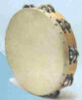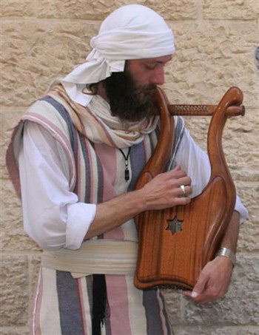
timbrel harp

^{Jb 30:15} Terrors are turned upon me; my honor is pursued as by the wind, and my prosperity has passed away like a cloud.
^{30:16} “And now my soul is poured out within me; days of affliction have taken hold of me. (Refers to the Final Test.)

^{Jb 36:11} If they obey and serve God, they spend their days in prosperity, their years in happiness.
^{36:12} But if they obey not, they perish; they die for lack of knowledge.

1) “They perish; they die for lack of knowledge”. The knowledge in which they lack is Jesus Passion. Heaven can only occur if we appreciate how Jesus took upon Himself the sorrows of all men.

Thinking yourself sufficient is called arrogance (pride).

I ask you; can the papyrus grow up without wetlands? Can the reed grass flourish without water? While it is yet green and uncut, it withers quicker than any grass. So is the end of everyone who forgets God, and so shall the hope of the godless man perish. Jb (8:11)


Papyrus growing in wetlands.

Brothers, in the Lord’s hand is the soul of every living thing, and the life breathe of all mankind. Jb (12:15) If He were to take back His Spirit to Himself, withdraw to Himself His breath, all flesh would perish together, and man would return to the dust. Jb (34:15)

^{Jer 49:4} Why do you glory in your strength, your dying strength, rebellious daughter? You who trust in your treasures, saying, “Who can come against me?”

^{Sir 11:24} Say not: “I am independent. What harm can come to me now?”

^{Ps 127:1} Unless the Lord builds the house, those who build it labor in vain. Unless the Lord watches over the city, the watchman stays awake in vain.

- “City” refers to a man’s soul. As the Israelites were protected from the Egyptians by the pillar of fire, we must be protected by the hand of Jesus at our Final Tests.

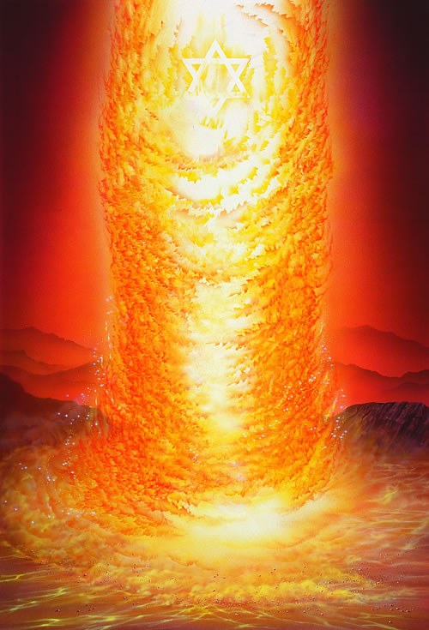

Trusting in your wealth is called arrogance (pride).

Consequently, the fool trusts in his wealth, the abundance of his riches is his boast. Ps (49:7)

^{Jas 4:13} Come now, you who say, “Today or tomorrow we will go into such and such a town and spend a year there and trade and get gain”;
^{4:14} whereas you do not know about tomorrow. What is your life? For you are a mist that appears for a little time and then vanishes.
^{4:15} Instead you ought to say, “If the Lord wills, we shall live and we shall do this or that.”
^{4:16} As it is, you boast in your arrogance. All such boasting is evil.

1) “You boast in your arrogance”. No one can and will escape the Final Test. Men make plans but he can die at anytime.

Trusting in people or your armies is called arrogance (pride).

Jer 17:5 Thus says the LORD: Cursed is the man who trusts in human beings, who seeks his strength in flesh, whose heart turns away from the LORD.

He trusts in his bow and he thinks his sword will bring him victory. Ps (44:7)

^{Ps 147:10} God’s delight is not in the strength of the horse, nor his pleasure in the runner’s stride.

Rom 1:25 They exchanged the truth of God for a lie and revered and worshiped the creature rather than the creator, who is blessed forever. Amen.

- “Revered and worshiped the creature”. This line refers to how we seek the applause of men, by seeking to be honored by them. Sports are a very good example how we seek worldly applause.

Thinking that sin will not be punished is arrogance (pride).

^{Is 47:10} You felt secure in your wickedness, you said, “No one sees me”; your wisdom and your knowledge led you astray, and you said in your heart, “I am, and there is no one besides me.”

^{Ob 1:3} The arrogance of your heart has deceived you: you who dwell in the clefts of the rock, whose abode is in the heights, Who say in your heart, “Who will bring me down to earth?”

Giving authority to your own ideas is called arrogance (pride).

In the verse below, God speaks to Jeremiah the prophet and says:

^{Jer 23:33} "Suppose one of the people or one of the prophets or priests asks you, 'What prophecy has the Lord burdened you with now?' You must reply, 'You are the burden! And I will cast you off, says the Lord.
^{23:34} If any prophet, priest, or anyone else says, 'I have a prophecy from the Lord,' I will punish that person along with his household.
^{23:35} You should keep asking each other, 'What is the Lord’s answer?' or 'What is the Lord saying?'
^{23:36} But stop using this phrase, 'prophecy from the Lord.' For people are using it to give authority to their own ideas, perverting the words of the living God, the living God, the Lord Almighty.
^{23:37} "This is what you should say to the prophets: 'What is the Lord’s answer?' or 'What is the Lord saying?'
^{23:38} But suppose they respond, 'This is a prophecy from the Lord!' Then you should say, 'This is what the Lord says: Because you have used this phrase, "prophecy from the Lord," even though I warned you not to use it,
^{23:39} therefore, behold, I will surely lift you up and cast you away from My presence, you and the city which I gave to you and your fathers.
^{23:40} And I will bring upon you everlasting reproach and perpetual shame, which shall not be forgotten.‘“

When Jeremiah lived in Jerusalem, he would preach a message of repentance from sin and would warn the king, priests and people of punishment if they failed change their ways. The false prophets of the city would refute Jeremiah by saying God would make the city prosperous. But God spoke to Jeremiah and told him to warn the false prophets. Punishment will come to those who give authority to their own ideas that pervert the words of the living God.

^{Eph 5:17} Therefore do not be foolish, but understand what the will of the Lord is.

Questions.

1) The very rich of the world will forget their prosperity when their death comes because they will be forced into the valley of death. It says in the Book of Sirach found in the Catholic Bible that in the day of adversity, prosperity is not _____.

2) God speaks to us in our prosperity, but most will not _______. Men will not obey God's voice.

3) People think in their hearts they will never ____: never will we see _______.

4) An arrogant emotion is to say, "What is the Almighty that we should _____ Him? And what gain shall we have if we ____ to Him?

5) If people obey not, they perish, they die for lack of ______.

6) Can papyrus grow without wetlands? Can man live without God?

7) People think they can live independent and be way from God. This is an emotion and this emotion is called ________.

8) Unless the Lord watches over the city, the city is not protected. Unless the Lord guards your soul from your accusers, you will fail your _____ _____.

9) Men love to plan their futures. Put the Apostle James says this an arrogant _______.

10) Men like to prophecy and thus give authority to their own ideas and this causes them to pervert the ____ of the living God. _______ the prophet would warn the king and the Jews about their sins and the punishment that was coming. But false prophets would say only good things would happen.

