Suffer in the flesh.

regarded the Samaritans as a people to themselves, in spite of an obviously

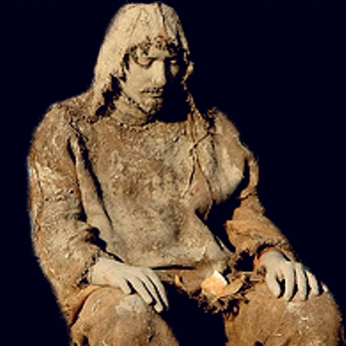
A man wearing sackcloth.

Love is to offer the Passion of Jesus to the Father.

Suffer in the flesh is intercessory prayer.

Before reading this lesson, you must first read the lesson "What is love"?

Our intercessions, which also means "suffer in the flesh", must be much more than a string of words. Our lives should be worn out by sorrow, by years of sighing”. Ps (31:11) In fact, our grief should be with us always”. Ps (38:18) Our sorrow is much more than in name only, but a face inflamed with weeping. Jb (16:16) Recall the words spoken by Jesus to His Apostles, “My soul is very sorrowful, even to death”. Mt (26:38) Jesus gave us a model to follow, yes the model of His anguish.

"Suffer in the flesh" is symbolized as sackcloth.

Sackcloth is a very uncomfortable because it's coarse and irritates the skin.


Sackcloth material

^{Is 22:12} On that Day the Lord, the GOD of many, called on you to weep and mourn, to shave your head and put on sackcloth.
^{22:13} But look! You feast and celebrate, you slaughter oxen and butcher sheep, You eat meat and drink wine: “Eat and drink, for tomorrow we die!”
^{22:14} This reaches the ears of the LORD of many— You shall not be pardoned this wickedness till you die, says the Lord, the GOD of many.

^{Jer 6:26} O daughter of My people, gird on sackcloth, roll in the ashes. Mourn as for an only child with bitter wailing, for sudden upon us comes the destroyer. (Destroyer represents our accusers at our Final Tests.)


Ashes

^{Bar 4:22} I have taken off the clothing of peace, have put on sackcloth for my prayer of supplication (Intercessory Prayer.), and while I live I will cry out to the Eternal God.

^{Ps 35:13} Yet I, when they were ill, (Being ill is a reference to sin.) put on sackcloth, afflicted Myself with fasting, sobbed My prayers upon My bosom (chest).
^{35:14} I went about in grief as for My brother, bent in mourning as for My mother.

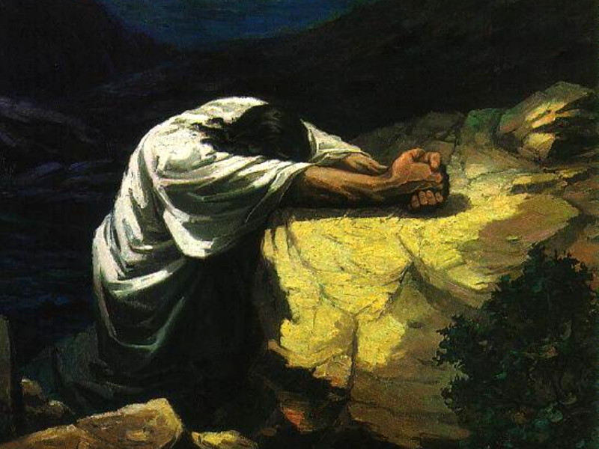
Bent in morning.

The Intercessions of Daniel.

^{Dn 9:3} Then I (I refers to Daniel) turned my face to the Lord God, seeking Him by prayer and supplications (Intercessions) with fasting and sackcloth and ashes.
^{9:4} I prayed to the LORD my God and made confession, saying, “O Lord, the great and awesome God, You who keep Your merciful covenant (promises) toward those who love You and observe Your Commandments!
^{9:5} we have sinned and done wrong and acted wickedly and rebelled, turning aside from Your Commandments and ordinances;
^{9:6} we have not listened to Your servants the prophets, who spoke in Your Name to our kings, our princes, and our fathers, and to all the people of the land.
^{9:7} To You, O Lord, belongs righteousness, but to us confusion of face, as at this day, to the men of Judah, to the inhabitants of Jerusalem, and to all Israel, those that are near and those that are far away, in all the lands to which You have driven them, because of the unfaithfulness which they have committed against You.
^{9:8} To us, O Lord, belongs confusion of face, to our kings, to our princes, and to our fathers, because we have sinned against You.
^{9:9} To the Lord our God belong mercy and forgiveness; but yet we have rebelled against Him,
^{9:10} and have not obeyed the Voice of the LORD our God by following His laws, which He set before us by His servants the prophets.
^{9:11} All Israel has transgressed Your law and turned aside, refusing to obey Your Voice. And the curse and oath which are written in the Law of Moses the servant of God have been poured out upon us, because we have sinned against You.
^{9:12} You carried out the threats You spoke against us and against those who governed us, by bringing upon us in Jerusalem the greatest calamity that has ever occurred under heaven. (The destruction of Jerusalem by Babylon.)

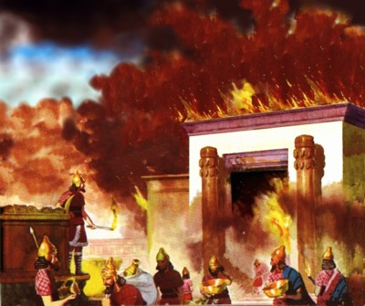
Temple in Jerusalem torched by the Babylonians.

^{Dn 9:13} As it is written in the Law of Moses, all this calamity has come upon us, yet we have not begged the favor of the LORD our God, turning from our sins and giving heed to Your truth.
^{9:14} Therefore the LORD has kept ready the calamity and has brought it upon us; for the LORD our God is righteous in all the works which He has done, and we have not obeyed His Voice.
^{9:15} And now, O Lord our God, who brought Your people out of the land of Egypt with a mighty hand, and made a name for Yourself even to this day, we have sinned, we have done wickedly.
^{9:16} O Lord, according to all Your righteous acts, let Your anger and Your wrath turn away from Your city Jerusalem, Your holy hill; because for our sins, and for the sins of our fathers, Jerusalem and Your people have become a slogan among all who are round about us. (Jerusalem was defeated by Babylon.)
^{9:17} Now therefore, O our God, listen to the prayer of Your servant and to his supplications, and for Your own sake, O Lord, cause Your face to shine upon Your temple, (Refers to the temple in Jerusalem.) which is deserted.
^{9:18} O my God, incline Your ear and hear; open Your eyes and behold our desolations, and the city which is called by Your name; (City of David) for we do not present our supplications before You on the ground of our righteousness, but on the ground of Your great mercy.
^{9:19} O LORD, hear; O LORD, forgive; O LORD, give heed and act; delay not, for Your own sake, O my God, because Your city and Your people are called by Your Name.”

Let us search and examine our ways that we may return to the Lord! Let us reach out our hearts toward God in heaven! We have sinned and rebelled. Lam (3:40)

Daniel lived in Jerusalem when the king of Babylon attached and defeated Jerusalem. Daniel and many other Jews were taken prisoner and were held captive in Babylon.

regarded the Samaritans as a people to themselves, in spite of an obviously

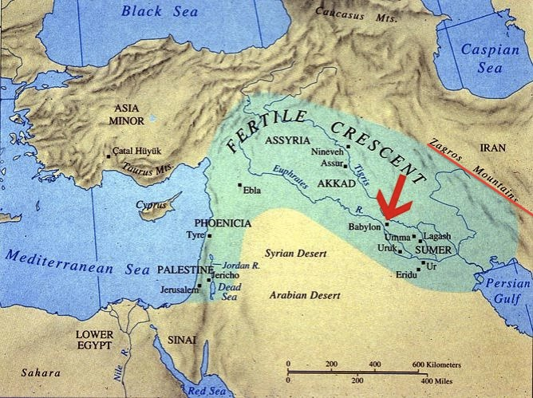
A man wearing sackcloth.

The Intercessions of Moses.

^{Ex 32:7} The LORD said to Moses, “Go down at once to your people, whom you brought out of the land of Egypt, for they have become corrupted.
^{32:8} They have soon turned aside from the way I pointed out to them, making for themselves a molten calf and worshiping it, sacrificing to it and crying out, ‘This is your God, O Israel, who brought you out of the land of Egypt!’

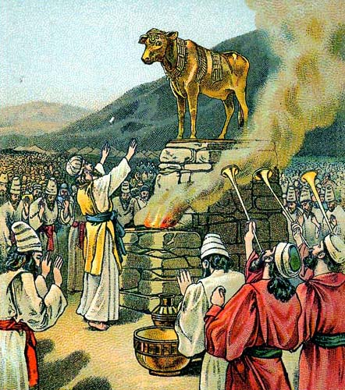

^{32:9} I see how stiff-necked this people is,” continued the LORD to Moses.
^{32:10} “Let Me alone, then, that My wrath may blaze up against them to consume them. Then I will make of you (Moses) a great nation.”
^{32:11} But Moses implored the LORD, his God, saying, “Why, O LORD, should Your wrath blaze up against Your own people, whom You brought out of the land of Egypt with such great power and with so strong a hand?
^{32:12} Why should the Egyptians say, ‘With evil intent He brought them out, that He might kill them in the mountains and exterminate them from the face of the earth’? Let Your blazing wrath die down; relent in punishing Your people.
^{32:13} Remember Your servants Abraham, Isaac and Israel, and how You swore to them by Your own self, saying, ‘I will make your descendants as numerous as the stars in the sky; and all this land that I promised, I will give Your descendants as their perpetual heritage.’”
^{32:14} So the LORD relented in the punishment He had threatened to inflict on His people.



The word "stiff-necked" comes from the image of a stubborn goat. The goat's owner wants the goat to move in a certain direction and the goat resists. This same image is how mankind reacts to God's Commandments.

God the Father speaks to Saint Catherine.

God the Father said the following to Saint Catherine:

Though I once reconciled (forgave) sinners to Myself through the Blood of My Son, but their sins have again made them My enemies. But I have one remedy (cure) to calm My wrath: My servants who care enough to press Me with their tears and bind (tie) Me with the chain of their desire. You see, you have bound Me with that chain- and I Myself gave you that chain because I wanted to be merciful to the world. I put into My servants a hunger and longing for My honor and the salvation of souls so that I might be forced by their tears to soften the fury (anger) of My divine justice.

Bring, then, your tears and your sweat, you and My other servants. Draw them from the fountain of My divine love and use them to wash the face of My bride. (Refers to Catholic Church.) I promise you that thus Her beauty will be restored. Not by the sword or by war or by violence will she regain Her beauty, but through peace and through the constant and humble prayers and sweat and tears poured out by My servants with eager desire.

But do not think that such zeal and nourishment is to be had from vocal prayer alone, as many souls believe. Their prayer consists more in words than in affection, and they seem to be concerned only to complete their multitude of psalms (songs of praise) and to say a great many Our Fathers. When they have finished the number they have set themselves to say, they seem to think of nothing more. It seems they place the whole purpose of prayer in what is said vocally. But that is not how they should act, for if that is all they do they will draw little fruit from it and will please Me little.

"I am one who is pleased by few words and many works." I wanted to show you that I am not much pleased with one who simply shouts, "Lord, Lord, I would like to do something for you!" Nor with one who wishes to kill the body with great penances without slaying the selfish will. (desires of the flesh) What I want is many works of patient and courageous endurance and of the other virtues I have described to you- interior virtues that are all active in bearing the fruit of grace.

Brothers, we are required to be con-tinually slaying our selfish wills. And when we slay our desires to commit sin, this can be called good works.

Actions based on any other principle I would consider a mere "shouting of words." For these are finite works, and I who am infinite insist upon infinite works, that is, infinitely desirous love. I want works of penance and other bodily practices to be undertaken as means, not as your chief goal. By making them your chief goal you would be giving Me a finite thing- like a word that comes out of the mouth and then ceases to exist- unless indeed that word comes out of the soul's love, which conceives virtue and brings it to birth in truth. I mean that finite works- which I have likened to words- must be joined with loving charity. Such works, undertaken not as your chief goal but as means, and not by themselves but in the company of true discernment, would please Me.

It would not be right to make penance or other bodily works either your motivation or your goal, for, as I have already said, they are only finite. They are done in time that comes to an end, and sometimes one has to abandon them or have them taken away. In fact, it would not only be without merit but would offend Me if you continued in these works when circumstances or obedience to authority made it impossible to do what you had undertaken. So you see how finite they are. Take them up, then, not as your goal but only as they are useful. For if you take them as a goal and then have to abandon them at some point, your soul will be left empty.

As for words, I want few not because I have no use for them, but to emphasize that any act in itself is finite and can please Me only if it is taken as an instrument of virtue and not as virtuous in itself.

Let no one, therefore, make the judgment of considering those great penitents (People who do penance.) who put much effort into killing their bodies more perfect than those who do less. I have told you that penance is neither virtuous nor meritorious in itself. Were that the case, how unfortunate would be those who for legitimate reasons cannot perform actual works of penance! But the merit of penance rests completely in the power of charity enlightened by true discernment.

The priorities set by holy discernment direct all the soul's powers to serving Me courageously. Then she must love her neighbors with such affection that she would bear any pain or torment to win them the life of grace, ready to die a thousand deaths, if that were possible, for their salvation. And all her material possessions are at the service of her neighbors' physical needs. Such is the work of the light of discernment born of charity.

The purpose of prayer is our opportunity to experience the emotions of charity, compassion and mercy. We will need these emotions at our Final Tests in order for us to appreciate Jesus Passion. Those who fail their Final Tests were not able to find any joy in the Blood of Jesus because their lives experienced very little charity, compassion and mercy. It's not possible to appreciate Jesus' Passion unless we have had charity for the sorrows of others.

The Book of Jeremiah.

God's anger can be so great against sinners that God will not listen to our prayers. The following is from the Book of Jeremiah.

^{Jer 7:1} The word that came to Jeremiah from the Lord:
^{7:2} “Stand in the gate of the Lord’s house, and proclaim there this word, and say, Hear the word of the Lord, all you men of Judah who enter these gates to worship the Lord.
^{7:3} Thus says the Lord of hosts, (hosts means many.) the God of Israel, Amend your ways and your doings, and I will let you dwell in this place.
^{7:4} Do not trust in these deceptive words: ‘This is the temple of the Lord, the temple of the Lord, the temple of the Lord.’ (Saying words with no love.)
^{7:5} “For if you truly amend your ways and your doings, if you truly execute justice one with another,
^{7:6} if you do not oppress the alien, the fatherless or the widow, or shed innocent blood in this place, and if you do not go after other gods to your own hurt,
^{7:7} then I will let you dwell in this place, in the land that I gave of old to your fathers for ever.
^{7:8} “Behold, you trust in deceptive words to no avail.
^{7:9} Will you steal, murder, commit adultery, swear falsely, burn incense to Baal, and go after other gods that you have not known,
^{7:10} and then come and stand before Me in this house, which is called by My name, and say, ‘We are delivered!’ —only to go on doing all these abominations?
^{7:11} Has this house, which is called by My name, become a den of robbers in your eyes? Behold, I Myself have seen it, says the Lord.
^{7:12} Go now to My place that was in Shiloh, where I made my name dwell at first, and see what I did to it for the wickedness of My people Israel.

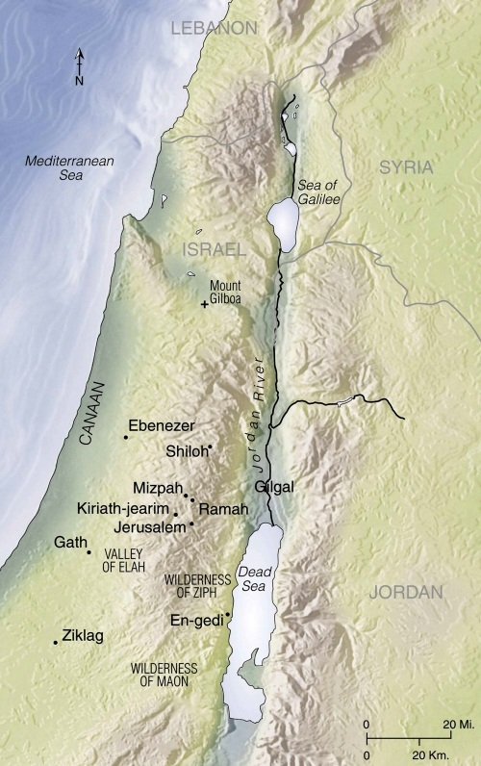
Shiloh is north of Jerusalem was conquered by Assyrians. Shiloh was the place in which the meeting tent was assembled during the time of Josiah and Eli.

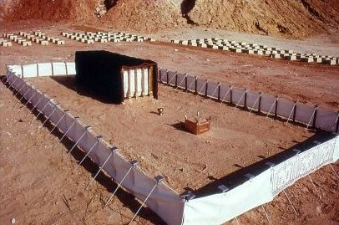
Meeting tent that Moses constructed.
^{Jer 7:13} And now, because you have done all these things, says the Lord, and when I spoke to you persistently you did not listen, and when I called you, you did not answer,
^{7:14} therefore I will do to the house (Temple in Jerusalem.) which is called by My name, and in which you trust, and to the place which I gave to you and to your fathers, as I did to Shiloh.
^{7:15} And I will cast you out of My sight, as I cast out all your kinsmen, all the offspring of Ephraim.
^{7:16} “As for you, (You refers to Jeremiah.) do not pray for this people, or lift up cry or prayer for them, and do not intercede with Me, for I do not hear you.
^{7:17} Do you not see what they are doing in the cities of Judah and in the streets of Jerusalem?
^{7:18} The children gather wood, the fathers kindle fire, and the women knead dough, to make cakes for the queen of heaven; (false god) and they pour out drink offerings to other gods, to provoke Me to anger.
^{7:19} Is it I whom they provoke? says the Lord. Is it not themselves, to their own confusion?
^{7:20} Therefore thus says the Lord GOD: Behold, My anger and My wrath will be poured out on this place, upon man and beast, upon the trees of the field and the fruit of the ground; it will burn and not be quenched.”

The Gospel of John.

On Good Thursday, the night Jesus was arrested by Jews, Jesus said the following prayer to the Father.

^{Jn 17:1} When Jesus had said this, He raised His eyes to heaven and said, “Father, the hour has come. Give glory to Your Son, so that Your Son may glorify You,
^{17:2} just as You gave Him authority over all people, so that He may give eternal life to all You gave Him.
^{17:3} Now this is eternal life, that they should know You, the only true God, and the one whom You sent, Jesus Christ.
^{17:4} I glorified You on earth by accomplishing the work that You gave Me to do. (Definition for giving glory to God.)
^{17:5} Now glorify Me, Father, with You, with the glory that I had with You before the world began.
^{17:6} “I revealed Your Name to those whom You gave Me out of the world. They belonged to You, and you gave them to Me, and they have kept Your word.
^{17:7} Now they know that everything You gave Me is from You,
^{17:8} because the words You gave to Me I have given to them, and they accepted them and truly understood that I came from You, and they have believed that You sent Me.
^{17:9} I pray for them. I do not pray for the world but for the ones you have given Me, because they are Yours,
^{17:10} and everything of Mine is Yours and everything of Yours is Mine, and I have been glorified in them.
^{17:11} And now I will no longer be in the world, but they are in the world, while I am coming to You. Holy Father, keep them in Your Name that You have given Me, so that they may be one just as We are.
^{17:12} When I was with them I protected them in Your Name that You gave Me, and I guarded them, and none of them was lost except the son of destruction, (Refers to Judas.) in order that the Scripture might be fulfilled.
^{17:13} But now I am coming to you. I speak this in the world so that they may share My joy completely.
^{17:14} I gave them Your word, and the world hated them, because they do not belong to the world any more than I belong to the world.
^{17:15} I do not ask that you take them out of the world but that you keep them from the evil one.
^{17:16} They do not belong to the world any more than I belong to the world.
^{17:17} Consecrate them in the truth. (Consecrate means dedicated to a sacred purpose.) Your word is truth.
^{17:18} As you sent Me into the world, so I sent them into the world.
^{17:19} And I consecrate Myself for them, so that they also may be consecrated in truth.
^{17:20} “I pray not only for them, but also for those who will believe in Me through their word,
^{17:21} so that they may all be one, as you, Father, are in Me and I in you, that they also may be in us, that the world may believe that You sent Me.
^{17:22} And I have given them the glory you gave Me, so that they may be one, as We are one,
^{17:23} I in them and You in Me, that they may be brought to perfection as one, that the world may know that You sent Me, and that you loved them even as you loved Me.
^{17:24} Father, they are Your gift to Me. I wish that where I am they also may be with Me, that they may see My glory that you gave Me, because You loved Me before the foundation of the world.
^{17:25} Righteous Father, the world also does not know You, but I know You, and they know that You sent Me.
^{17:26} I made known to them Your Name and I will make it known, that the love with which You loved Me may be in them and I in them.”

It’s very interesting that Jesus is not praying for the world, but only for the souls that the Father has given Him.

^{Jn 17:9} I pray for them. I do not pray for the world but for the ones you have given Me, because they are Yours,

In the lesson named “Natural Law”, only those souls who heard and learned from the Father would be sent to the Son.

^{Jn 6:45} It is written in the prophets, ‘And they shall all be taught by God.’ Every one who has heard and learned from the Father comes to Me. (Jesus spoke these words.)

Jesus does not explain what the Father taught us. But the argument can be made it is the Natural Law the Father teaches all men. Thus if we hear the Father speak to us the Natural Law and if we obey the Natural Law, we will come to Jesus.

The Lord tells Jeremiah not to pray for the Jews.

^{Jer 7:16} “As for you, (You refers to Jeremiah.) do not pray for this people, or lift up cry or prayer for them, and do not intercede with Me, for I do not hear you.

Why does the Lord not listen to prayers or say prayers for those not given to Him? These men will not ask for forgiveness and reform their lives.

Apostle John writes in his Epistle the following; (Epistle means letter.)

^{1 Jn 5:16} If anyone sees his brother sinning, if the sin is not deadly, he should pray to God and he will give him life. This is only for those whose sin is not deadly. There is such a thing as deadly sin, about which I do not say that you should pray.
^{5:17} All wrongdoing is sin, but there is sin that is not deadly.

Have you ever heard any priest or preacher say that we should not pray for deadly sin? But Scripture tells us that Jeremiah was told by the Lord not to pray for the sinful Jews. Jesus Himself prays to the Father for those who the Father has given Him, but not for the world. And Apostle John also says not to pray for those whose sins are deadly. Did you know that God has known from the beginning of the world who would be in heaven and those who would be in hell? The time before the world existed is called in Scripture “before the foundation of the world”. Rev (13:8 & 17:8) In those verses it says “The Book of life of the Lamb” was written “before the foundation of the world”. God has always known those souls who will reject His words and who will appreciate the Blood of Jesus.

In the Gospel of Matthew Jesus said the following;

^{Mt 5:43} “You have heard that it was said, ‘You shall love your neighbor and hate your enemy.’
^{5:44} But I say to you, love your enemies, and pray for those who persecute you,
^{5:45} that you may be children of Your heavenly Father, for He makes His sun rise on the bad and the good, and causes rain to fall on the just and the unjust.
^{5:46} For if you love those who love you, what recompense will you have? Do not the tax collectors do the same?
^{5:47} And if you greet your brothers only, what is unusual about that? Do not the pagans do the same?
^{5:48} So be perfect, just as your heavenly Father is perfect.

Since we do not know whose names are in the Lamb’s Book of life, we do not know which of our enemies will repent and appreciate the Blood of Jesus. Combining the Scripture verses, we should ask the Lord to have mercy on all those written in the Lamb’s Book of Life. We should recognize that most men’s names will not be written in the Book. It’s a good possibility that 2/3 of mankind will end up in hell. Zech (13:8) With so many who are not listed, it’s obvious that the Father's justice would not hear our prayers for the damn. Some will ask why pray if the names in the Book of Life are set. The answer is that God also knows who will intercede and He knew this before the “foundations of the earth”. Yes, God knew our actions before the world was created. It says the following in the Epistle of James.

^{Jas 5:19} My brethren, if any one among you wanders from the truth and some one brings him back,
^{5:20} let him know that whoever brings back a sinner from the error of his way will save his soul from death and will cover a multitude of sins.

Saint Peter also wrote the same thing.

^{1 pet 4:7} The end of all things is at hand; therefore keep sane and sober for your prayers.
^{4:8} Above all hold unfailing your love for one another, since love covers a multitude of sins.

Before the “foundations of the earth”, God knew who would love others in the way Jesus loved us and thus God applied their efforts to the salvation of souls.

Questions

1) Intercessory prayer is much more than a group of words. Our prayers should be with sorrow. Why?

2) "Suffer in the flesh" is symbolized as _________.

3) Verse 35:13 in Psalms says "Yet I, when they were ill, put on sackcloth, afflicted Myself with fasting, sobbed My prayers upon My bosom". What illness is the verse referring to?

4) Jerusalem was defeated by the king of Babylon and a prophet named Daniel was taken prisoner and was held captive in what city?

5) Fasting, sackcloth and ashes represent the sadness in Daniel's heart and were used when Daniel prayed to God. Daniel recognized how the Jews had sinned against God. Daniel called upon God's great _______.

6) The word "stiff-necked" comes from the image of what animal?

7) If we resist God's commandments we can be liked to what animal?

8) God wanted to destroy the Jews because they made a golden calf and said this is our "god". Who interceded to stop God from destroying them?

9) God the Father wants to be merciful to the world. How can we soften the anger of God's Justice?

10) Vocal prayer will not be pleasing to God unless our vocal prayer has what?

11) Finite works like intercessory prayer must be joined to _______ charity. We must have discernment on why we are doing penance. Our focus must be love of neighbors by bearing pain and torment to win them the life of grace, ready to die a ________ deaths, if that were possible for their salvation.

11) The purpose of prayer is our opportunity to experience the emotions of ______, ________, and ________. Why do we need these emotions?

12) What prophet was told by the Lord not to pray for the people?

13) When a person's sins become so great, God will not hear the _______ of those who pray for them.

14) Looking at the map, is Shiloh to the north or south of Jerusalem?

15) What prophet was told by the Lord not to pray for the people?

16) We are all taught by the Father. All those who fail to hear and act upon the Natural Law are not listed in “The ______ _______ of _______.

17) On Good Thursday, Jesus didn’t pray for the world, who did He pray for?

