The Natural Law and Conscience

regarded the Samaritans as a people to themselves, in spite of an obviously

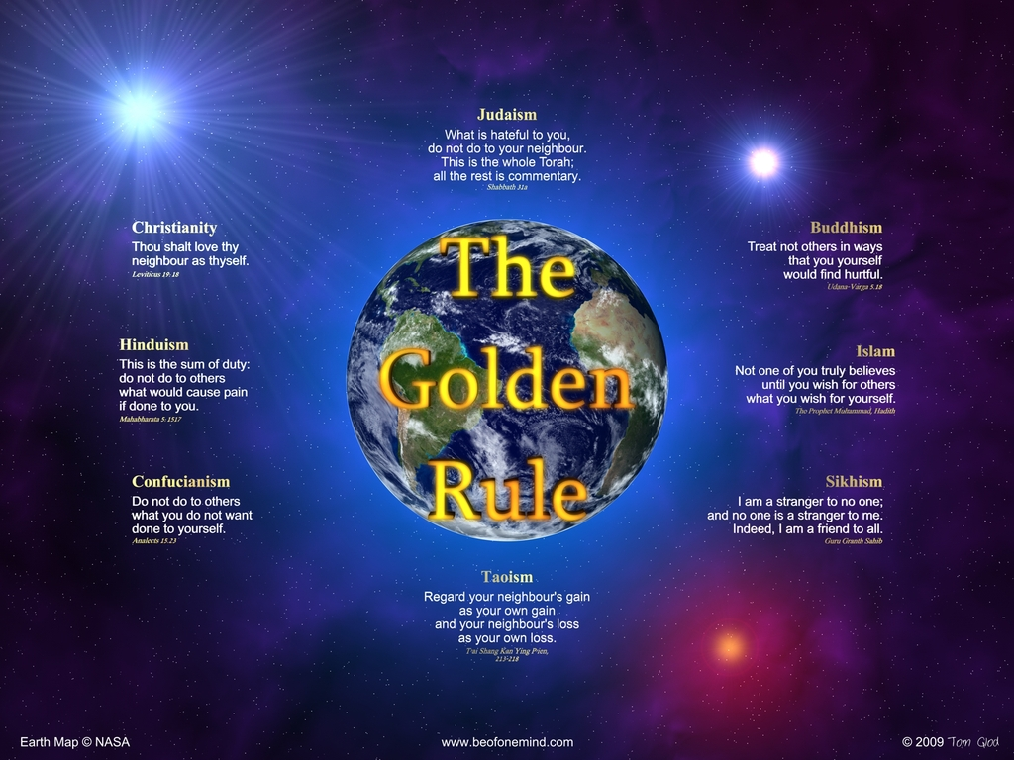

People around the world know how to treat one another because God the Father has taught each of us the Natural Law.

^{Jn 6:45} It is written in the prophets, ‘And they shall all be taught by God.’ Every one who has heard and learned from the Father comes to Me. (Jesus spoke these words.)

Jesus was referring to Isaiah as the prophet.

^{Is 54:13} All your sons shall be taught by the LORD, and great shall be the prosperity of your sons.

Jesus does not explain what the Father taught us. But the argument can be made it is the Natural Law the Father teaches all men. Thus if we hear the Father speak to us the Natural Law and if we obey the Natural Law, we will come to Jesus. If we come to Jesus we be asked to pick up our crosses and follow Him. In other words, we will be asked to imitate Jesus.

The Natural Law

^{Mt 7:12} “Do to others whatever you would have them do to you.

^{Sir 31:15} Judge your neighbor’s feelings by your own, and in every matter be thoughtful.

^{Tb 4:15} And what you hate, do not do to any one.

^{Jas 4:17} So for one who knows the right thing to do and does not do it, it is a sin.

^{Dt 30:10} if you obey the Voice of the LORD Your God, to keep His Commandments and His statutes which are written in this book of the law, if you turn to the LORD your God with all your heart and with all your soul.
^{30:11} “For this commandment which I command you this day is not too hard for you, neither is it far off.
^{30:12} It is not in heaven, that you should say, ‘Who will go up for us to heaven, and bring it to us, that we may hear it and do it?’
^{30:13} Neither is it beyond the sea, that you should say, ‘Who will go over the sea for us, and bring it to us, that we may hear it and do it?’
^{30:14} But the word is very near you; it is in your mouth and in your heart, so that you can do it.

^{Rom 2:14} When Gentiles (The uncircumcised.) who do not have the law, keep it as by instinct.
^{2:15} They show that the demands of the law are written in their hearts. Their conscience will accuse or defend them on the last day. (Refers to the Final Test.)

^{Jn 6:45} It is written in the prophets: ‘They shall all be taught by God.’ Everyone who listens to My Father and learns from Him comes to Me. (Me refers to Jesus.)

1) “They shall all be taught by God”. Behold, the Natural Law was taught to us by the Father.

2) “Everyone who listens to My Father and learns from Him”. Not only must we listen to the Natural Law written on our hearts, we must place the Natural Law into action.

3) “Comes to Me”. All those that violate the Natural Law will reject Christ. My point to you is this; those that are attracted to the Plan of God must be attracted to the Natural Law first.

^{Sir 17:1} The LORD from the earth created man, and in His own image He made him.
^{17:2} Limited days of life He gives him and makes him return to earth again.
^{17:3} He endows man with a strength of his own, and with power over all things else on earth.
^{17:4} He puts the fear of Him in all flesh, and gives him rule over beasts and birds.
^{17:5} He forms men’s tongues and eyes and ears, and imparts to them an understanding heart.
^{17:6} With wisdom and knowledge He fills them; good and evil He shows them.

1) “In His own image He made him”. Image and likeness will be discussed in another lesson.

2) “He (God) puts the fear of Him in all flesh”. As a person commits sin after sin, the fear of God disappears.

3) “Gives him rule over beast and birds”. Scripture is not talking about actual beast and birds but rather it is referring to sin. This subject is discussed in another lesson.

4) "Good and evil He shows them". At six month babies can barely sit up - let along take their first tottering steps, crawl or talk. But, according to psychologists, they have already developed a sense of moral code - and can tell the difference between good and evil. An astonishing series of experiments is challenging the views of many psychologists and social scientists that human beings are born as 'blank slates' - and that our morality is shaped by our parents and experiences. Instead, they suggest that the difference between good and bad may be hardwired into the brain at birth.

In one experiment involving puppets, babies six months old showed a strong preference to 'good' helpful characters - and rejected unhelpful, 'naughty' ones. In another, they even acted as judge and jury. When asked to take away treats from a 'naughty' puppet, some babies went further - and dished out their own punishment with a smack on its head. Leading research: Professor Paul Bloom, of Yale University, said a series of morality tales featuring puppets were shown to babies of varying ages.

Professor Paul Bloom, a psychologist at Yale University in Connecticut, whose department has studied morality in babies for years, said: 'A growing body of evidence suggests that humans do have a beginning moral sense from the very start of life. 'With the help of well designed experiments, you can see glimmers of moral thought, moral judgment and moral feeling even in the first year of life. 'Some sense of good and evil seems to be bred in the bones.' (From article written by David Derbyshire)

^{Rom 5:13} Sin indeed was in the world before the law was given, but sin is not counted where there is no law.
^{5:14} Yet death reigned from Adam to Moses, even over those whose sins were not like the transgression of Adam, who was a type of the one who was to come.

1) “Sin indeed was in the world before the law was given”. The law was given to Moses. (The Ten Commandments.) Before Moses, people would sin against the Natural Law.

2) “But sin is not counted where there is no law”. Clearly, if the Lord has not spoken to us the Written Law, there is no sin counted against us. There are 7 billion people on earth and billions of people who have died in the past. God will consider many of these people as people He has not spoken too. Thus they will not be guilty of sins against the Law found in the Scriptures.

^{Jn 15:22} If I (Jesus) had not come and spoken to them, they would have no sin; but as it is they have no excuse for their sin.

Remind yourselves that spiritual laziness is held against us. The Lord has spoken to us and if we fail to read His Word, we are guilty of sin.

The verses above reveal how God the Father taught all men us good and evil. Evil is to treat others in such away that we ourselves would not want to be treated. If we fail to apply the Natural Law to our actions, Jesus will call us hypocrites. See lesson on hypocrites http://www.4kingdoms.com/hypocrite.html

The reason why we have so many religions and religious opinions is because God did not teach us our faith. God taught us the Natural Law, but not our Faith. Faith is to be learned from other men and if we are taught incorrectly, our faith will also be incorrect.

What is our conscience?

The Natural Law is written on our hearts, but it's our minds that understand it. Repeating the verses written by Paul;

^{Rom 2:14} When Gentiles (The uncircumcised.) who do not have the law, keep it as by instinct.
^{2:15} They show that the demands of the law are written in their hearts. Their conscience will accuse or defend them on the last day. (Refers to the Final Test.)

^{Sir 4:12} Blessed is he whose heart does not condemn him, and who has not given up his hope.

The Natural Law is written on the heart. When we hear a voice within our minds that says we violated the Natural Law, this is our conscience. At our Final Tests, if our conscience becomes distressed, it's because we can hear our minds condemning us for our sins. When the distress becomes too great, the person will fall into suicidal depression.

^{Wis 17:11} For wickedness, of its nature cowardly, it condemns itself, and because of a distressed conscience, always magnifies misfortunes. (Refers to the Final Test.)

^{Sir 14:2} Happy the man whose conscience does not reproach him, who has not lost hope.

When a soul loses hope at his Final Test, that soul fails the Final Test. During life, that soul suppressed his conscience, his eyes would not look to heaven and he did not keep in mind the punishments that God's justice would apply. Dan (13:9) Be like Saint Paul who said, "I always strive to keep my conscience clear before God and man". Act (24:16) Because by rejecting conscience, souls can make a shipwreck of their faith. 1 Tim (1:1) We need faith in order to be saved at our Final tests. Hypocrites reject conscience. And no hypocrite will pass their Final Test unless he confesses his hypocrisy. Treating others in the way you would not want to be treated is rejecting conscience.

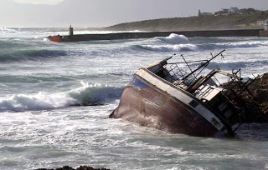

Questions

1) Who teaches us the Natural Law?

2) Explain what the Natural Law is?

3) Most people call the Natural Law by another name. What is that name?

4) What prophet is Jesus referring too when Jesus says it is written in the prophets "they shall all be taught by God"?

5) If we treat others in away in which we would hate, Jesus will call us a __________.

6) Jesus says if we hear and learn from the Father we will come to _______.

7) Because the Natural Law was written on all men hearts, _______ was in the world before God gave Moses the Law.

8) Christians who have the Written Law and the Natural Law can sin against God because God has spoken to us. If God has not spoken to us the Written Laws, there is no _______.

9) Our faith is taught us by other ________. If we are taught incorrectly, our faith will also be __________.

10) People do not come to Jesus because they are taught the wrong faith and because they do not obey the __________ Law.

11) Hypocrites suppress their _________.

12) How does a soul lose hope at their Final Test?

13) What causes our faith to become shipwrecked?

