High Above the Earth is the Heavens.

regarded the Samaritans as a people to themselves, in spite of an obviously

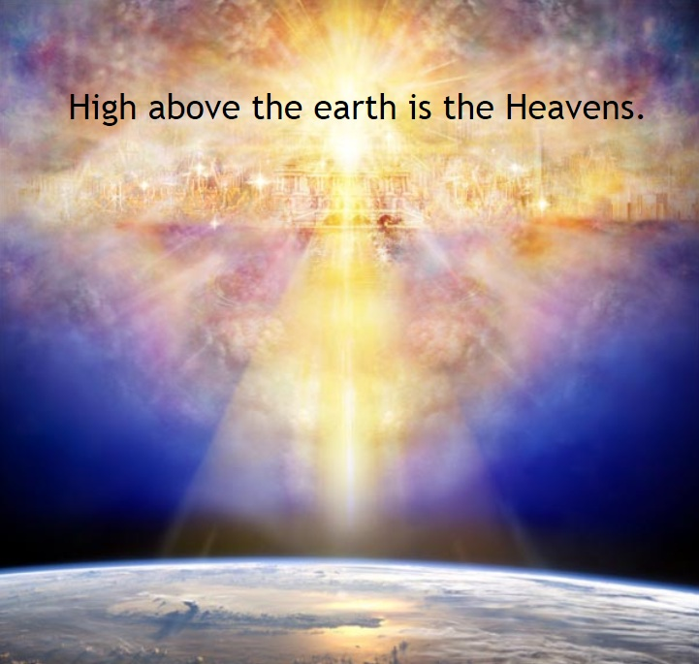

^{Is 55:8} For My thoughts are not your thoughts, neither are your ways My ways, says the Lord.
^{55:9} For as the heavens are higher than the earth, so are My ways higher than your ways and My thoughts than your thoughts.

What makes God's ways so different from man's ways? God actually answers this question with the verses that follows Isaiah 55:9.

^{Is 55:10} “For as the rain and the snow come down from heaven, and return not thither but water the earth, making it bring forth and sprout, giving seed to the sower and bread to the eater,
^{55:11} so shall My word be that goes forth from My mouth; it shall not return to Me empty, but it shall accomplish that which I purpose, and prosper in the thing for which I sent it.



God's warning is this, His word should not come back to Him empty. But men have other ideas and easily become drunk on their passions and appetites. (dopamine) The penalty is everlasting punishment if we make God's words empty. The parable below reveals how men will be treated by God's justice.

^{Mt 25:24} He also who had received the one talent came forward, saying, ‘Master, I knew you to be a hard man, reaping where you did not sow, and gathering where you did not winnow; (Winnow is the process of removing chaff from the grain.)
^{25:25} so I was afraid, and I went and hid your talent in the ground. Here you have what is yours.’
^{25:26} But his master answered him, ‘You wicked and slothful servant! You knew that I reap where I have not sowed, and gather where I have not winnowed?

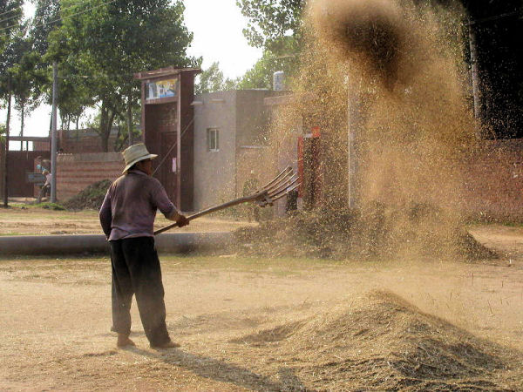
Winnow is the process of removing chaff from the grain.

^{Mt 25:27} Then you ought to have invested my money with the bankers, and at my coming I should have received what was my own with interest.
^{25:28} So take the talent from him, and give it to him who has the ten talents.
^{25:29} For to every one who has will more be given, and he will have abundance; but from him who has not, even what he has will be taken away.
^{25:30} And cast the worthless servant into the outer darkness; there men will weep and gnash their teeth.’

What is a talent? The Scriptures do not reveal the meaning of the talent. But a reasonable definition can be brought to the table to discuss. The talent can be thought of as the Natural Law Mt (7:12) which has been taught to all men by the Father. Jn (6:45) If we play the hypocrite by treating others in ways we would never want to be treated, God will call us wicked and lazy servants. God demands we treat others in the way we would want to be treated. But men's ways are not God's ways. Men do not take God's warnings of punishment seriously because men are thinking like men. Men are constantly playing the hypocrite and thus have buried the talent. The next verses below again speaks about God's justice against those who fail to apply God's words to their lives.

^{Jn 15:5} I am the vine, you are the branches. He who abides in Me, and I in him, he it is that bears much fruit, for apart from Me you can do nothing.
^{15:6} If a man does not abide in Me, he is cast forth as a branch and withers; and the branches are gathered, thrown into the fire and burned.



God demands we take His words and act upon them. God calls our actions "fruits" if we do them in the name of His Son Jesus. Does humanity knows this? Do even Christians know they must produce fruit? Jesus commanded us on the night He was arrested to love one another as He loved us. Jn (13:34) Do we study how Jesus loved us? Baptized Catholics can be likened to a vineyard. The following verses illustrate this.

^{Is 5:1} Let me sing for my beloved a love song concerning his vineyard: My beloved had a vineyard on a very fertile hill.
^{5:2} He digged it and cleared it of stones, and planted it with choice vines; he built a watchtower in the midst of it, and hewed out a wine vat in it; and he looked for it to yield grapes, but it yielded wild grapes.
^{5:3} And now, O inhabitants of Jerusalem and men of Judah, judge, I pray you, between me and my vineyard.
^{5:4} What more was there to do for my vineyard, that I have not done in it? When I looked for it to yield grapes, why did it yield wild grapes?
^{5:5} And now I will tell you what I will do to my vineyard. I will remove its hedge, and it shall be devoured; I will break down its wall, and it shall be trampled down.
^{5:6} I will make it a waste; it shall not be pruned or hoed, and briers and thorns shall grow up; I will also command the clouds that they rain no rain upon it.

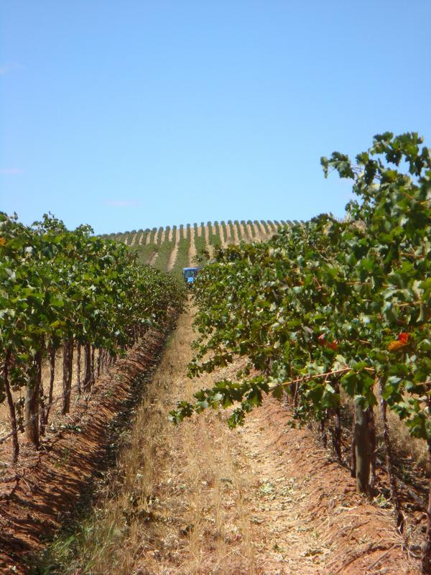
A vineyard has a far greater value than a talent. God requires interest on a talent. In other words, applying the Natural law to our lives is small compared to producing fruit. The Word of God (Jesus) came into the world to love us in such away that we can imitate Him. Catholics are given this vineyard when they have received the Sacraments of Baptism, Reconciliation, Holy Eucharist and Confirmation. The Protestants have only the Scriptures. But Catholics are very quick to rebel and thus they will not discipline themselves. The next parable illustrates men's rebellion.

^{Mt 21:33} “Hear another parable. There was a householder who planted a vineyard, and set a hedge around it, and dug a wine press in it, and built a tower, and let it out to tenants, and went into another country.
^{21:34} When the season of fruit drew near, he sent his servants to the tenants, to get his fruit;
^{21:35} and the tenants took his servants and beat one, killed another, and stoned another.
^{21:36} Again he sent other servants, more than the first; and they did the same to them.
^{21:37} Afterward he sent his son to them, saying, ‘They will respect my son.’
^{21:38} But when the tenants saw the son, they said to themselves, ‘This is the heir; come, let us kill him and have his inheritance.’
^{21:39} And they took him and cast him out of the vineyard, and killed him.
^{21:40} When therefore the owner of the vineyard comes, what will he do to those tenants?”
^{21:41} They said to him, “He will put those wretches to a miserable death, and let out the vineyard to other tenants who will give him the fruits in their seasons.”

Doing as we please is rebellion in the eyes of God. But people do not see "doing as they please" as rebellion. That is why God's thoughts are so much different than man's thoughts. The verses below are a example of how God thinks differently than man.

^{Mt 16:21} From that time Jesus began to show His disciples that He must go to Jerusalem and suffer many things from the elders and chief priests and scribes, and be killed, and on the third day be raised.
^{16:22} And Peter took Him and began to rebuke Him, saying, “God forbid, Lord! This shall never happen to you.”
^{16:23} But He turned and said to Peter, “Get behind me, Satan! You are an obstacle in My path, because you are thinking not as God thinks but as human beings do.’

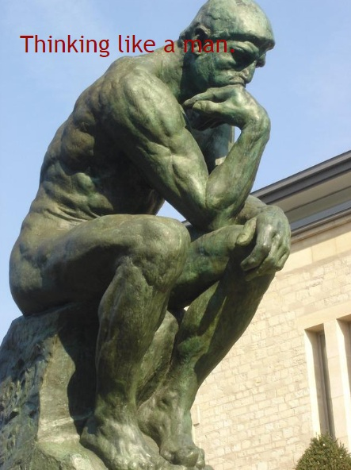

The reason why we have so many Christian denominations is because each person thinks he is thinking as His creator does. They fail to see they are thinking as men do. This is a sin called arrogance.

The Protestants and their protest against Catholics is that they believe that it is faith alone that you have salvation. They believe these verses above pertain to law and are for the Jews and not to the Christian church. But the Epistle of James puts it best when he says:

^{Jas 2:21} Was not Abraham our father justified by works when he offered his son Isaac upon the altar?
^{2:22} You see that faith was active along with his works, and faith was completed by the works.
^{2:23} Thus the scripture was fulfilled that says, “Abraham believed God, and it was credited to him as righteousness,” and he was called “the friend of God.”
^{2:24} See how a person is justified by works and not by faith alone.

^{Jas 2:26} For as the body apart from the spirit is dead, so faith apart from works is dead.

Unfortunately their are many protestors that say James is speaking to the Jews and not the Christian church. They say that James' Epistles do not apply to them. What if they are wrong?

Faith followed by virtuous deeds (love) in the name of Jesus is Catholic Doctrine. What are virtuous deeds? When we love others in the way Jesus loved us this is called virtuous deeds or "fruit".

^{Is 55:10} “For as the rain and the snow come down from heaven, and return not thither but water the earth, making it bring forth and sprout, giving seed to the sower and bread to the eater,
^{55:11} so shall My word be that goes forth from My mouth; it shall not return to Me empty, but it shall accomplish that which I purpose, and prosper in the thing for which I sent it.

As I said earlier, the rain represents the word of God. But what does the snow represent? Snow can be defined from the following verse from the Book of Proverbs.

^{Prv 31:20} She opens her hand to the poor, and reaches out her hands to the needy.
^{31:21} She is not afraid of snow for her household, for all her household are clothed in scarlet.
^{31:22} She makes herself coverings; her clothing is fine linen and purple.

The verses above are describing the good wife. Scripture is not talking about a man who is married and his partner is called a wife, Scripture is referring to a man's conscience. This "wife" is found in every person and governs our every action. If we have a good wife, our actions are symbolized as our children being clothed in obedience (scarlet). Because it says "she is not afraid of the snow", this line is referring to our Final Tests. Scripture describes our Final Tests in many ways always depicting harsh conditions. It's in God plan that all souls must enter into the Final Test after physical death. This "snow" will produce patience and perseverance in those who have been obedient to God's words when they pass through this great distress.

As we learn more about the plan of God, the human spirits that God gave us will not agree with God. This is why God has said to us,

^{Is 55:8} For My thoughts are not your thoughts, neither are your ways My ways, says the Lord.
^{55:9} For as the heavens are higher than the earth, so are My ways higher than your ways and My thoughts than your thoughts.

God's thoughts will be completely different than our thoughts. And because men follow their personal thoughts, far more people will end up in hell than will be in heaven.

Jesus instructed us to call God our Father. Unfortunately we visualize God as a earthly father. Would a earthly father test his children? Would an earthly father condemn his children to hell if they failed the test? So all of you who can't understand this, it's because you are using a human way to describe God the Father. The fact is this, He is not like an earthly father because our heavenly Father is testing us.

In the next lesson it will be discussed how God will push away every soul from Him when they sin. For example when Adam and Eve sinned, God forced them to leave the garden and a Angel (cherubim) with a flaming sword guarded the Tree of Life. Gn (3:24) Scripture makes it clear that God will make a man's heart hardened when they sin, as in the case of Egypt's Pharaoh. Evil spirits are given to those who do not obey, as in the case of Saul the first king of Israel. When souls rebel against authority, God will open the earth to swallow rebels like Korah and Dathan. Punishments against rebellion even occurred to Moses' sister Merriam when she was inflicted with leprosy and pushed outside the camp. The sins of Israel were so great, that God empowered Israel's enemies to defeat them and Israel's enemies drove them away from the Temple and made them live in foreign lands. These examples and others will illustrate how God's ways and thoughts are far different than man's ways and thoughts. I ask you, is there an earthly father that would treat their children in such away as to punish them children so severely? Hell does exist and God has made the road to hell much easier to follow than is the road to heaven. Would an earthly father test his children with a test that could easily lead to hell? My point to you is this, the human spirit will not agree with God's Spirit.

Questions

1) God's thoughts are not man's thoughts. What Book does this verse come from?

2) God's thoughts are so different compared to man's that God uses what physical description to illustrate this truth?

3) Rain and snow come down from heaven and water the earth and produce wheat. God likens this description to His _____ that goes forth from His Mouth and shall not return ______.

4) When a man fails to apply God's words to His life, he is liken to a man that buries his _______.

5) A talent represents something that has value. In the parable about the servant that received one talent, this one talent represents what?

6) If we are guilty of burying our talent, God will cast us into the outer ______: there men will _____ and _____ their _______.

7) If we are likened to branches connected to the vine who is Jesus, what will happen to the branches if they produce no fruit?

8) On the night Jesus was betrayed and arrested, He gave us a new commandment. What is this commandment?

9) A vineyard is a greater wealth than one talent. A vineyard can produce fruit. If we are given a vineyard then we are a Catholic because we have been given the ____ of Peter. Our vineyard must produce the fruit of loving others in the way _____ loved us.

10) Which Apostle did Jesus say "get behind Me satan"?

11) Thinking like a man is a sin called ______.

12) What verse tells us that we will not agree with God?

13) People think of God as Father and equate this thinking to God being earthly. But would an earthly father ______ his children? Even if an earthly father _______ his children, if they failed would he send them to damnation?

